Music at Junction 50
Press Release
Music at Junction 50 announces its 2025 concerts
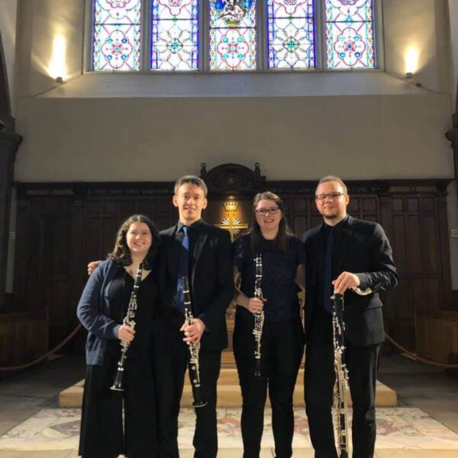
On Thursday 19th June at 7pm we welcome the Silver Keys Clarinet Quartet. They are based in Scotland and with members from English, Lithuanian, Polish and Scottish/American roots are truly an international group. This is reflected in the music they play which explores the rich traditions from all over the world.

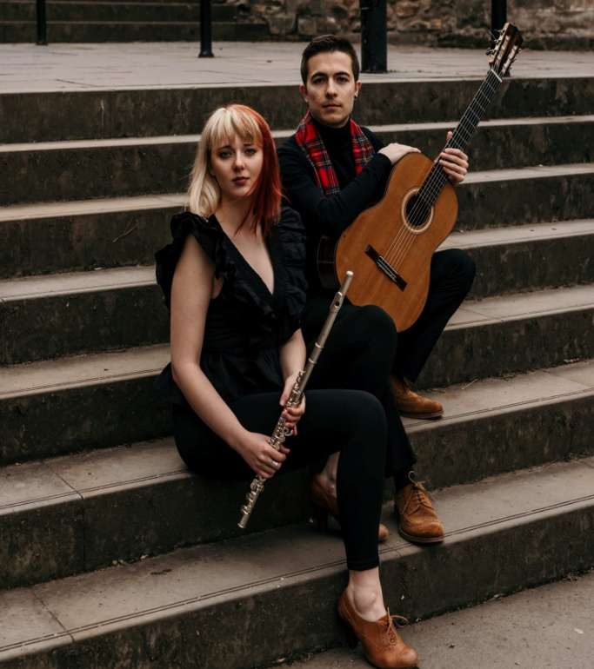
The JKL DUO will appear on Thursday 17th July also at 7pm. They were scheduled to play last year on July 4th but the General Election forced the cancellation of the concert as the venue was being used as a polling station It’s a delight to be able to finally hear this lovely husband and wife guitar and flute duo in Baldersby.

Both concerts take place in the Church of St James in the tiny village of Baldersby St James. Tickets cost £12 including refreshments (Under 18s free) and are available from Colin Reid (colinreid97@yahoo.co.uk) or Pay at the door on the night.

Silver Keys and JKL DUO are represented by Classical Musicians Scotland

