Benefice Online Magazine

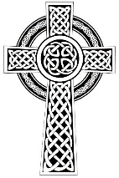
for the Parishes of Topcliffe, Baldersby with Dishforth and Skipton on Swale, and Dalton
Cross Talk
December 2024
Cross Talk is published monthly by email. To receive a copy please contact kitnorris@live.co.uk
Cross Talk contains the weekly Collect and Readings together with details of Church services in the Benefice and news and items of interest supplied by our readers. The magazine will also be available on the web sites: www.achurchnearyou.com/church/3447 and baldersbychurch.com.

CHURCH SERVICES

St. James’ Church, Baldersby St. James with Dishforth, Rainton
and Skipton on Swale

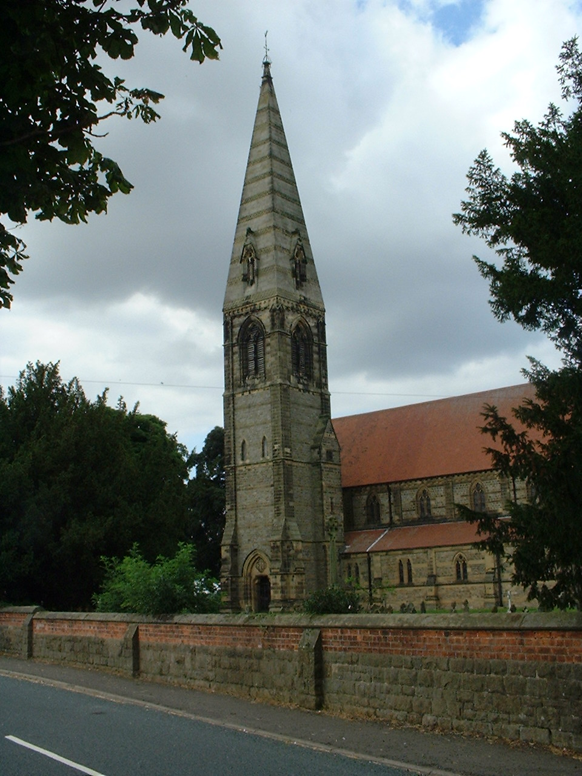
Sunday 1st December, 10.45am Holy Communion followed by coffee

Sunday 8th December, 9.30am Breakfast Service with coffee and croissants
5.00pm Carols and Christmas Cheer

Sunday 15th December, 10.45am Holy Communion followed by coffee

Sunday 22nd December, 9.30am Morning Service followed by coffee

Tuesday 24th December, 6.30pm Carols by Candlelight

Wednesday 25th December, 9.30am Christmas Morning Service
in the Mission Room, Baldersby

Sunday 29th December No Service

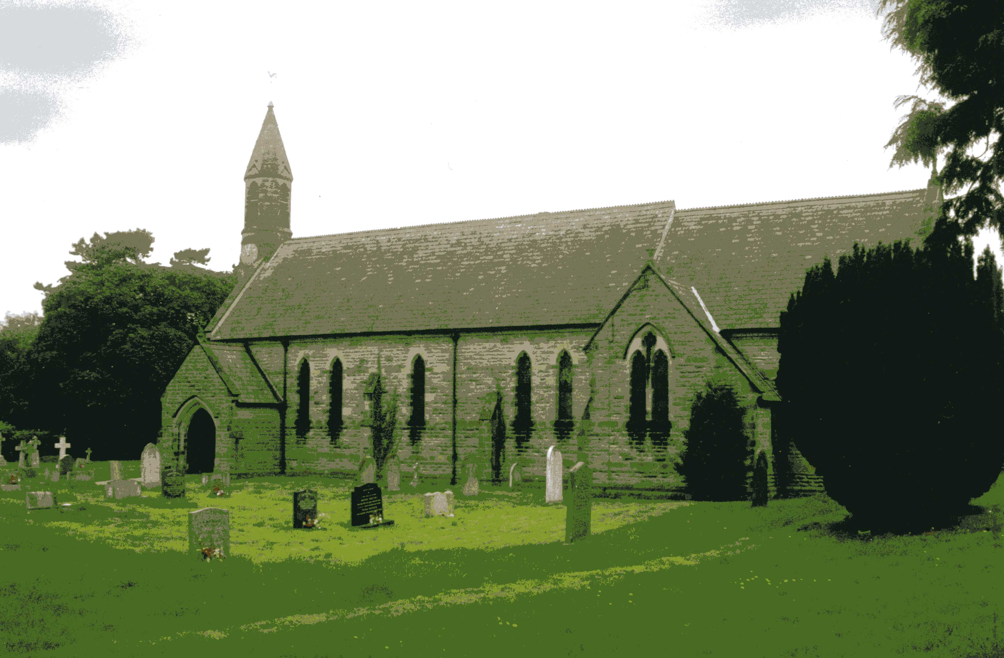
St John the Evangelist Church, Dalton
Sunday 1st December, 11am Holy Communion
Sunday 15th December, 6.30pm Carols by Candlelight
followed by refreshments
Tuesday 24th December, 10.00pm Midnight Mass



St. Columba’s Church, Topcliffe
Corporate Member of the Prayer Book Society
Sunday 1st December, 6.30pm Choral Evensong followed by
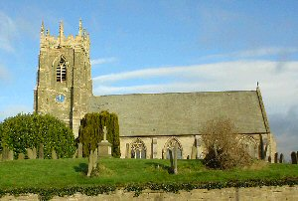
pre-supper refreshments and wine

Wednesday 4th December, 7pm Compline for Advent

Sunday 8th December, 10.45am Holy Communion
led by Father Robert Williamson

Wednesday 11th December, 7pm Compline for Advent

Sunday 15th December, 10.45am Sung Matins followed by refreshments
Wednesday 18th December, 2pm School Carol Service
7pm Compline for Advent

Sunday 22nd December, 10.45am Holy Communion led by
Father Robert Williamson
6.30pm Traditional Service of Nine Lessons and Carols
led by Revd Dawn Ward
followed by refreshments and wine

Monday 23rd December, 2.00pm Crib Service for Children led by
Revd Dawn Ward

Tuesday 24th December, 11.30pm Midnight Mass Father Robert Williamson

Wednesday 25th December Christmas Day - No Service

Sunday 29th December No Service
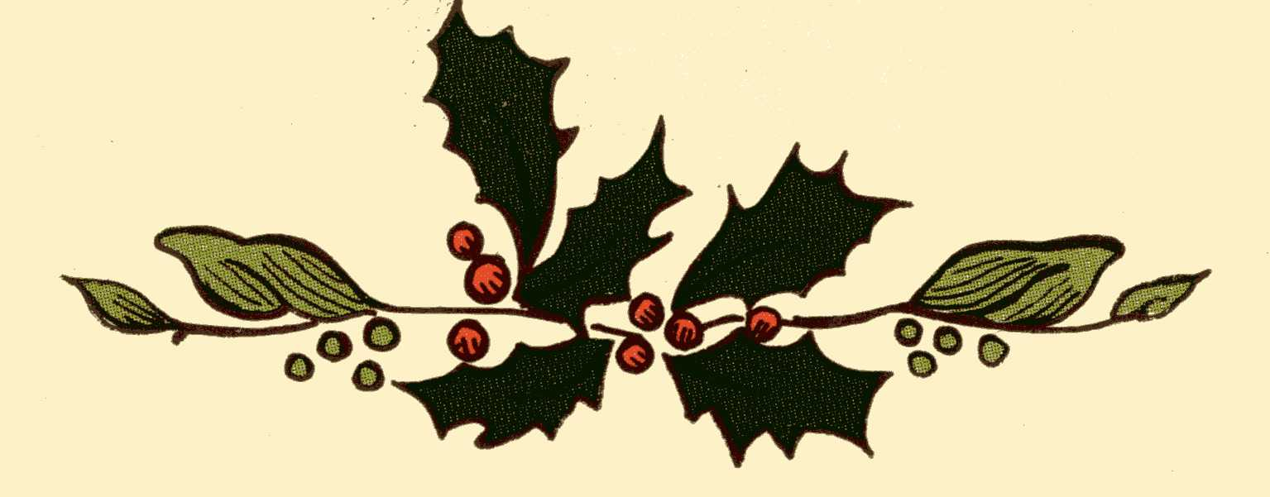

Christmas Reflection page 6

A History of Christmas in Yorkshire page 8

Village News page 11

Readings for the First Sunday in Advent to the First Sunday of Christmas
(Page numbers refer to the Common Worship Lectionary.)

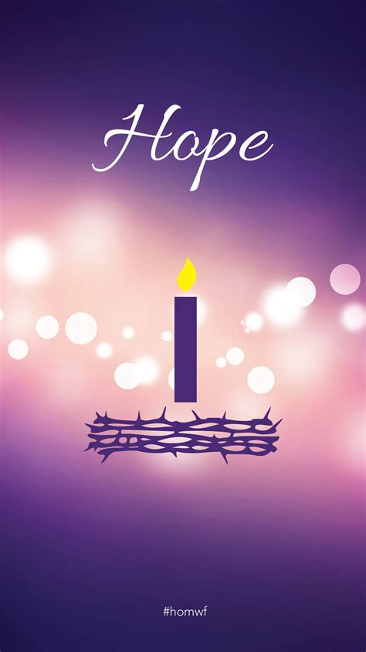
Sunday 1st December, First Sunday in Advent
Collect
Almighty God,
give us grace to cast away the works of darkness
and to put on the armour of light,
now in the time of this mortal life,
in which your Son Jesus Christ
came to us in great humility;
that on the last day,
when he shall come again in his glorious majesty
to judge the living and the dead,
we may rise to the life immortal;
through him who is alive and reigns with you,
in the unity of the Holy Spirit,
one God, now and for ever.

Readings (p735)
Jeremiah 33.14-16
Psalm 25.1-9
1 Thessalonians 3.9-13
Gospel: Luke 21.25-36

Sunday 8th December, The Second Sunday of Advent
Collect
O Lord, raise up, we pray, your power
and come among us,
and with great might succour us;
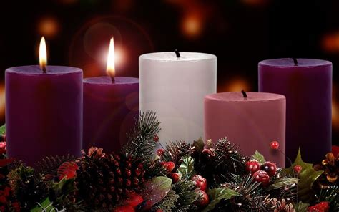
that whereas, through our sins and wickedness
we are grievously hindered
in running the race that is set before us,
your bountiful grace and mercy
may speedily help and deliver us;
through Jesus Christ your Son our Lord,
to whom with you and the Holy Spirit,
be honour and glory, now and for ever.

Readings (p738)
Baruch 5.1-9 or Malachi 3.1-4
Canticle: Benedictus [Luke 1.68-79]
Philippians 1.3-11
Gospel: Luke 3.1-6


Sunday 15th December, The Third Sunday of Advent
Collect
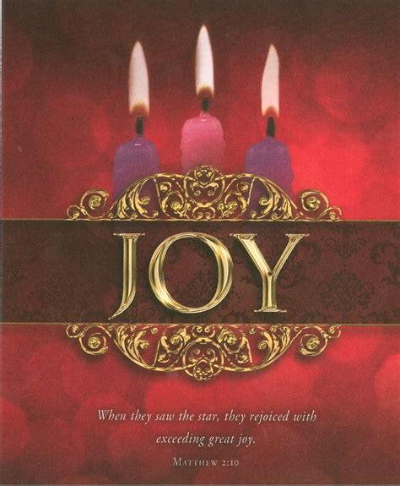
O Lord Jesus Christ,
who at your first coming sent your messenger
to prepare your way before you:
grant that the ministers and stewards of your mysteries
may likewise so prepare and make ready your way
by turning the hearts of the disobedient
to the wisdom of the just,
that at your second coming to judge the world
we may be found an acceptable people in your sight;
for you are alive and reigns with the Father
in the unity of the Holy Spirit,
one God, now and for ever.

Readings (p741)
Zephaniah 3.14-20
Canticle: Isaiah 12.2-6 or Psalm 146.4-9
Philippians 4.4-7
Gospel: Luke 3.7-18

Sunday 22nd December, The Fourth Sunday of Advent
Collect
God our redeemer,
who prepared the Blessed Virgin Mary
to be the mother of your Son:
grant that, as she looked for his coming as our saviour,
so we may be ready to greet him
when he comes again as our judge;
who is alive and reigns with you,
in the unity of the Holy Spirit,
one God, now and for ever.

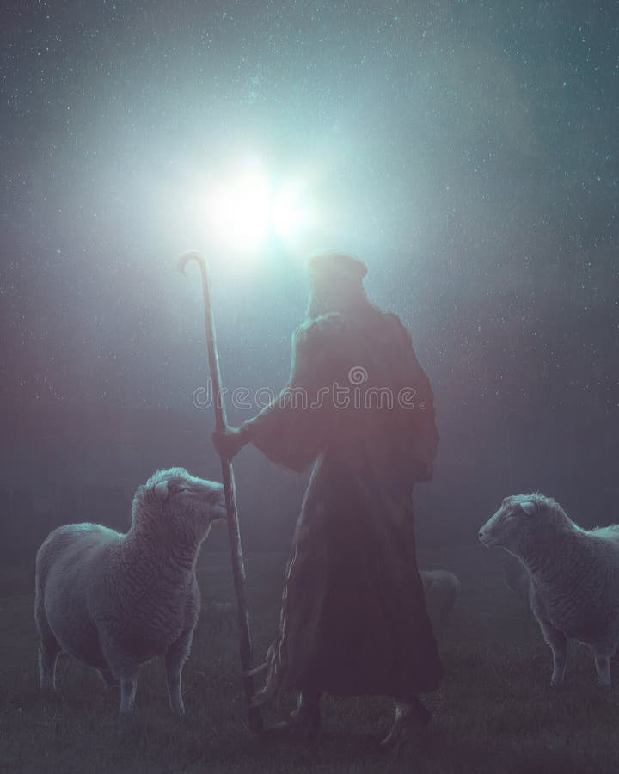
Readings (p744)
Micah 5.2-5a
Canticle: Magnificat [Luke 1.46-55] or Psalm 80.1-7
Hebrews 10.5-10
Gospel: Luke 1.39-45, [46-55]

Tuesday 24th December : Christmas Eve
Collect
Almighty God,
you make us glad with the yearly remembrance
of the birth of your Son Jesus Christ:
grant that, as we joyfully receive him as our redeemer,
so we may with sure confidence behold him
when he shall come to be our judge;
who is alive and reigns with you,
in the unity of the Holy Spirit,
one God, now and for ever.

Readings (p.748)
2 Samuel 7.1-5, 8-11, 16
Psalm 89.2, 21-27
Acts 13.16-26
Gospel: Luke 1.67-79

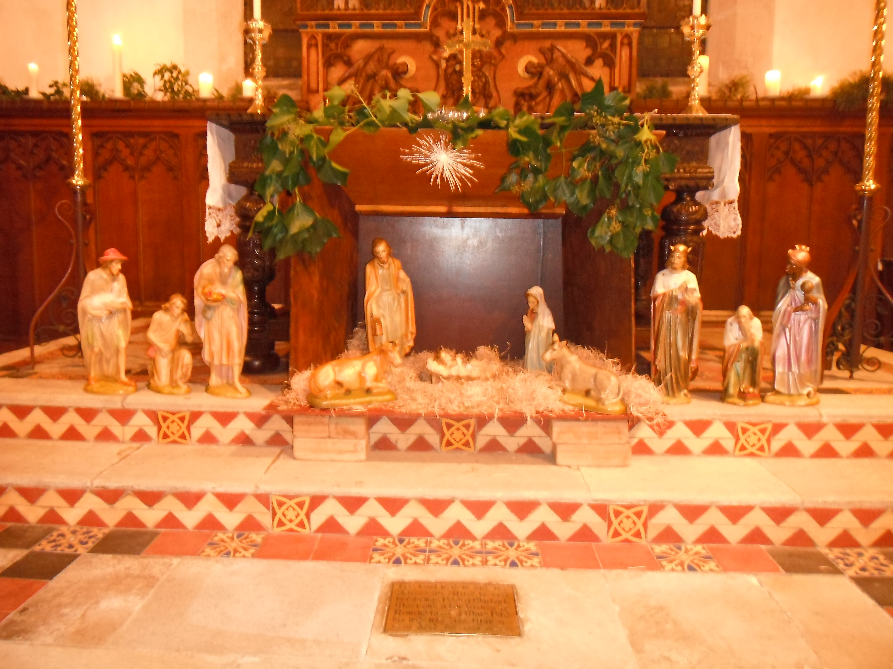
Wednesday 25th December : Christmas Day
SET III
Collect
Almighty God,
you have given us your only-begotten Son
to take our nature upon him
and as at this time to be born of a pure virgin:
grant that we, who have been born again
and made your children by adoption and grace,
may be daily renewed by your Holy Spirit;
through Jesus Christ your Son our Lord,
him who is alive and reigns with you,
in the unity of the Holy Spirit,
one God, now and for ever.

Readings (p.759)
Isaiah 52.7-10
Psalm 98
Hebrews 1.1-4, [5-12]
Gospel: John 1.1-14

Sunday 29th December, The First Sunday of Christmas
Collect
Almighty God,
who wonderfully created us in your own image
and yet more wonderfully restored us
through your Son Jesus Christ:
grant that, as he came to share in our humanity,
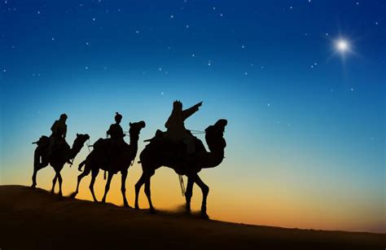
so we may share the life of his divinity;
who is alive and reigns with you,
in the unity of the Holy Spirit,
one God, now and for ever.

Readings (p762)
1 Samuel 2.18-20, 26
Psalm 148.[1-6,] 7-14
Colossians 3.12-17
Gospel: Luke 2.41-52

Christmas Reflection December 2024
We all know the Christmas story – but what we think we know is a mixture of the Bible readings and other people’s interpretations of the story such as we find in the carols. The interpretation of the Christmas story has gone on for a long time – from the medieval mystery plays to our own time when we often get a ‘cute’ interpretation of the story in children’s nativity plays or a sanitized picture of a clean and orderly stable and Holy Family on Christmas cards.
Another interpretation has been people imagining what it would have been like to be actually there. David Kossoff in the 1970’s and more recently Nick Fawcett have tried to put Bible stories in context telling the story of those who were there – who were witnesses to the events – in their own words. So as a reflection on the Christmas story, here is the witness of Peter the Innkeeper who, when he is speaking, is in his mid-sixties and to all outward appearances has had a successful business career:
Peter the innkeeper’s story:
I have been coming to the fellowship of Jesus’ followers here in Nazareth for about a month now with my son and my wife, but this is the first time I’ve felt able to talk about my life and I’m doing so now because it is something that my wife and son have been urging me to do. Many of you here either knew Jesus as he grew up working in the family’s carpentry shop or became aware of him in the last three years during his preaching ministry. I now believe Jesus has influenced my life for over 30 years - but I didn’t realise it until recently.
As you will be able to tell from my accent, I’m not originally from around here. I’ve been an inn keeper here in Nazareth for about 30 years but originally I owned an inn in Bethlehem which had belonged to my father and his father before him. My story starts with the Roman census when Augustus was emperor and Quirinius was governor of Syria.
I’ve never known any inn to be so busy before or after. As I said to my wife at the time, if a census brings in all this business, then they should have one every year! Well, as I said, we were busy – often when busy we’d put two people in the same room, even three if we were very busy but at the time of the census, we had at least four in every room and six in some of them. If they could lie down without being actually on top of one another we piled them in. They needed a roof over their heads, and we appreciated the business – very good business, and there were enough people ready to pay. However, we were soon full, and I had to start turning people away. No one likes to turn business away but there really was nowhere else to pack them in. As you can imagine it was chaos a lot of the time.
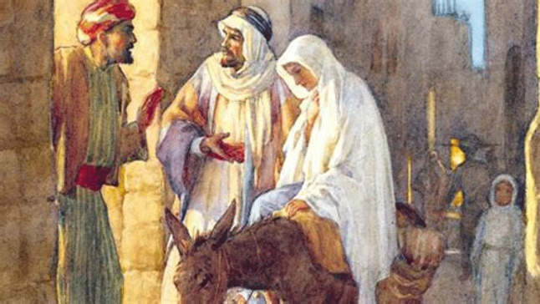
On this particular day I’d already turned two or three people away when this chap and his young wife turned up – she on a donkey, he walking. She was obviously pregnant, and he was begging for me to find him a room. But we were full – nothing I could do about that. I felt sorry for him, but they should have come earlier. I was just about to be very firm with him and tell him to move on when I looked at his young wife. It was her eyes that held my attention – very hard to describe but unlike her husband who was getting excited she looked so calm as if she knew that I would be able to help them and I heard myself saying ‘you can stay in the stable if you like’. It was all I could suggest.
I knew the stable would be filthy – we were so busy in the inn that the stable hadn’t been mucked out for over two weeks. However, I told him there was a hurdle in there so the animals could be moved behind it, and they could have a stall – and he was welcome to use any hay or straw they found to try to clean it up a bit.
We were too busy to pay any more attention to the young couple and it was maybe two or three nights later that it happened. We had gone to bed exhausted and promptly fell asleep. I woke to find the room bathed in light coming in through the shutters. The light was certainly from outside and not from a fire – it was too steady and very peaceful. Then I realized just how quiet everything was – unnaturally quiet. In an inn there is always noise at night, people snoring, people coughing, but it was totally silent. It was then I realized that my wife was also awake. With an elbow in my ribs, she asked what was happening and told me to get up and find out. I feared it was something to do with Roman soldiers and didn’t want to draw attention to myself by opening the shutters but just as I moved to get out of bed the light rapidly faded. I lay back and the usual noise of the inn resumed.
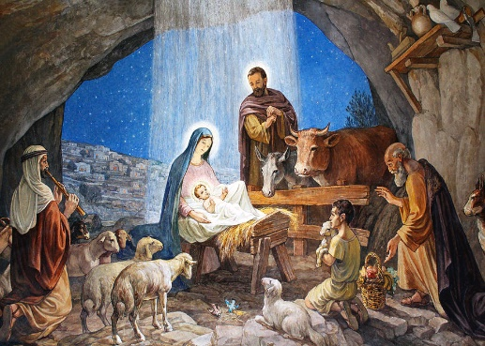
It was just before dawn when I was again woken up but this time by voices from near the stable. I dressed and went out to see what was happening. There were shepherds there, excitedly chatting and they had obviously been into the stable. Well, the last thing you want around a decent establishment are dirty shepherds, they really are the lowest of the low. I was just about to tell them to get off my land when one of them started telling me about seeing angels and coming down to town to see the future Messiah. I nearly told him I’d never heard such a load of rubbish in my life. Surely angels would give such a message to the High Priest in Jerusalem, or maybe our local priests or to good law-abiding Jews like me and my friends. But then I remembered the light and wondered if that was what they had seen. I didn’t really believe them however, and by the time I’d thought of a sarcastic reply they were halfway down the street telling their tale to anyone who would listen.
I went to the stable door – the young woman had her back to me and was bending over the manger – I assumed the baby was in there – and her husband was sitting nearby. I simply asked if they were alright, and he replied ‘fine’ so I went back into the inn. My wife was livid at the thought of shepherds on our land, what would the neighbours think? Whoever the young couple were, they were they were not the sort of guests we wanted. Thankfully within a few days they had gone, the hurdle was against the wall and the livestock had their stable to themselves again.
That should have been the end of the story but about two years later there was a commotion in the town and armed men appeared. These were Herod’s men, not Romans, with orders to take any young boy of two or under to Jerusalem. Something about Herod adopting one of them. Also, something about Herod being told about this future king by Magi. I felt that if they knew the story about the couple in my stable from a couple of years ago I and my family could be in danger.
I felt real fear, so we quickly sold up and moved away from Bethlehem and to Nazareth. We bought another inn and after a few years life again seemed good and settled. Then the carpenter’s son from just down the road started preaching and drawing attention to himself and the area. You know what happened. The Romans crucified him. It was then that it hit me. There had been something vaguely familiar about the widow whose sons ran the carpenter’s shop. I hadn’t seen much of her but the first time I saw her I felt I had seen her before somewhere. It gave me an uneasy feeling. She came back briefly after her son’s death, poor soul, and it was then that I looked at her and knew where I’d seen her before. It was the eyes. I can’t put it into words – calmness, peace – maybe that’s not right but it was the same look as that young woman in Bethlehem whose baby had made us flee our home. I just knew it was the same person.
Again, I was terrified, wanted to sell up and move on, expected any moment that Herod’s men would be back and this time my family and I would perish. However, neighbours encouraged me to come to this fellowship and learn about Jesus. As we learnt about him, I noticed how changed both my wife and I had become. I realised from what I’ve been told Jesus said, that the shepherds mattered as much to God as the rest of us. Suddenly what happened all those years ago made sense and my own fears have now vanished.
Now there is no way I’ll run again, I know that Jesus is the Messiah and now it doesn’t matter what happens, what becomes of my standing in the town or synagogue, whether or not my inn is successful. I know that there is a more important way to live – to follow Jesus and so do God’s will. That is why I have joined this fellowship and why I now have the courage to tell my story.
A History of Christmas in Yorkshire
Yorkshire can claim numerous contributions to British celebrations at Christmas time. From bringing the first turkeys to England, to carrying on ancient rituals. Although the celebration of Christmas has changed throughout history, and continues to change, many of the basic ingredients that we acknowledge as central to our celebrations can be traced back many centuries and even to pre-Christian times.
In Roman times, in the city of York, the Saturnalia festival took place from 17th - 25th December. As the name implies this festival was dedicated to Saturn, the god of harvest and agriculture and the festivities included a relaxing of the normal Roman society rules. Courts were suspended, gambling was permitted, crime was more tolerated, masters would serve their slaves a banquet of food and singing in the streets was encouraged.
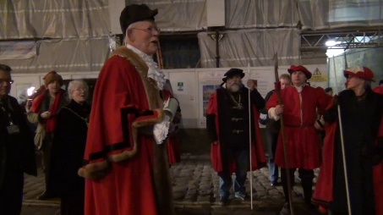
This is still reflected in the ceremony of the Sheriff’s riding which takes place in York on December 21st (St Thomas’ Day). This is a combination of two ancient traditions, the Sheriff’s ride around the city accompanied by musicians and the reading of the Yulegirthol, which is of Viking origin. This involves ceremonial horn-blowing around the city starting at Micklegate bar accompanied by a proclamation in these words ‘We command that the peace of our Lord the King be well kept by night and day …. But that all manner of whores, thieves, dice-players and other unthrifty folk, whether they come late or early, at the reverence of the high feast of Yule, till the twelve days be past.
The elements of the Saturnalia festival, such as over-indulgence, merriment and singing are features of our Christmases even today. These winter celebrations gradually converted from a pagan ritual to a Christian one and the idea that the final day of Saturnalia, the 25th December marked the day of Jesus’ birth was first recognised by Pope Julius I in 221AD when Christian ideology began to take hold.
Another strong influence of Yorkshire Christmases came from both the Anglo Saxons and the Vikings, whose Yule celebrations were also absorbed into the winter festivities. Yule marked the winter solstice on 21st December, rather than worship of a god or prophet. The word, “yuletide” is still associated with the festive season today and Yule celebrations lasted for around twelve days from the shortest day.
With the Norman invasion the celebration became more religious in nature and the word “Christes Maesse” (Festival of Christ) was first used as a description for the festival around 1038.
Religious observance in Yorkshire Medieval society was emphasised at Christmas, with church attendance and worship put at the forefront of the festivities.
During Medieval times carol-singing was banned in churches because they disrupted the religious services and so the vocalists would have to go elsewhere instead. Over the centuries this custom of carol-singing manifested itself in several ways. Some sang near a prominent landmark in the town or village which today may be carols around the village Christmas tree. Other singers went from house to house collecting money and gifts from residents, whilst many congregated in public houses and taverns, where the added warmth and ready availability of ale helped to loosen their tongues in song.
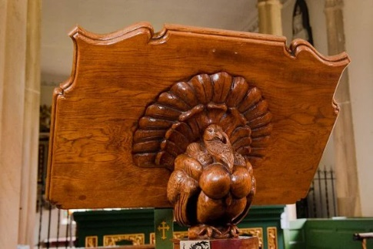
Yorkshire has also made several contributions to the food we eat around Christmas time. The first turkeys were brought over to England from the Americas in 1526 by Yorkshire explorer William Strickland who was originally from Marske. With the profits he made from selling these exotic creatures he built estates at both Wintringham and Boynton Hall near Bridlington. Boynton village church lectern is carved in the shape of a turkey instead of a traditional eagle in honour of Strickland. The custom of eating turkey on Christmas Day only became popular centuries after Strickland’s death in 1598, during the Victorian Period.
Yorkshire pudding is also an important accompaniment to our traditional Christmas dinner, and this is often followed with Christmas cake and a slice of Wensleydale cheese which is a largely Yorkshire culinary tradition, which is said to date back to the 1890s.
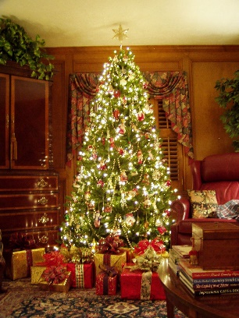
The celebration of Christmas declined over the years largely due to a general banning of the festival by the Puritans in the 1650s and it was overtaken by other important religious dates such as Easter. However, the 19th Century saw a revival of Christmas celebrations. Before 1837 there were no Christmas cards, crackers, trees or even holidays for workers, apart from on Christmas Day itself. Charles Dickens’, “A Christmas Carol,” which was published in 1843, had one of the most profound influences of how Christmas was celebrated and changed the festive season in the working-class industrial towns of Yorkshire forever.
The common theme running throughout the book was that of the rich giving to the poor. Ebeneezer Scrooge, the wealthy, mean industrialist becomes a changed man after being visited by the three ghosts of past, present and future. He gives a turkey to Bob Cratchitt; one of Scrooge’s poor, underpaid employees and learns the importance of being kind to his workers, especially at Christmas. The re-invention of Christmas in the 19th Century also started some traditions in Yorkshire which are still ongoing or in living memory.
At Clifford’s Tower in York a tradition known as “The Kissing bough” has recently been revived. A huge bunch of mistletoe is suspended above the ancient monument and couples can visit it and kiss each other underneath the bough. This tradition which dates back to Medieval Times, was revived by the Victorians and once again in 2010.
Yorkshire can claim numerous contributions to British celebrations at Christmas time. From bringing the first turkeys to England, to carrying on ancient rituals. For those who feel that Christmas today isn’t what it used to be, if we look closely, we can find links that take us back many centuries.
A Happy Yorkshire Christmas everyone!
Richard Byas
At Sunday school, the younger children were drawing pictures illustrating Biblical stories.
The teacher walked by and noticed one little boy was drawing an airplane!
"Oh, what Bible story are you drawing?" she asked.
"This is the Flight into Egypt," the little boy answered. "See, here is Mary, Joseph and baby Jesus. And this," he said, pointing to the front of the plane, "is Pontius. He's the Pilot."

Richard Byas

Baldersby St. James Church Events and News
Carols and Christmas Cheer Sunday 8th December
This is an informal event at 5pm in our cafe area with carols, mulled wine and nibbles.
Please choose your favourite carol and fill in a sheet in church or e-mail Rosemarie
at carter-stuart@btconnect.com

Coffee and Cake
On Tuesday mornings will continue through Christmas and New Year.
Message from Church Wardens
2024 has been a rewarding year for our church with enthusiastic support from so many people. Our church numbers are growing – everyone helped with our huge Book Sale (best ever!) and were patient and generous when we closed to repair our ceiling. Our beautiful building had an excellent report from our church architect and is now amazingly warm with new boilers.
Best wishes and our prayers to you all for 2025.
Rosemarie and David.
Susan Brown, PCC member.

St Columba’s Church, Topcliffe
The Churchwarden and PCC send our warmest greetings to everyone in the villages, Benefice and wider community for a peaceful and blessed Christmas.

Dalton Events
Carols by Candlelight
This year’s Carols by Candlelight will be on Sunday 15th December at 6.30pm, not Friday as in previous years. The service will be followed by refreshments. The Dalton Dazzlers Children’s Choir will be making an appearance too.
Christmas Fair
The Christmas Fair will be held on Saturday 7th December, 10 am until 12 noon. There will be lots of stalls, a tombola, carol singing, a visit from Santa, and bacon butties for sale. Admission is £2 for adults, which includes a drink and mince pie, admission for children £1 which includes a gift from Santa.
Well-being Session
There will be guided meditation, reiki healing and sound bath well-being in the Village Hall on Friday 13th December, 6.30 pm to 8.30 pm.. To book a place contact Sam Cellier on 07793 035059.
Pop-up Pub and Bingo
This will be held in the Village Hall on Saturday 14th December from 7 pm. Come along and see if you can win your fortune! Everyone in aid of the village Christmas tree. All welcome. The Dalton Dazzlers children’s choir will be singing at Ivy House at 6.45 pm before you head off to the pop-up pub and bingo.
Christmas Panto
This year’s Christmas Panto will be Beauty and the Beast. It will be held in the village hall on Monday 23rd December and is presented by Chaplins Mini Pantos (this is not the same company as last year). Doors open at 6.15 pm for a prompt 6.30 start. Tickets are Adults £14, Children £8, Family of 2 Adults and 2 Children £40, Under 4 years old are free. Please contact the Facebook page to book tickets or call Eleanor on 07841 0363.

PARISH DIRECTORY
The Parishes of Topcliffe, Baldersby with Dishforth and Skipton on Swale, and Dalton.
There is currently no Vicar of the parishes. Until one is appointed, please contact our Area Dean,
Rev’d Mary Rolls, mob: 07877 213327 email: mary.rolls@mowbraydeanery.org.uk

BALDERSBY with DISHFORTH and SKIPTON-ON-SWALE - PCC Secretary: Mrs Jennifer Wharton wharton370@btinternet.com

DALTON - PCC Secretary: Mrs Hannah Bissett tel: 07739 382831 spannerb79@gmail.com

TOPCLIFFE – PCC Secretary: Mrs Roz Norris RozNorris@aol.com

