Benefice Online Magazine

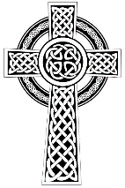
for the Parishes of Topcliffe, Baldersby with Dishforth and Skipton on Swale, and Dalton
Cross Talk
November 2024
Cross Talk is published monthly by email. To receive a copy please contact kitnorris@live.co.uk
Cross Talk contains the weekly Collect and Readings together with details of Church services in the Benefice and news and items of interest supplied by our readers. The magazine will also be available on the web sites: www.achurchnearyou.com/church/3447 and baldersbychurch.com.

CHURCH SERVICES

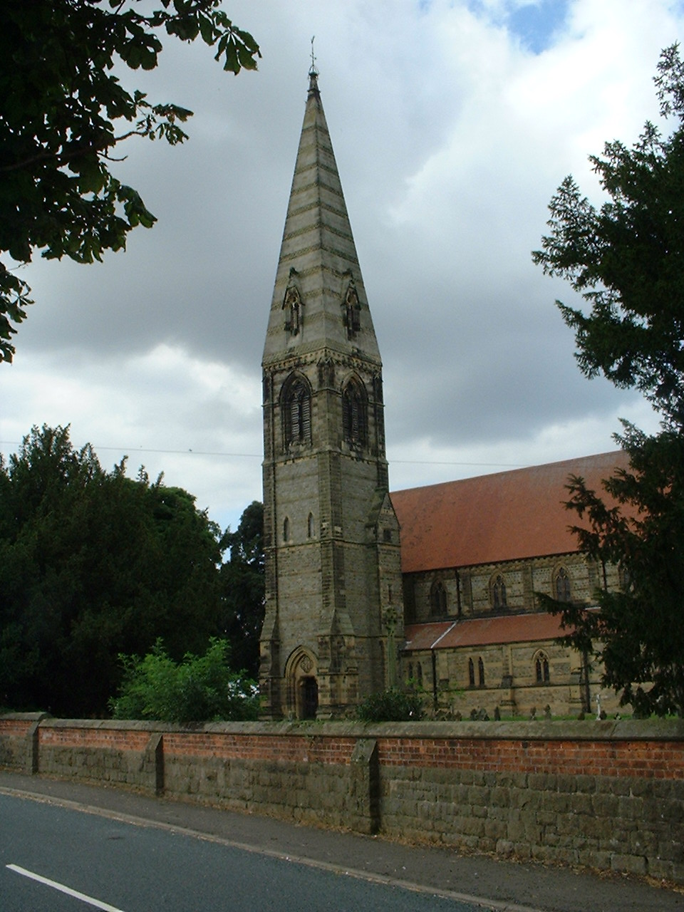
St. James’ Church, Baldersby St. James with Dishforth, Rainton
and Skipton on Swale
Sunday 3rd November, 10.45am Holy Communion “All Souls Day”

Sunday 10th November, 9.30am Breakfast Service “Remembrance Sunday”
with Coffee and Croissants

Sunday 17th November, 10.45am Holy Communion
followed by refreshments

Sunday 24th November, 9.30am Morning Service
followed by refreshments

St. Columba’s Church, Topcliffe
Corporate Member of the Prayer Book Society
Sunday 3rd November, 6.30pm Choral Evensong followed by
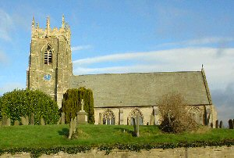
nibbles and wine

Thursday 7th November, 7.30pm All Souls Service with Requiem Mass led by Rev’d Robert Williamson

Sunday 10th November, 10.45am Holy Communion and Act of Remembrance led by
Rev’d Robert Williamson

Sunday 17th November, 10.45am Sung Matins followed by refreshments
Sunday 24th November, 10.45am Holy Communion led by
Rev’d Robert Williamson

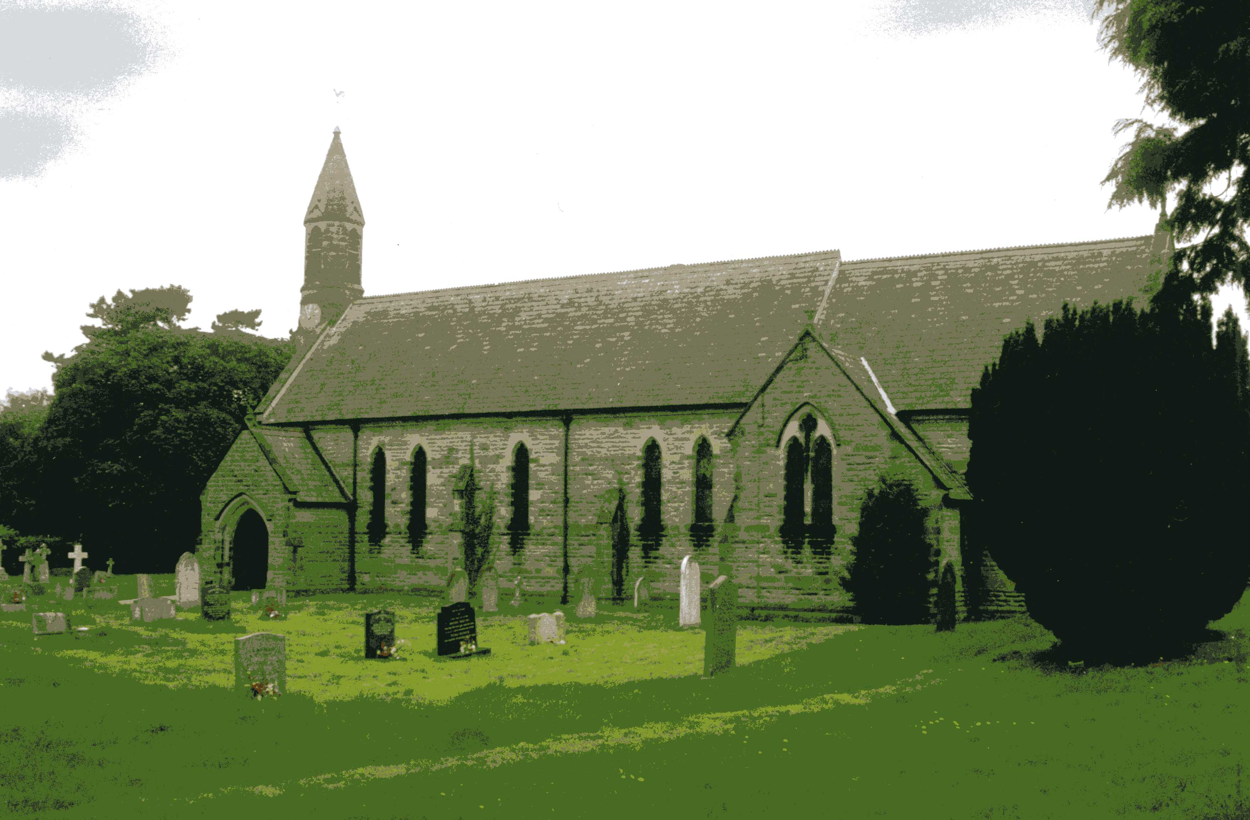
St John the Evangelist Church, Dalton
Sunday 3rd November, 11am Holy Communion
Sunday 17th November, 11am Family Service

All welcome to the services and coffee and biscuits afterwards.

November Reflection page 3
Village News pages 7-8
Readings for All Saints Day to the Sunday before Advent
(Page numbers refer to the Common Worship Lectionary.)

Friday 1st November, All Saints Day
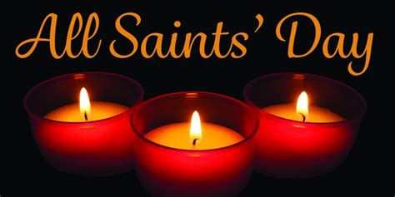
Collect
Almighty God,
you have knit together your elect
in one communion and fellowship
in the mystical body of your Son Christ our Lord:
grant us grace so to follow your blessed saints
in all virtuous and godly living
that we may come to those inexpressible joys
that you have prepared for those who truly love you;
through Jesus Christ your Son our Lord,
who is alive and reigns with you,
in the unity of the Holy Spirit,
one God, now and for ever.

Readings (p706)
Wisdom 3.1-9 or Isaiah 25.6=9
Psalm 24.1-6
Revelation 21.1-6a
Gospel: John 11.32-44

Sunday 3rd November, The 4th Sunday before Advent (unless kept as All Saints Day)
Collect
Almighty and eternal God,
you have kindled the flame of love
in the hearts of the saints:
grant to us the same faith and power of love,
that, as we rejoice in their triumphs,
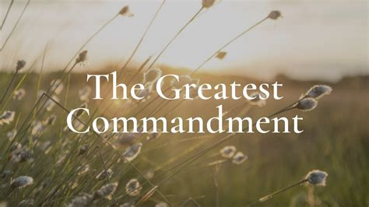
we may be sustained by their example and fellowship;
through Jesus Christ your Son our Lord,
who is alive and reigns with you,
in the unity of the Holy Spirit,
one God, now and for ever.

Readings (p712)
Deuteronomy 6.1-9
Psalm 119.1-8
Hebrews 9.11-14 Gospel: Mark 12.28-34

Sunday 10th November, The 3rd Sunday before Advent, Remembrance Sunday
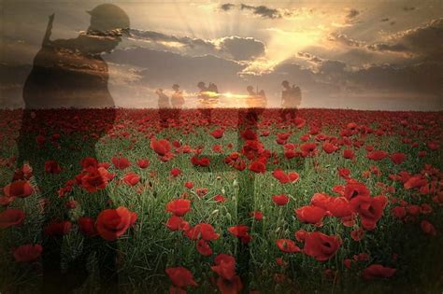
Collect
Almighty Father,
whose will is to restore all things
in your beloved Son, the king of all:
govern the hearts and minds of those in authority,
and bring the families of the nations,
divided and torn apart by the ravages of sin,
to be subject to his just and gentle rule;
who is alive and reigns with you,
in the unity of the Holy Spirit,
one God, now and for ever.
Readings (p715)
Jonah 3.1-5, 10
Psalm 62.6-14
Hebrews 9.24-28
Gospel: Mark 1.14-20

Sunday 17th November, The 2nd Sunday before Advent
Collect
Heavenly Father,
whose blessed Son was revealed
to destroy the works of the devil
and to make us the children of God and heirs of eternal life:
grant that we, having this hope,
may purify ourselves even as he is pure;
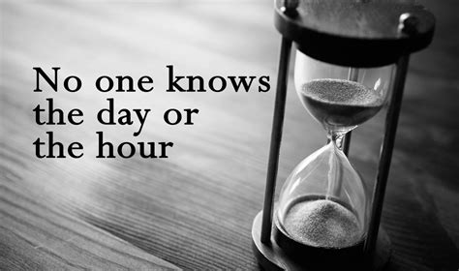
that when he shall appear in power and great glory
we may be made like him
in his eternal and glorious kingdom;
where he is alive and reigns with you,
in the unity of the Holy Spirit,
one God, now and for ever.

Readings (p717)
Daniel 12.1-3
Psalm 16
Hebrews 10.11-14, [15-18,] 19-25
Gospel: Mark 13.1-8

Sunday 24th November : Christ the King, The Sunday next before Advent
Collect
Eternal Father,
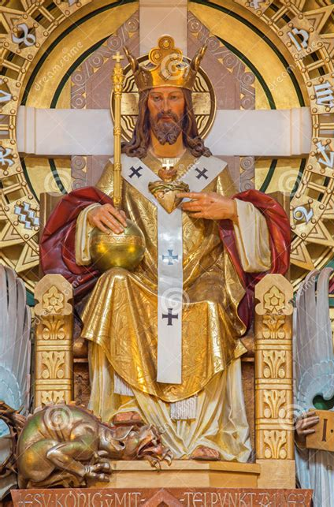
whose Son Jesus Christ ascended the throne of heaven
that he might rule over all things as Lord and King:
keep the Church in the unity of the Spirit
and in the bond of peace,
and bring the whole created order to worship at his feet;
who is alive and reigns with you,
in the unity of the Holy Spirit,
one God, now and for ever.

Readings (p.720)
Daniel 7.9-10, 13-14
Psalm 93
Revelation 1.4b-8
Gospel: John 18.33-37

Year C begins
Sunday 1st December : The First Sunday of Advent
Collect
Almighty God,

give us grace to cast away the works of darkness
and to put on the armour of light,
now in the time of this mortal life,
in which your Son Jesus Christ
came to us in great humility;
that on the last day,
when he shall come again in his glorious majesty
to judge the living and the dead,
we may rise to the life immortal;
through him who is alive and reigns with you,
in the unity of the Holy Spirit,
one God, now and for ever.

Readings (p.735)
Jeremiah 33.14-16
Psalm 25.1-9
1 Thessalonians 3.9-13
Gospel: Luke 21.25-36

Reflection November 2024
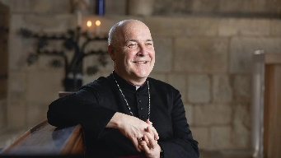
At nearly every church service we attend we say the Lord’s Prayer. It is so familiar to many people that we may recite it without fully appreciating what we are praying for.
Writing in the Credo column in The Times on 12th October, the Archbishop of York explored how the Lord's Prayer can teach us how to pray and how to live. The article follows in full...
What is prayer for? Listening to prayer being offered in Church, you'd be forgiven for thinking the idea is to change God's mind. Or maybe let God know what's going on down here. But that can't be right. Just before he teaches his disciples, the prayer we call, the Lord's Prayer, Jesus says that God ‘knows what you need before you ask him.’ In which case, ‘Why pray at all?’ Or to ask the question again: ‘What is prayer for?’ Well, perhaps it’s to change our mind? The Lord's Prayer is an education in desire. God may know what we need. But we don't. It teaches us ‘what to want’ and ‘how to live’, as well as what to pray for. A great Anglican theologian of the last century, Austin Farrah, described the Lord's Prayer as three hearty praises followed by three humble petitions.
First, we learn that God is like a loving parent, the one Jesus calls ‘Father’ and that God's name and God’s nature is holy. Secondly, we learn that God's will is to be followed and established in our lives and in the life of the world. Thirdly we learn that God’s kingdom, which means God's rule and God's commonwealth, is the way of peace and justice the world must seek. In this way, earth becomes like heaven and heaven comes down to earth. All this Jesus lays out for us, resetting the compass of the heart in these profound opening petitions –
Our Father who art in heaven, hallowed to be thy name. Thy kingdom come, thy will be done on earth as it is in heaven.
Then we find out what to ask for.
Firstly, enough. Give us our daily bread means, ‘Give me what is sufficient for today.’
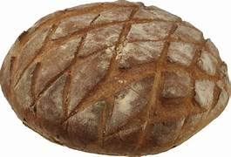
In the midst of the heat and horror of a climate crisis is there anything more important for the human race to learn? These words are a guard against envy and avarice, challenging those economic conventions that think everything must always be growing and we must always want more. Not only this; by preventing ourselves from always wanting more, we may be become much better at sharing what we have.
Secondly, reconciliation. We need to be forgiven. We all know this, even if we never acknowledge it. And even though we live in a society where most of us want to be understood, rather than forgiven, the fact is that most of us fall short of our own standards, let alone God’s. Moreover, being known and understood and still being forgiven is liberating good news, probably the greatest gift of the Christian faith and the reason Christ came to reconcile us to God and to each other. It is the meaning of his cross and resurrection.
But this petition carries a condition. If we receive this mercy, then we must be merciful to others too. This is hard, especially as many of us have been damaged, exploited and abused by others. Nevertheless, it is the only way of breaking the cycle of vengeance that convulses the world, breaking so many human relationships, whether it is between nations, countries, communities, families, or friends.
Thirdly, deliverance. We ask that God will be alongside us in times of temptation, darkness, and fear; the Good Shepherd walking with us through the valley of the shadow of death.
We pray –
Give us today our daily bread, forgive us our trespasses as we forgive those who trespass against us, lead us not into temptation but deliver us from evil.
All this beauty and challenge is contained in the Lord's prayer - and in less than 70 words.
At a recent meeting of bishops in the Church of England we were addressed on Zoom by a young climate activist from Uganda, one of those places in the world where the debilitating effects of the climate emergency are felt most keenly. She was asked about where she found her vision and resolve. She replied by speaking about her Christian faith, the narrative of hopeful change that faith declares, and the life of prayer. In prayer, she said, ‘We envision a world that we cannot see with our eyes.’
Prayer is for God. We are God’s children, and we offer God our praise and adoration. We acknowledge God's sovereignty. We seek God's way. We discover God’s vision.
Prayer is for us and for others. We are taught what to want. We recognise our belonging to each other. The opening word of the Lord's Prayer says it all: ‘Ours.’ Not my God. Not your God. Ours. We belong to each other, and when we pray, we enter into community with God and with each other. We bring to God our praise and our need. We envision a new and better future.
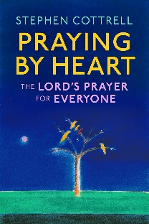
Prayer is for the world.
Praying by Heart: The Lord's Prayer for Everyone by Stephen Cottrell was published on 10th October 2024. In it he explores The Lord’s Prayer, phrase by phrase, exploring its meaning and its significance for today.
Hardback, 176 pages, 978-1399805308, £14.99.
It is available to buy from Church House Bookshop or other retailers.
Richard Byas
Quaint Church Offices (Dog Whippers and Sluggard Wakers)
It is likely that church services were much more lively events in days of yore and to maintain some sense of order and decorum, officials, whose jobs no longer appear in present PCC records, were appointed by the church authorities. Among these were ‘dog whippers’ and ‘sluggard wakers’ although in many churches these duties were performed by the same person.
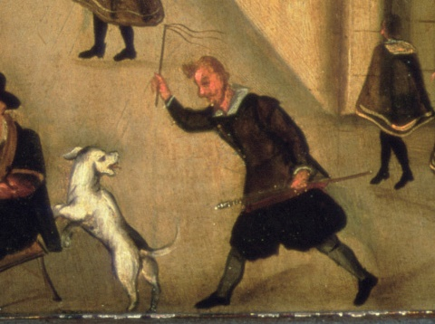
A dog whipper was a church official charged with removing unruly dogs from church grounds during services. They were most prominent in areas of England and continental Europe between the 16th and 19th centuries. In 16th-century England, stray dogs disrupting church service had become such a big problem that many parishes employed “dog whippers”, whose job was to frighten away dogs and prevent them from crowding around the church or attacking the priest when he was handing out communion bread and wafers on the church steps.
Those employed as dog whippers were given a three-foot-long whip and a pair of dog tongs with which to remove the animals. The whip was utilized both for enforcement and as a deterrent while the tongs enabled the whipper to clasp a fractious animal from a safe distance. In earlier centuries it was not uncommon for household dogs to accompany their owners to the church and if at any point they became loud, fought with other animals, attacked congregation members, or were otherwise disruptive, it was the job of the dog whipper to remove them from the church as well to allow the service to continue in peace. Although often the dogs would patiently wait outside for the services to be over, fighting would at times break out among the pack gathered outside the church door. The dog whipper would then pull out his whip and begin lashing at those who made the most noise. The tongs came in handy when the dogs fought back, or when the pack became difficult to control.
The dog whipper was a paid position in the church with records showing the dog whipper at East Witton receiving a salary of 8s (40p) per year.
The job of ‘dog whipper’ started to fade from the late 18th century onwards, as churches began instructing those attending services to leave their dogs at home. One of the last recorded dog whippers was John Pickard, at Exeter Cathedral. He was appointed in 1856. Exeter Cathedral still has a dog whipper but only for ceremonial purposes
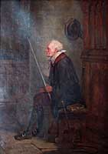
A ‘sluggard waker’ was an 18th-century job undertaken by a parishioner (often the parish clerk or the dog whipper), in British churches. The sole task of the sluggard waker was to watch the congregation during the services and tap anyone who appeared to be falling asleep sharply on the head. The actual tapping was not done by hand, nor was it done particularly gently or subtly. The sluggard waker carried a long wooden pole, tipped with a brass knob or a fork, with which he knocked sharply on the heads of the dozing men, or poked between the shoulder blades with the fork. The sticks (or wands) used to do the tapping were usually long straight poles of stout local woods, and were sometimes tipped with either brass knobs, forks (both added and natural in the wood), or fox tails. In some regions of England there was a clear definition of which tips were for what purpose, sometimes to the extent of the stick having two ends. A brass tip or fork would usually be used for waking the men, while the fox tail was used for waking the female congregants.
The job of sluggard waker seems to have died out naturally, possibly due to modern services having shorter sermons than in previous centuries although some may feel that there are still services where a sluggard waker could be employed!
Divine Justice
One Sunday, a vicar decides he doesn’t want to lead the church service but would rather go and play golf instead. He calls the Area Dean to tell him he is sick, and the Area Dean agrees to lead the service on his behalf.
So, the vicar grabs his golf clubs and he drives for a while, finding a course where he wouldn’t be recognized, and starts playing his game.
He tees up on the first hole, squares off, and hits the ball. To his great surprise, it flies perfectly off the tee, heads downrange, and onto the green. To his further surprise, when he gets to the green, he finds that the ball had landed in the hole. The vicar is jubilant. Never, in 20 years of golfing has he been able to hit a hole in one. The same thing happens at each hole he plays.
Up in heaven, Jesus is sitting beside his Father watching the priest. He looks over and says, “Are you really going to let him get away with this?” God smiles. “Who is he going to tell?”


Richard Byas
Baldersby St. James Church Events and News
“All Souls Day” Sunday 3rd November at 10.45am
This Sunday we remember relatives and friends who have died and light candles for them. If you would like to have their names read out in church please record them on the list in church or e-mail Rosemarie at carter-stuart@btconnect.com
“Remembrance Sunday”
Sunday 10th November at the 9.330am Breakfast Service we will read out the names of our young fallen servicemen from Rainton, Baldersby and Skipton.
A Christmas Carol – Scrooge – with a difference!
Friday 6th December – doors open 7.30pm to 9.30pm. Refreshments – bring your own drinks. Tickets £10.00 pay on the door. A fun evening on our stage at the back of church, sitting in our cafe area.
Coffee and Chat
Tuesday mornings 10am to 12 noon. Drop in to church for a chat. It is always well attended and very cosy with our new heating!
Church Repairs
Our Spire has had the vegetation removed by Stone Tech which is brilliant. While up the ladders they did a survey of the whole tower with excellent pictures. As a result we need to point the top 2 metres of the Spire as with heavy rain we are getting leaking on to the bells. This will be done in Spring at a cost of £3,000. The good news is that we have just received a grant of £2000 from the Yorkshire Churches Trust towards the cost. Fingers crossed that this will stop any heavy rain sneaking into our very exposed Spire.
Susan Brown, PCC member.

St Columba’s Church, Topcliffe
All Souls Service with Requiem Mass 7.30pm Thursday 7th November. The Requiem Mass will be celebrated by Rev Robert Williamson to mark the Feast of All Souls. (This service has been transferred from its usual date of 2 November). The choral setting is the beautiful and uplifting Missa Pro Defunctis by Claudio Casciolini (1697-1760), which will be sung by St Columba’s choir, directed by Linda Hewlett. Congregation members will be invited to remember and give thanks for the lives of family and friends who are no longer with us. Everyone is most welcome to attend this wonderful commemoration of those they have loved, and there is an opportunity for them to be remembered by name and also to light a candle during the service. Names to be remembered can be added to the list before the service or, if preferred, emailed to John Phillips (johnphillips05@gmail.com) or Chris Hewlett (celhewlett@outlook.com).

Remembrance Sunday 10th November
The Holy Communion Service at 10.45am will include our Act of Remembrance at 11am when the names of the local men who died in the two world wars will be read out and two minutes silence held.

Dalton Events
130 Club October Result
£15 David Spence No. 47; £10 Doreen Hebden No. 7; £6 Matthew Spence No. 49
Domino Drive
There will be a Domino Drive in the village hall on Saturday 2nd November at 7pm, proceeds in aid of the village Christmas tree. All welcome. Please note there will be no Domino Drive on the 4th Saturday in November as the hall is booked for another event.

PARISH DIRECTORY
The Parishes of Topcliffe, Baldersby with Dishforth and Skipton on Swale, and Dalton.
There is currently no Vicar of the parishes. Until one is appointed, please contact our Area Dean,
Rev’d Mary Rolls, mob: 07877 213327 email: mary.rolls@mowbraydeanery.org.uk

BALDERSBY with DISHFORTH and SKIPTON-ON-SWALE - PCC Secretary: Mrs Jennifer Wharton wharton370@btinternet.com

DALTON - PCC Secretary: Mrs Hannah Bissett tel: 07739 382831 spannerb79@gmail.com

TOPCLIFFE – PCC Secretary: Mrs Roz Norris RozNorris@aol.com

