Benefice Online Magazine

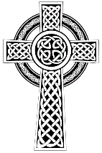
for the Parishes of Topcliffe, Baldersby with Dishforth and Skipton on Swale, and Dalton
Cross Talk
October 2024
Cross Talk is published monthly by email. To receive a copy please contact kitnorris@live.co.uk
Cross Talk contains the weekly Collect and Readings together with details of Church services in the Benefice and news and items of interest supplied by our readers. The magazine will also be available on the web sites: www.achurchnearyou.com/church/3447 and baldersbychurch.com.

CHURCH SERVICES

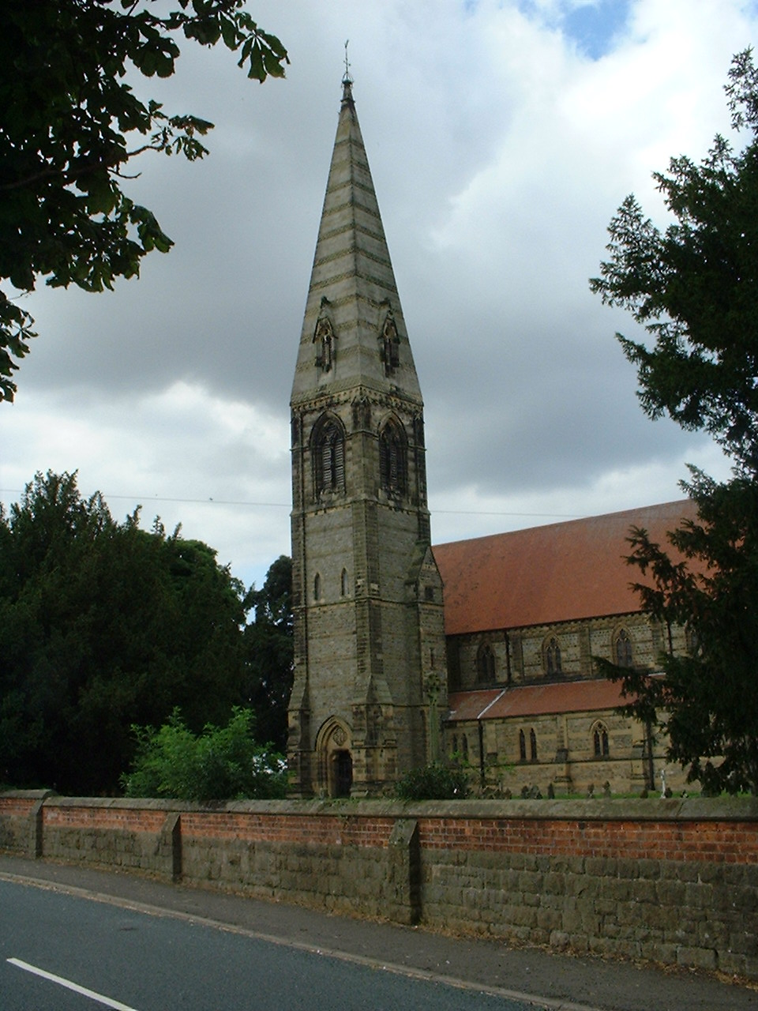
St. James’ Church, Baldersby St. James with Dishforth, Rainton
and Skipton on Swale
Sunday 6th October, 10.45am Harvest Festival
followed by Bring and Share Lunch

Sunday 13th October, 9.30am Breakfast Service
with Coffee and Croissants

Sunday 20th October, 10.45am Holy Communion
followed by refreshments

Sunday 27th October, 9.30am Morning Service
followed by refreshments

St. Columba’s Church, Topcliffe
Corporate Member of the Prayer Book Society
Sunday 6th October, 6.30pm Harvest Evensong followed by
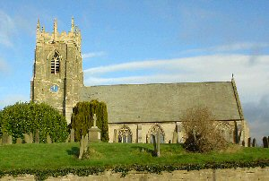
Bring and Share Supper with wine

Sunday 13th October, 10.45am Holy Communion led by
Rev’d Robert Williamson

Sunday 20th October, 10.45am Sung Matins followed by refreshments
Sunday 27th October, 10.45am Holy Communion led by
Rev’d Robert Williamson

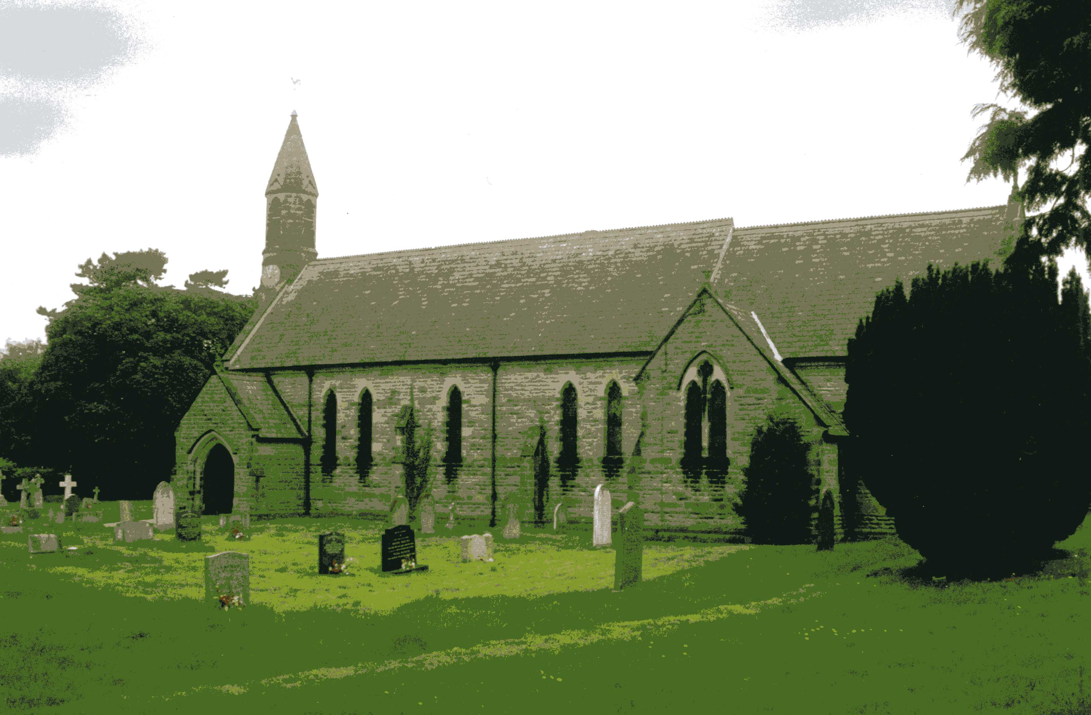
St John the Evangelist Church, Dalton
Sunday 6th October, 11am Holy Communion
Sunday 20th October, 11am Family Service

All welcome to the services and coffee and biscuits afterwards.

October Reflection page 3
St Aelred’s Pilgrimage trail page 5

Family Visit to St Columba’s Church page 6

Village News pages 7-8
Readings for the 19th Sunday after Trinity to the Last Sunday after Trinity
(Page numbers refer to the Common Worship Lectionary.)

Sunday 6th October, The 19th Sunday after Trinity
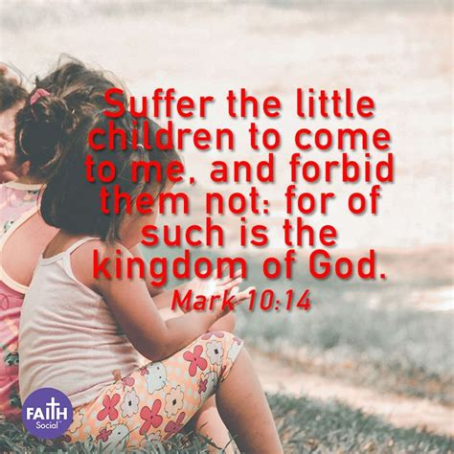
Collect
O God, forasmuch as without you
we are not able to please you;
mercifully grant that your Holy Spirit
may in all things direct and rule our hearts;
through Jesus Christ your Son our Lord,
who is alive and reigns with you,
in the unity of the Holy Spirit,
one God, now and for ever.

Readings Proper 22 Related (p688)
Genesis 2.18-24
Psalm 8
Hebrews 1.1-4; 2.5-12
Gospel: Mark 10.2-16

Sunday 13th October, The 20th Sunday after Trinity
Collect
God our Father,
whose Son, the light unfailing,
has come from heaven to deliver the world
from the darkness of ignorance:
let these holy mysteries open the eyes of our understanding
that we may know the way of life,
and walk it without stumbling;
through Jesus Christ our Lord.

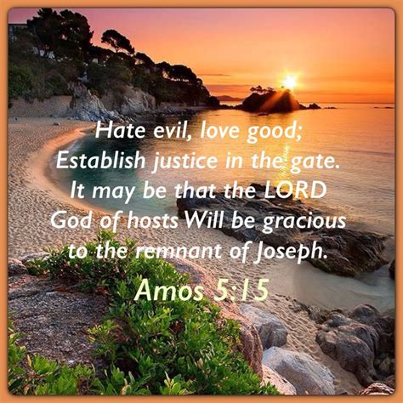
Readings Proper 23 Related (p693)
Amos 5.6-7, 10-15
Psalm 90.12-17
Hebrews 4.12-16
Gospel: Mark 10.17-31

Sunday 20th October, The 21st Sunday after Trinity
Collect
Grant, we beseech you, merciful Lord,
to your faithful people pardon and peace,
that they may be cleansed from all their sins
and serve you with a quiet mind;
through Jesus Christ your Son our Lord,
who is alive and reigns with you,
in the unity of the Holy Spirit,
one God, now and for ever.

Readings Proper 24 Related (p698)
Isaiah 53.4-12
Psalm 91.9-16
Hebrews 5.1-10
Gospel: Mark 10.35-45
Sunday 27th October : The Last Sunday after Trinity
Collect
Blessed Lord,
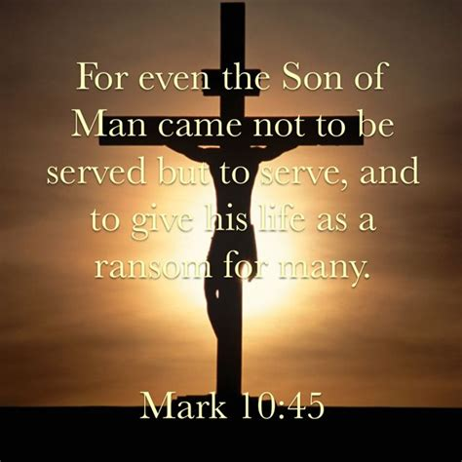
who caused all holy scriptures
to be written for our learning:
help us so to hear them,
to read, mark, learn and inwardly digest them
that, through patience, and the comfort of your holy word,
we may embrace and for ever hold fast
the hope of everlasting life,
which you have given us in our Saviour Jesus Christ,
who is alive and reigns with you,
in the unity of the Holy Spirit,
one God, now and for ever.

Readings Proper 25 Related (p.704)
Jeremiah 31.7-9
Psalm 126
Hebrews 7.23-28
Gospel: Mark 10.46-52

Reflection October 2024
Late September and early October are the traditional times for churches to hold their Harvest Festival services.
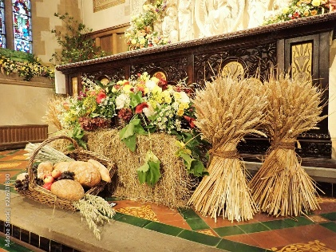
As a youngster, the Harvest Festival service in my local village church was always very well attended, and the sight of all the fresh fruit and vegetables that had been brought by people in the congregation to decorate the church was amazing. After the service, the children in the Sunday School went out to take what had been offered to those who were in need in the village. I remember taking a container of fruit and veg to an elderly gentleman, who I didn’t really know, who lived just a few houses away from my home. He greeted me with a warm smile and grateful thanks for what he had received. I’m sure the produce itself would have been welcome but the knowledge that he had been remembered by the church and community was also very important.
It’s sad that this tradition has fallen by the wayside (but maybe in these risk-averse times sending children out by themselves to knock on the doors of people they hardly know would not be allowed) so where food collections are still accepted it is usually dried and tinned goods plus other items suitable for the local food bank. This reflects modern living, as we now buy most of our food in supermarkets and we no longer worry about whether or not there has been a good harvest because we expect that whatever we need is sat on a shelf ready for us to buy.
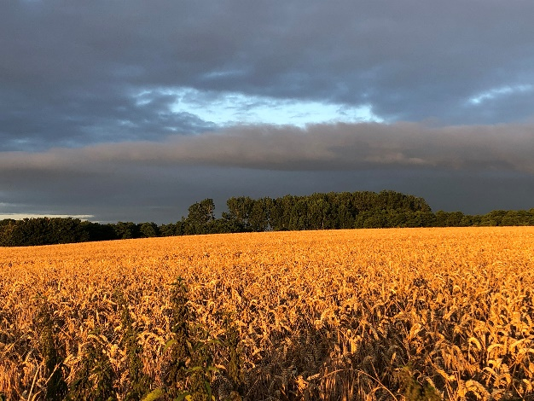
Even for those living in countryside areas who see the fields being harvested, it is usually only the farmers who are concerned with the quality of the harvest as food is imported to make up any shortfalls in home production (we only grow about 60% of the food we need as a nation). The price the farmers receive for many products is now more often related to global food prices than to the success or failure of local production.

Today, for the vast majority of us who attend a Harvest Festival service, our thoughts are no longer just saying thanks for our local harvest, but rather we are encouraged to re-affirm and re-cultivate the Christian virtue of thankfulness for the generosity of God for all his good gifts through the symbolism of the harvest. As British people have come to rely less heavily on home-grown foods, there has been a shift in emphasis in many Harvest Festival celebrations. Increasingly, churches have linked Harvest with an awareness of and concern for people in the developing world for whom growing crops of sufficient quality and quantity remains a struggle. However, we must also remember our own farmers who are facing uncertain times following Brexit and who often work very long hours for little return to supply the nation with food.
The idea for a Harvest Festival service in church is less than 200 years old. For centuries most farmers celebrated the end of the harvest with a big meal called the harvest supper, to which all who had helped in the harvest were invited. This was purely a secular event, and it was Robert Hawker, a priest in Morwenstow near to the North Cornish coast, who instituted the modern harvest festival in 1843. He was a man who understood the importance of the harvest to his congregation and other clergy then copied the idea until it became a fixture in the calendar of many churches in the country.
So, in addition to giving us the opportunity to say thank you for all of God’s good gifts to us, the Harvest Festival also gives us the opportunity to stop and think of all those who aren’t as lucky as we are. For those in other countries, where the failure of a crop can mean that a whole community may go hungry. Even worse, a community may not be able to afford to buy the seed to plant a new crop for the following season.
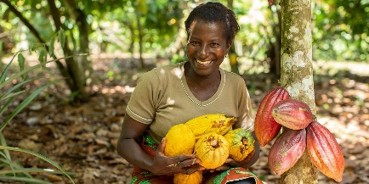
We need to continue to support movements such as Fairtrade who ensure that Third-world farmers receive fair pay, so that their communities can thrive and continue to grow, and work towards equality of all God’s people in the world whilst supporting our own farmers by buying local produce when it is available.
So let us take the opportunity at Harvest Festival time to thank God for life; thank God for food; thank God for family and friends; thank God for the opportunity of living our lives in this rich and beautiful land, a land that could be said to be ‘flowing with milk and honey’.
And let us thank God for being able to express our gratitude in acts of love, sharing and giving. Then will we be able to gather as church in body and spirit, stand before God, and offer our thanksgiving to God for all that he provides to us.
Richard Byas
Saint Aelred’s Pilgrim trail
Our newest, local pilgrim trail was officially launched on Saturday 14th September 2024. It is the 41-mile Saint Aelred’s Pilgrim circular trail, which links the 12 churches in the Benefice of Helmsley and Upper Ryedale.
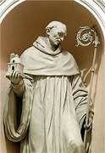
The trail has been created to honour Aelred of Hexham, the abbot of Rievaulx from 1147-1167 who wrote about Christian friendship and was gifted with the wisdom to lead others in the way of holiness. Saint Aelred was a keen walker and author who wrote ‘On Spiritual Friendship’ in which he highlights the importance of having friends to turn to during troubled times, as well as sharing happy moments.
In 1143, Aelred was appointed abbot of the new Revesby Abbey, a daughter house of Rievaulx in Lincolnshire. In 1147, he was elected abbot of Rievaulx itself, a position he was to hold until his death. Under his administration, the abbey is said to have grown to some 140 monks and 500 lay brothers and laymen.
His role as abbot required him to travel. Cistercian abbots were expected to make annual visitations to daughter-houses, and Rievaulx had five in England and Scotland by the time Aelred held office. Moreover, Aelred had to make the long sea journey to the annual general chapter of the Order at Cîteaux in France.
Alongside his role as a monk and later abbot, Aelred was involved throughout his life in political affairs. Aelred also found time to write several influential books on spirituality, among them Speculum caritatis ("The Mirror of Charity,") and De spiritali amicitia ("On Spiritual Friendship"). He also wrote seven works of history, addressing three of them to Henry II of England, advising him how to be a good king and declaring him to be the true descendant of Anglo-Saxon kings.
In his later years, he is thought to have suffered from the kidney stones and arthritis. Walter reports that in 1157 the Cistercian General Council allowed him to sleep and eat in Rievaulx's infirmary; later he lived in a nearby building constructed for him.
Aelred died at Rievaulx in the winter of 1166–7, probably on 12th January 1167 which has become his saint’s day.
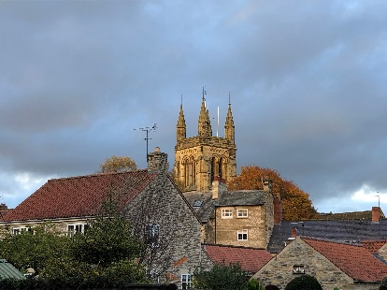
The St Aelred’s Pilgrim Trail starts and ends in the market town of Helmsley and leads walkers along a 41-mile route through a land shaped by Christianity through the ages. It includes eight Anglican churches, two Methodist chapels and the magnificent ruins of Rievaulx Abbey. The trail is accessible to walkers and riders and links the historic rural churches of Upper Ryedale ( Saint John's Bilsdale, All Saints Hawnby, All Saints Old Byland, Saint Mary's Scawton, Saint Michael's Cold Kirby) with the historic Church of All Saints Helmsley and the 19th century Methodist Church, together with the historic hamlet churches of Saint Mary Magdalene East Moors (built by Temple Moore and famous for having a poem written about it by the poet John Betjeman), the “slipper chapel” of the Abbey - the Church of Saint Mary the Virgin Rievaulx, the Methodist Chapel Rievaulx, the beautiful Rievaulx Abbey, and the restored Elizabethan building of the Church of Saint Chad Sproxton.
The trail would take a good 3 or 4days to walk but it also gives the opportunity for just a day or section walk, for anyone who loves walking or riding through the North York Moors countryside.
Richard Byas

During his sermon on Jesus’s teaching that we should love our enemies, the vicar asked the congregation to raise their hands if they had any enemies.
Everyone did so except for an elderly lady in the front row, who had just turned 95.
The vicar asked, ‘how could you live for 95 years and have no enemies?’
‘That’s easy,’ the elderly lady replied, ‘I just outlived them!’


Family visit to St Columba’s Church
On 2nd August three generations of the Hansell family from Indiana in the USA visited St. Columba’s church during a special trip to Yorkshire to investigate their forebears, two generations of whom had weddings at St. Columba’s in 1735 and 1770. They were welcomed by Chris and Linda Hewlett and John Phillips and were very interested in the church and everything they were shown, including the Father Willis organ (which a couple of them enjoyed playing), the Flemish brass, the Burn Jones window, and the old church silver, which predated their 18th century family by a long time, especially the one chalice that was almost as old as the voyage of the original Pilgrim Fathers!
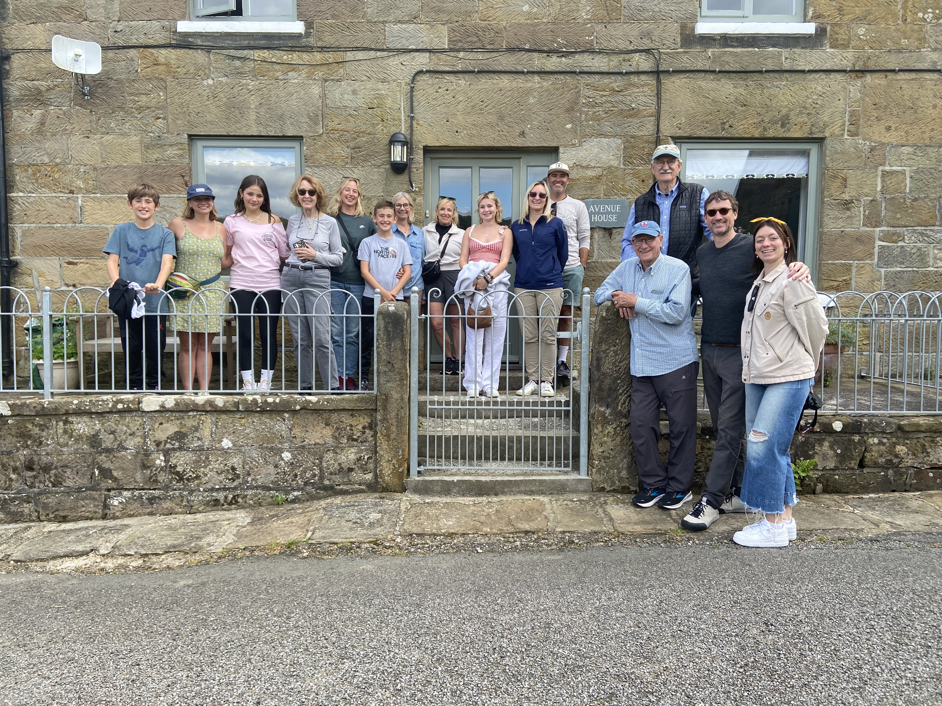
The picture is of the 16 who visited St. Columba’s. All are descendants (or spouses of descendants) of Thomas Harrison (January 19, 1712-August 25, 1790) a farmer and carpenter in the Rainton area, and Francis Fawbert Harrison (March 10, 1708 - ?) also from the Rainton area. Thomas and Francis were married at St. Columba’s on August 12, 1735 and both were buried in St. Columba’s churchyard. Their daughter, Ann Harrison, married John Hansell at St. Columba’s on April 16, 1770, and later moved to Thirsk where John had a successful weaving, “banking”, and grocery business. Their son, Thomas Luke Hansell married Ann Collier of Fryup Dale and they left Thirsk and emigrated to Indiana, USA, in 1819 with their 8 children.
The visitors were all very keen to investigate everything in the church, engaged and engaging people. Their visit was rounded of with cups of tea and Linda’s cake – we are not sure who enjoyed the afternoon the most but we certainly loved spending time with such interesting people.
John Phillips
Baldersby St. James Church Events and News
Tea Dance – Thursday 3rd October from 2.30pm to 4pm in church.
Music and Drama Group - Wednesday 9th and 23rd October 6.30pm to 8pm, led by David Keir.
Defibillator Training - Tuesday 8th October at 10.15am in church. Baldersby St James now has a defibrillator and Yorkshire Ambulance is providing training in its use. Everyone is very welcome to attend from Baldersby and Rainton as well as Baldersby St James. If you have had previous training this will be a chance to update your skills. As usual, refreshments will be provided.
Food Bank Donations – We are collecting in church for Thirsk Community Food Bank until 14th October. They need food staples, cleaning materials and toiletries within date, but nothing perishable. Everyone has been very generous in supporting our collections in previous years. The Food Bank is so necessary for those whose benefits have not been paid or are facing unexpected expenses, so please help if you are able.
Musical Evening – Friday 25th October at 7.30pm, with “The Hummingbirds” a close harmony trio that performs 1930s-1950s classic songs with a twist. A great evening with supper. Please bring your own drinks. Tickets £8.00 on the door. We will sit in the cafe area in front of the stage.
Book Sale – Good News! What an amazing event and massive thanks to everyone who helped from our villages and further afield. We had more books than ever to put out and groups of helpers appeared as if by magic and turned the church into a huge book sale. Over 700 people came in (according to our door counter) which was amazing, helpers appeared with food for refreshments and 22 valiant souls packed up books at the close and returned the church to its beautiful self in two hours. As this year was our most successful the PCC can carry on with repairs to the church. This year we hope to renovate the stained glass windows near the kitchen.
Church Spire – Stone-tech put ladders up to the top of the spire in August and removed the elder bushes that had been growing away for several years at the top. Although this cost £3,500 we also had a report indicating that the spire is in good condition for its age!
Junction 50 Concert – We had a wonderful duo, probably the most talented violin and accordian players we have heard in church. This gave us the opportunity to try out our new boilers which were brilliant – everyone was warm and the radiators were so quiet no one realised the heating was on. Such a relief to us organisers used to radiators so noisy that we had to turn them off and a temperamental old boiler.
Susan Brown

Dalton Events
130 Club September Result
The new series of monthly draws is for St John’s Church.
£15 John Barker No. 41; £10 Colin Smith No. 130; £6 Maureen Hardwick No. 73
Pop-up Cafe
There will be a Pop-up Cafe on Saturday 5th October, 9.30am til 11am. Bacon and sausage sarnies with tea, coffee or juice. All are welcome.
Kids Halloween Party
Thursday 31st October from 3.30pm to 5.30pm. Admission £2 to include a hotdog and there will be a disco.
Sylvia Binks

PARISH DIRECTORY
The Parishes of Topcliffe, Baldersby with Dishforth and Skipton on Swale, and Dalton.
There is currently no Vicar of the parishes. Until one is appointed, please contact our Area Dean,
Rev’d Mary Rolls, mob: 07877 213327 email: mary.rolls@mowbraydeanery.org.uk

BALDERSBY with DISHFORTH and SKIPTON-ON-SWALE - PCC Secretary: Mrs Jennifer Wharton wharton370@btinternet.com

DALTON - PCC Secretary: Mrs Hannah Bissett tel: 07739 382831 spannerb79@gmail.com

TOPCLIFFE – PCC Secretary: Mrs Roz Norris RozNorris@aol.com

