Benefice Online Magazine


for the Parishes of Topcliffe, Baldersby with Dishforth and Skipton on Swale, and Dalton
Cross Talk
September 2024
Cross Talk is published monthly by email. To receive a copy please contact kitnorris@live.co.uk
Cross Talk contains the weekly Collect and Readings together with details of Church services in the Benefice and news and items of interest supplied by our readers. The magazine will also be available on the web sites: www.achurchnearyou.com/church/3447 and baldersbychurch.com.

CHURCH SERVICES

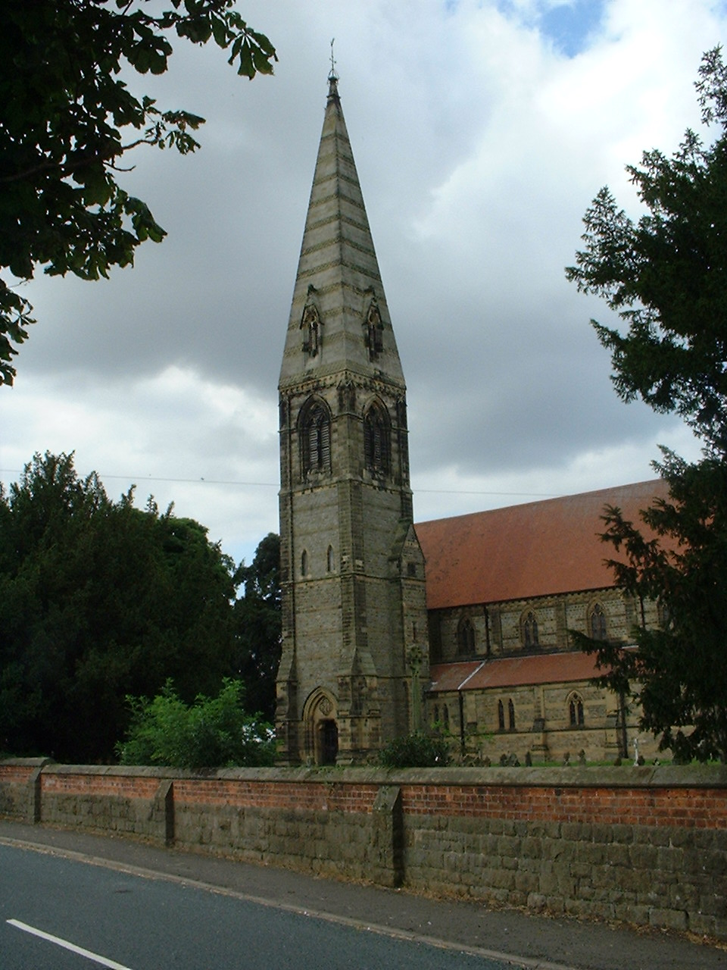
St. James’ Church, Baldersby St. James with Dishforth, Rainton
and Skipton on Swale
Sunday 1st September, 10.45am Holy Communion
followed by refreshments

Sunday 8th September BOOK SALE - NO SERVICE

Sunday 15th September, 10.45am Holy Communion
followed by refreshments

Sunday 22nd September, 9.30am Morning Service
followed by refreshments

Sunday 29th September, 6.00pm Hymns, Pimms and Nibbles

St. Columba’s Church, Topcliffe
Corporate Member of the Prayer Book Society
Sunday 1st September, 6.30pm Choral Evensong
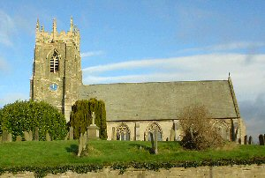
followed by wine and nibbles

Sunday 8th September, 10.45am Holy Communion led by
Rev’d Robert Williamson

Sunday 15th September, 10.45am Sung Matins followed by refreshments
Sunday 22nd September, 10.45am Holy Communion led by
Rev’d Robert Williamson

Sunday 29th September 5th Sunday No Service

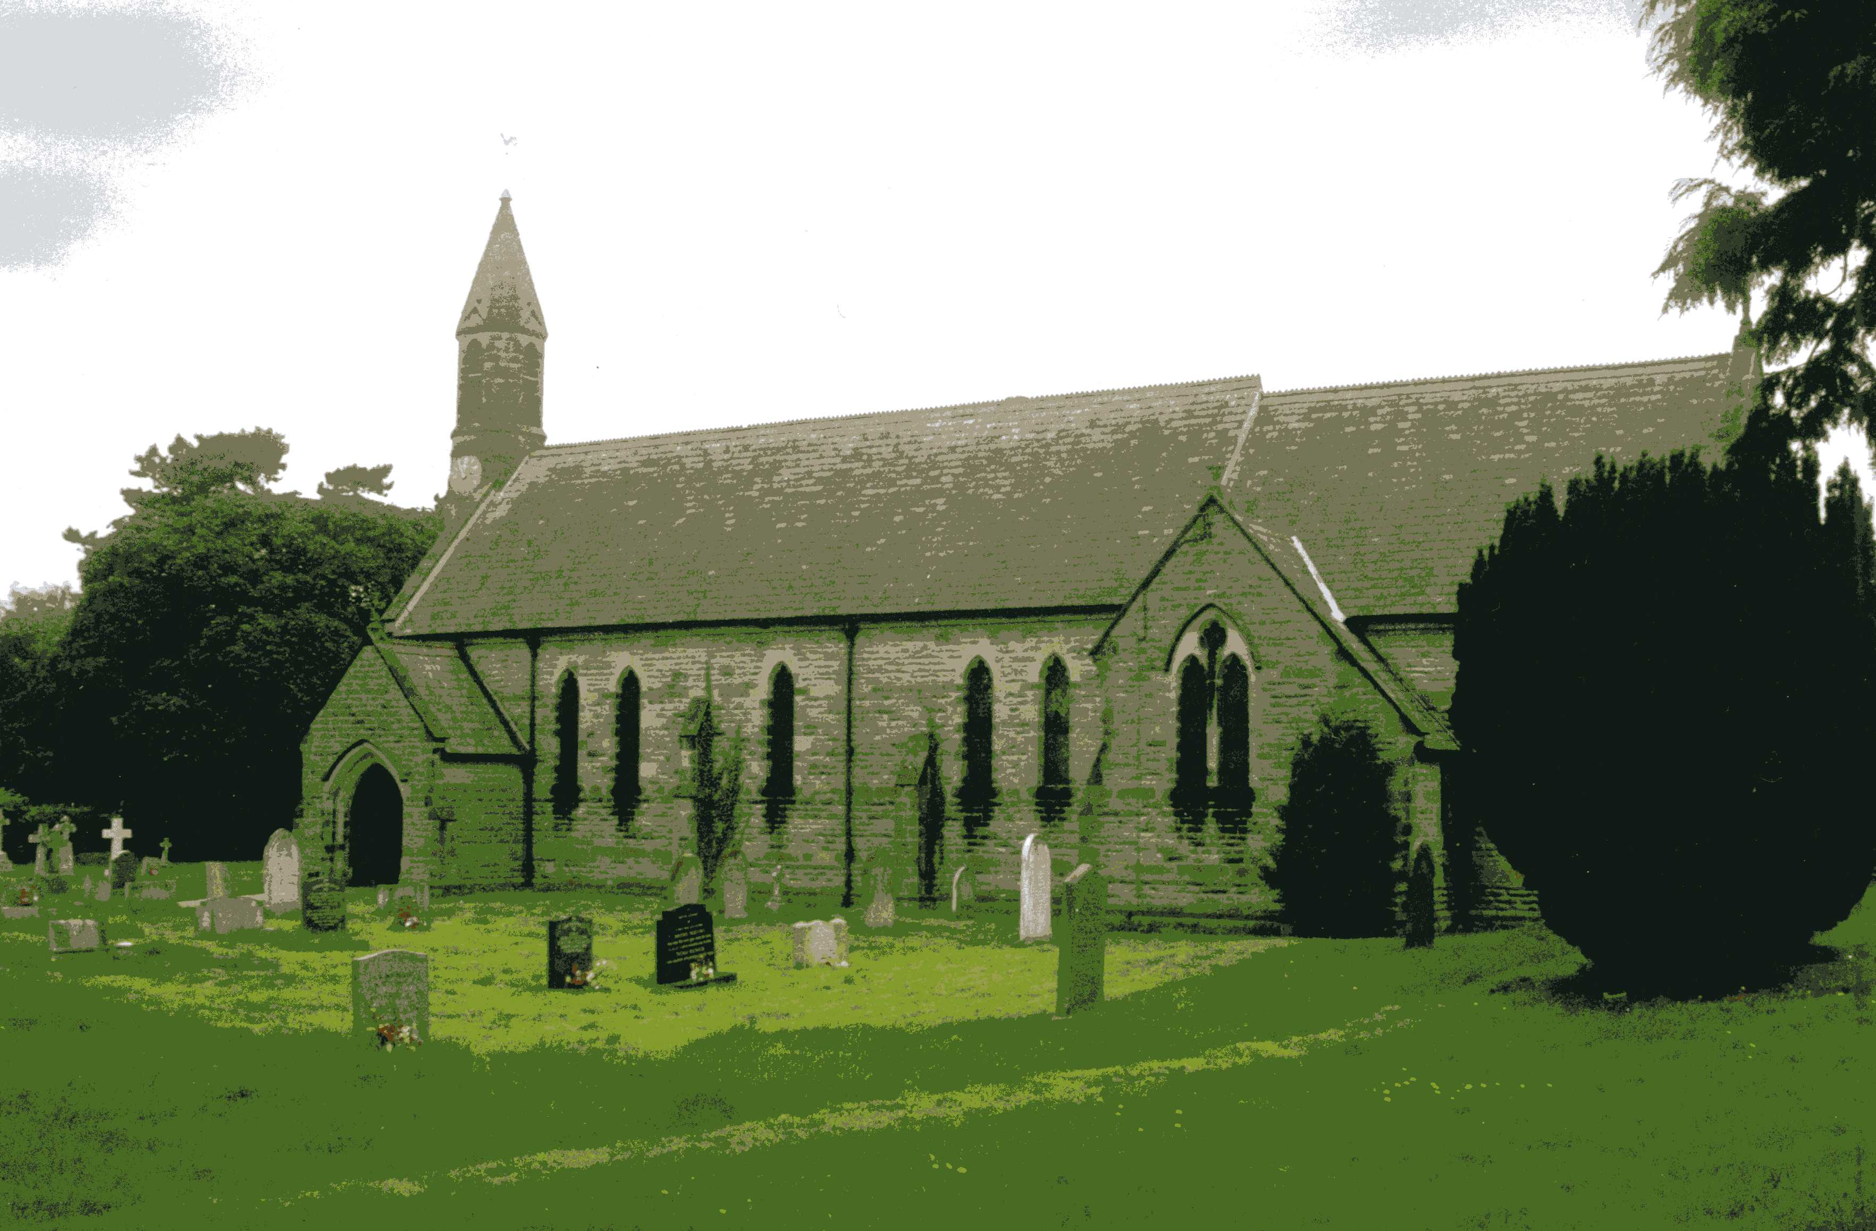
St John the Evangelist Church, Dalton
Sunday 1st September, 11am Holy Communion
Sunday 15th September, 11am Family Service

Friday 27th September, 7pm Harvest Celebration & Supper

All welcome to the services and coffee and biscuits afterwards.

September Reflection page 4
Baldersby News and Events page 6
Dalton News and Events page 7
Readings for the 14th Sunday after Trinity to the 18th Sunday after Trinity
(Page numbers refer to the Common Worship Lectionary.)

Sunday 1st September, The 14th Sunday after Trinity
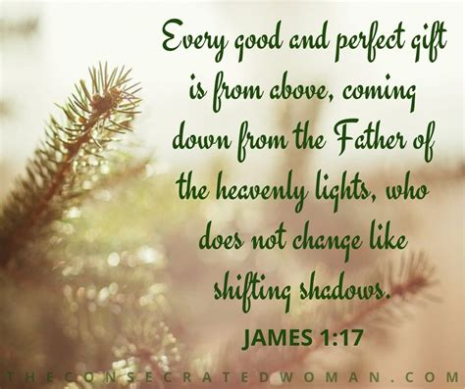
Collect
Almighty God,
whose only Son has opened for us
a new and living way into your presence:
give us pure hearts and steadfast wills
to worship you in spirit and in truth;
through Jesus Christ your Son our Lord,
who is alive and reigns with you,
in the unity of the Holy Spirit,
one God, now and for ever.

Readings Proper 17 Related (p660)
Deuteronomy 4.1-2, 6-9
Psalm 15
James 1.17-27
Gospel: Mark 7.1-8, 14-15, 21-23

Sunday 8th September, The 15th Sunday after Trinity [The Birth of the Blessed Virgin Mary]
Collect
God, who in generous mercy sent the Holy Spirit
upon your Church in the burning fire of your love:
grant that your people may be fervent
in the fellowship of the gospel
that, always abiding in you,

they may be found steadfast in faith and active in service;
through Jesus Christ your Son our Lord,
who is alive and reigns with you,
in the unity of the Holy Spirit,
one God, now and for ever.

Readings Proper 18 Related (p665)
Isaiah 35.4-7a
Psalm 146
James 2.1-10, [11-13], 14-17
Gospel: Mark 7.24-37

Sunday 15th September, The 16th Sunday after Trinity
Collect
O Lord, we beseech you mercifully to hear the prayers

of your people who call upon you;
and grant that they may both perceive and know
what things they ought to do,
and also may have grace and power
faithfully to fulfil them;
through Jesus Christ your Son our Lord,
who is alive and reigns with you,
in the unity of the Holy Spirit,
one God, now and for ever.

Readings Proper 19 Related (p671)
Isaiah 50.4-9a
Psalm 116.1-8
James 3.1-12
Gospel: Mark 8.27-38

Sunday 22nd September : 17th Sunday after Trinity
Collect
Almighty God,
you have made us for yourself,

and our hearts are restless till they find their rest in you:
pour your love into our hearts and draw us to yourself,
and so bring us at last to your heavenly city
where we shall see you face to face:
through Jesus Christ your Son our Lord,
who is alive and reigns with you,
in the unity of the Holy Spirit,
one God, now and for ever.

Readings Proper 20 Related (p.676)
Wisdom 1.16-2.1, 12-22 or Jeremiah 11.18-20
Psalm 54
James 3.13-4.3, 7-8a
Gospel: Mark 9.30-37

Sunday 29th September : 18th Sunday after Trinity : St Michael and All Angels
Collect
Almighty and everlasting God,
increase in us your gift of faith
that, foresaking what lies behind
and reaching out to that which is before,
we may run the way of your commandments
and win the crown of everlasting joy;

through Jesus Christ your Son our Lord,
who is alive and reigns with you,
in the unity of the Holy Spirit,
one God, now and for ever.

Readings Proper 21 Related (p.682)
Numbers 11.4-6, 10-16, 24-29
Psalm 19.7-14
James 5.13-20
Gospel: Mark 9.38-50

Reflection September 2024
The autumn equinox on Sunday 22nd September marks the arrival of the season of autumn, a period of changes leading to the dark of winter.
On 22nd September, the day and night will be of equal length. Many people can find the darker days depressing and spend their time looking forward to lighter days again and so miss out on the beauty that there is in the autumn season.
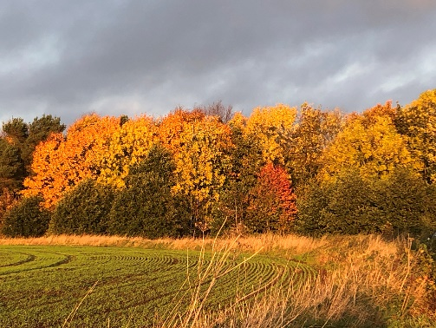
Autumn invites us to slow down and reflect on the passing of time. As the leaves transform into glorious hues of red, orange, and gold, we are reminded of the transient nature of life itself. Autumn reminds us of the impermanence of everything. We have experienced the budding of life in spring and the flowerings and profusions of summer. Now the leaves fall, and bare branches remind us of the fleeting nature of all things. Jewish rabbi and writer Harold Kushner in ‘The Lord Is My Shepherd’ suggests that when we contemplate autumn’s changes, we grow more appreciative of all the beauties that surround us.
As we watch leaves fluttering to the ground in autumn, we are reminded that nature's cycles are mirrored in our lives. Autumn is a time for letting go and releasing things that have been a burden. It is a time for getting things in order, tidy the garden, have the chimneys swept before we light winter fires, get the vehicle serviced for winter and doing the outside jobs that can only be done in the daytime whilst there is still enough light in the day. And it serves as a gentle nudge to pause and ponder our own spiritual journey. Just as the trees shed their leaves, we are called to let go of anything that hinders our growth in Christ, embracing the opportunity for renewal.
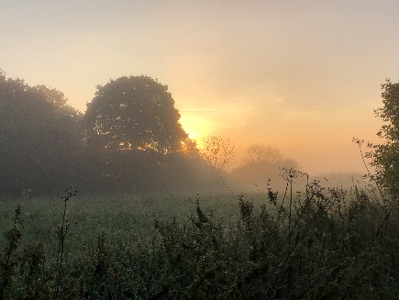
The seasonal nature of the year teaches us to trust in the sovereignty of God and the divine order He has established. Just as in autumn nature trusts that spring will come again, we can rest assured that God is working even in the midst of difficult seasons. In times of uncertainty, and there seems to be a lot of uncertainty in the world at present, we can find solace in knowing that God’s plans are greater than our own, and He is faithful to bring forth beauty from the bad times.
Autumn has a beauty all of its own. From the colour of the leaves on the trees to the mist over the fields on an autumn morning which disappears in the warmth of an autumn sun.
Autumn is also a season of harvest, a time to gather the fruits of our labour and offer gratitude for God’s provision. It prompts us to reflect on the blessings we have received and express our thankfulness to the Giver of all good gifts. We need to cultivate a heart of gratitude, not only for the abundant harvest in our lives but also for the spiritual growth and lessons learned along the way.
As we immerse ourselves in the embrace of autumn, may we open our hearts to the profound messages this season carries. Autumn invites us to reflect on the transient nature of life, trust in God’s perfect timing, and cultivate a heart of gratitude. The church’s new year starts late into autumn on the first Sunday of Advent so this season can be a time of spiritual renewal and a reminder of God’s unending love and faithfulness. Let us rejoice in the beauty of autumn and carry its lessons with us throughout the year, continually growing in our relationship with our Heavenly Father.
Richard Byas
Holy Trinity Church, Goodramgate, York
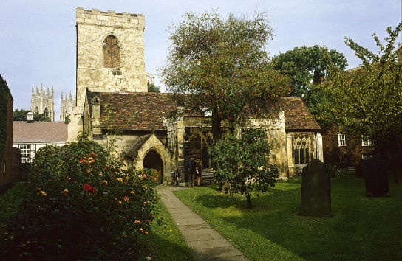
Holy Trinity Church is hidden away behind Our Lady's Row in Goodramgate, York. It was in existence by the late 11th century but the present building dates mainly from the 15th century. The church is a Grade I listed building and dates from between 1250 and the late 15th century but still shows some elements from its 12th-century foundation. Only minimal alteration has been undertaken since the 18th century. It is accessed via an 18th-century brick archway adjoining buildings whose original role seven centuries ago was as artisans’ workshops.
After St Mary Bishophill Junior, it is the oldest medieval church within the city walls of York. At first appearance it seems a very modest church, with uneven floors and listing arcades. It has a rare double-sloping, or 'saddleback', roof and an unusual medieval pool - a 'piscina' - used to wash the chalice after communion.
Holy Trinity is the only church in the city to have retained its box pews. The high sides protected worshippers from draughts and gave them some privacy during the service. Walking into the interior is like stepping back into Georgian times. There is no gas, electricity or running water in Holy Trinity Church, but candlelight in winter bestows a special atmosphere on the ancient building transporting you back in time.
The late medieval stained glass east window of late Perpendicular style dates back to 1470 and was gifted to the church by its then rector the Reverend John Walker. Among those depicted in the window are St George and St Christopher, among other saints, plus heraldic shields; the centre panel portrays God as the Trinity holding the dead Christ while the Reverend Walker immortalised himself in the glass as a kneeling figure in the central light, below the figures of the Holy Trinity.
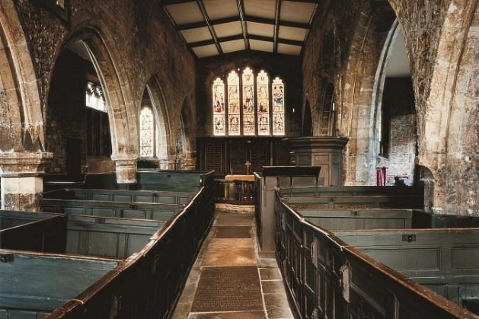
The church has points of great architectural and historical interest. Inside, its dimness can be suddenly lifted from light streaming through the windows dappling the honey-gold stone of the plain walls with flashes of colours. The setting is typical post Reformation. The simple font dates from the 15th century while the pulpit dates from 1695. The floors and arches are quaintly uneven and the 17th-century box pews are rare and unique to York.
A deed was granted in 1316 to build dwellings known as Our Lady’s Row within the churchyard space plus a separate house for the Chantry Priest, the rental income to be used for church maintenance and to endow a chantry fund of the Blessed Virgin in the church. Our Lady’s Row, a unique piece of architecture, blocks the view of the church from the street making it a real hidden treasure. In 1827 a motion was fortunately overturned that would have otherwise demolished the historic Our Lady’s Row and exposed Holy Trinity’s sheltered churchyard to all the passing bustle of Goodramgate. However, the derelict former Chantry Priest’s house was demolished.
Holy Trinity Church was declared redundant in1971 and has been in the care of The Churches Conservation Trust since 1972. This church is open to visitors and is still used for Christian worship at least twice a year - on Trinity Sunday and the second Sunday in Advent.
Opening times are Wednesday to Saturday from 11am - 4pm. These hours are dependent on volunteer availability and may be subject to change. Please contact york@thecct.org.uk to confirm opening times for specific days prior to a visit.
This church and its haven of a churchyard are ideal for relaxing and contemplating and remain a vital need among the modern-day rush of the city.
Richard Byas
A Sunday school teacher was discussing the Ten Commandments with her five and six-year-olds. After explaining the commandment to ‘Honour thy father and thy mother,’ the teacher asked, “Is there a commandment that teaches us how to treat our brothers and sisters?”
Without missing a beat, one little boy answered, “Thou shall not kill.”


Baldersby St. James Church
Book Sale
Saturday 7th & Sunday 8th September 10.00am to 5pm. Free Entry.
If you have a spare hour we could do with help putting out the large numbers of books. Church set up is from Wednesday to Friday 4th to 6th – church will be open 10am to 7pm so anyone can pop in and help. On Sunday from 4pm we will sort out and box books not sold and restore our church to normality! Last year, amazingly, we completed this by 6.30pm but had 24 helpers!
Music and Drama
Fortnightly from Wednesday 18th September at 6.30pm. Kindly led by Dave Kear. All welcome to come along.
Music at Junction 50
Thursday 19th September at 7pm. We are very lucky to welcome Ad Libitum (Violin/Accordion Duo) to church to play for us. Tickets £12 on the door or from the Good Food Shop. Drinks and supper.
Pimms, Nibbles and Hymns
Sunday 29th September at 6.00pm. Informal Service of hymns chosen by our community. If you have a favourite hymn please let Mike know by email – mrushmere24@gmail.com. We may have a draw for hymns if too many, to help our organist. We will sing from our cafe area – all very welcome.
Tea Dance – Monthly starting Thursday 3rd October from 2pm to 4pm in church.
Harvest Festival. Sunday 6th October during Holy Communion at 10.45am with Bring and Share Lunch as last year. For information e-mail c.b.brown398@hotmail.co.uk or 07840381558.

Dalton Events
130 Club August Result
£100 – Terry Thorpe (No.40); £50 – Tommy Spence (No.124); £30 – Les Binks (No.34); £20 – Tony Bird (No.35); £15 – Bob Clay (No.69); £10 – Anna Ramshay (No.53).
The new 6 months of monthly draws will begin in September and the proceeds will be for St John’s Church.
Table Top Sale
There will be a Table Top Sale around Dalton village in people’s gardens on Sunday 1st September from 10am until 1pm. A plan of the locations will be available from the village hall. Come along and grab some bargains.
Church Lunch
St John’s Church lunch will be on Sunday 8th September in the village hall, 12 for 12.30. Cottage pie and vegetables will be followed by an array of fantastic puds. Tickets are £12.50 for adults, £5 for children, available from Judy Spence on 01845 577607. Limited space so get your tickets early.
Harvest Festival
Our Celebration of the Harvest will be on Friday 27th September at 7pm, followed as always by our Harvest Supper. The Dalton Dazzlers children’s choir will also be singing for us, so do come along and enjoy the service and supper afterwards. Everyone is welcome.
PCC Members wanted
We are currently on the lookout for new members of the PCC. If you would like to join us, please contact our Secretary, Hannah, on 07739 382831. We would be pleased to have you join us.
PARISH DIRECTORY
The Parishes of Topcliffe, Baldersby with Dishforth and Skipton on Swale, and Dalton.
There is currently no Vicar of the parishes. Until one is appointed, please contact our Area Dean,
Rev’d Mary Rolls, mob: 07877 213327 email: mary.rolls@mowbraydeanery.org.uk

BALDERSBY with DISHFORTH and SKIPTON-ON-SWALE - PCC Secretary: Mrs Jennifer Wharton wharton370@btinternet.com

DALTON - PCC Secretary: Mrs Hannah Bissett tel: 07739 382831 spannerb79@gmail.com

TOPCLIFFE – PCC Secretary: Mrs Roz Norris RozNorris@aol.com

