Benefice Online Magazine

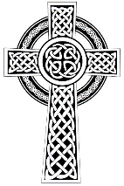
for the Parishes of Topcliffe, Baldersby with Dishforth and Skipton on Swale, and Dalton
Cross Talk
July 2024
Cross Talk is published monthly by email. To receive a copy please contact kitnorris@live.co.uk
Cross Talk contains the weekly Collect and Readings together with details of Church services in the Benefice and news and items of interest supplied by our readers. The magazine will also be available on the web sites: www.achurchnearyou.com/church/3447 and baldersbychurch.com.

CHURCH SERVICES

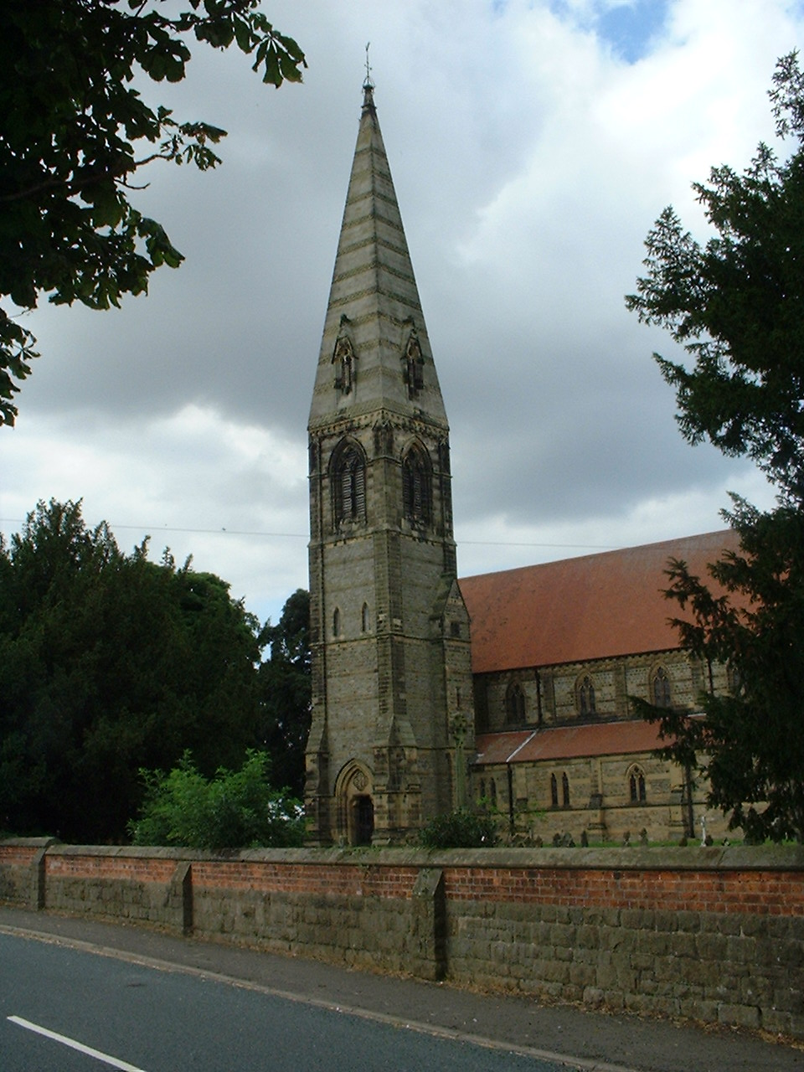
St. James’ Church, Baldersby St. James with Dishforth, Rainton
and Skipton on Swale
Sunday 7th July, 10.45am Holy Communion followed by refreshments

Sunday 14th July, 9.30am Breakfast Service
with Coffee and Croissants

Sunday 21st July, 10.45am Holy Communion followed by refreshments

Sunday 28th July, 9.30am Morning Service

St. Columba’s Church, Topcliffe
Corporate Member of the Prayer Book Society
Sunday 7th July, 6.30pm Choral Evensong
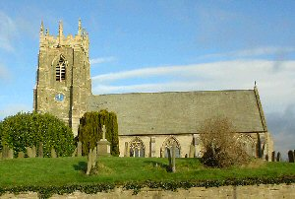
Sunday 14th July, 10.45am Holy Communion
led by Rev’d Robert Williamson

Friday 19th July, 10.00am School End of Term Service

Sunday 21st July, 10.45am Sung Matins

Sunday 23rd July, 10.45am Holy Communion
led by Rev’d Robert Williamson

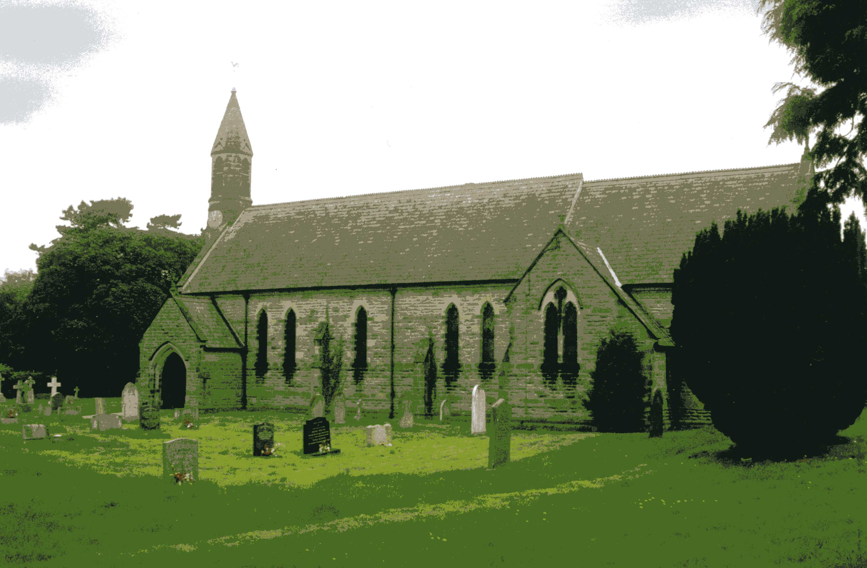
St John the Evangelist Church, Dalton
Sunday 7th July, 11am Holy Communion
Sunday 21st July, 11am Family Service

Everyone is very welcome to the services and coffee and biscuits afterwards.

Reflection page 3
Patronal Festival Sermon page 6
Summer Concert at St Mary’s Church, Thirsk page 8
Village News and Events see page 9

Readings for the 6th Sunday after Trinity to the 9th Sunday after Trinity
(Page numbers refer to the Common Worship Lectionary.)

Sunday 7th July, The 6th Sunday after Trinity
Collect
Merciful God,
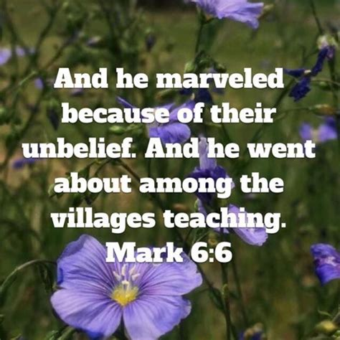
you have prepared for those who love you
such good things as pass our understanding:
pour into our hearts such love toward you
that we, loving you in all things and above all things,
may obtain your promises,
which exceed all that we can desire;
through Jesus Christ your Son our Lord,
who is alive and reigns with you,
in the unity of the Holy Spirit,
one God, now and for ever.

Readings Proper 9 Related (p617)
Ezekiel 2.1-5
Psalm 123
2 Corinthians 12.2-10s
Gospel: Mark 6.1-13

Sunday 14th July, The 7th Sunday after Trinity
Collect
Lord of all power and might,
the author and giver of all good things:
graft in our hearts the love of your name
increase in us true religion,
nourish us with all goodness,
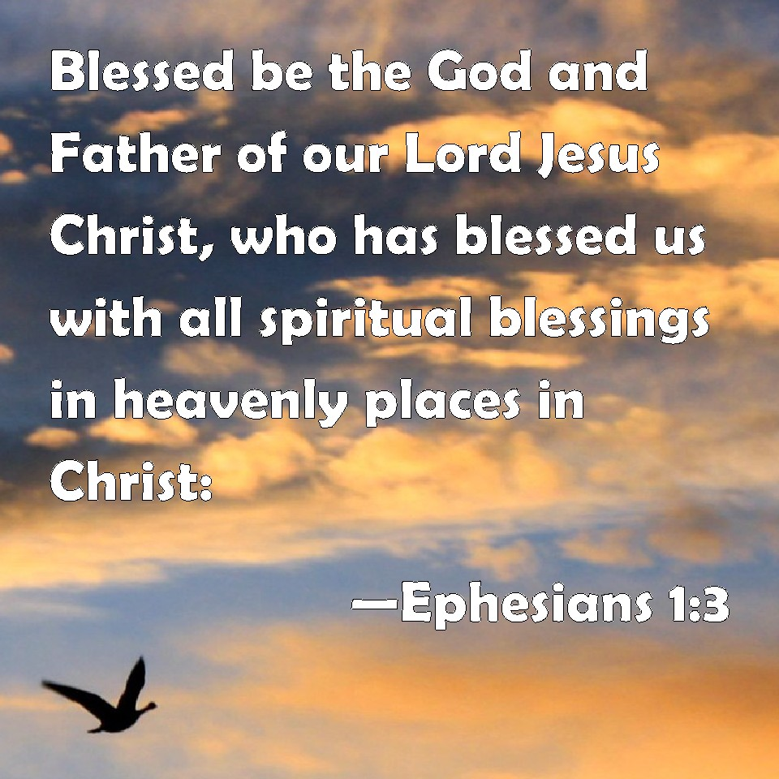
and of your great mercy keep us in the same;
through Jesus Christ your Son our Lord,
who is alive and reigns with you,
in the unity of the Holy Spirit,
one God, now and for ever.

Readings Proper 10 Related (p622)
Amos 7.7-15
Psalm 85.8-13
Ephesians 1.3-14
Gospel: Mark 6.14-29

Sunday 21st July, The 8th Sunday after Trinity
Collect
Almighty Lord and everlasting God,
we beseech you to direct, sanctify and govern
both our hearts and bodies in the ways of your laws
and the works of your commandments;
that through your most mighty protection, both here and ever,
we may be preserved in body and soul;
through our Lord and Saviour Jesus Christ,
who is alive and reigns with you,
in the unity of the Holy Spirit,
one God, now and for ever.
Readings Proper 11 Related (p628)
Jeremiah 23.1-6
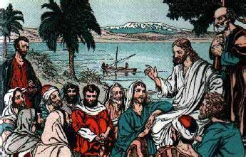
Psalm 23
Ephesians 2.11-22
Gospel: Mark 6.30-34, 53-56

Sunday 28th July : 9th Sunday after Trinity
Collect
Almighty God,
who sent your Holy Spirit
to be the life and light of your Church:
open our hearts to the riches of your grace,
that we may bring forth the fruit of the Spirit
in love and joy and peace;
through Jesus Christ your Son our Lord,
who is alive and reigns with you
in the unity of the Holy Spirit,
one God, now and for ever.
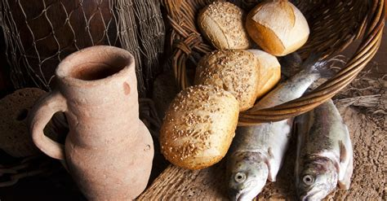
Readings Proper 12 Related (p.633)
2 Kings 4.42-44
Psalm 145.10-19
Ephesians 3.14-21
Gospel: John 6.1-21

Reflection July 2024
With a General Election just days away, we have had nearly six weeks of political campaigning. I don’t know if it is just me, but so much of what I have heard has appeared to be very negative with politicians in particular seeking to attack those that they see as ‘the opposition’ rather than looking for common ground to enable a building up of community. Very many of the policies put forward by all parties seem to be trying to divide society by promising benefits to one section of society at the expense of another.
Thinking back to the first head-to-head debate, the anger and animosity displayed by the participants seems to have been its most newsworthy outcome. Sadly, history can show us many examples of politicians’ angry exchanges spilling over into actual physical violence and even riots and killings out on the streets. Thankfully, nothing quite so bad has happened in this campaign.
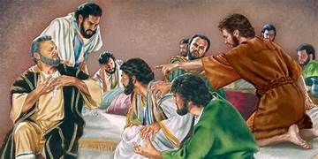
I imagine it was much the same in Jesus’ day. Samaritans, Jews, Romans, even different Jewish factions would have regularly confronted one another with insults, hostility and, not infrequently, violence. We know only too well how much the Holy Land today is still in such desperate need of peace, humanity and justice. In his world-changing Sermon on the Mount, Jesus tells us about another way, a far better way to live a better life, in greater harmony with God and with one another. We need to learn a new way of behaving, he says. And we need to understand where the anger and violence have their roots: in our hearts and minds. Jesus is keen to shift attention from our outward actions to our inward thoughts and feelings.
And in his letter to some early Christians, James tells them that just as a small rudder can steer a very large boat, so even the smallest things that we say can have a huge influence for better or for worse (James 3: 1-12). A word in season really does have power. James therefore challenges his readers to be careful about what they say, in the way that they speak and to remember that they are made in the image of God.
Anyone who points the finger at anyone else is always open to the charge of hypocrisy. But the truth is that we all fail, and we all have our inconsistencies. But that doesn’t prevent us from wanting to hold high expectations of one another. This is particularly true of those in public life to whom we entrust the leadership of our society. It is right that citizens should expect integrity, honesty and humility of those who wield power over the lives of others. Perhaps the key word there is ‘humility’. Holding others to account demands that we all face our own failure to live as we might wish. Those who ‘abide in the Lord’s tent’ share space with others who know their own weakness – those who know their need of God’s grace and the love of their neighbour.
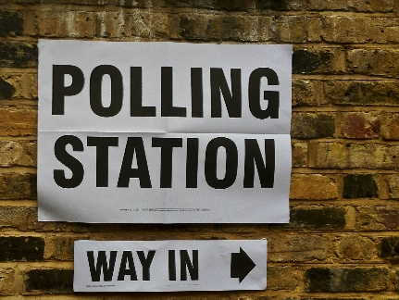
It’s important that we pray for those who expose themselves to public scrutiny and, too often, abuse – for those who stand for public office knowing the price that they and their loved ones might have to pay. And, as we rightly expect integrity in those engaged in public life, let’s pray, too, that we may, in humility, hold ourselves to the same high standards.
The Bible urges us to pray for those who make difficult decisions on our behalf; who shoulder great burdens; who, we pray, will carry out their duty with integrity and compassion. Across the political spectrum, Christians believe that those who offer themselves for public office need and deserve our support and our prayer.
So let us vote and let us pray for all those who are standing for election and for the future of our country.

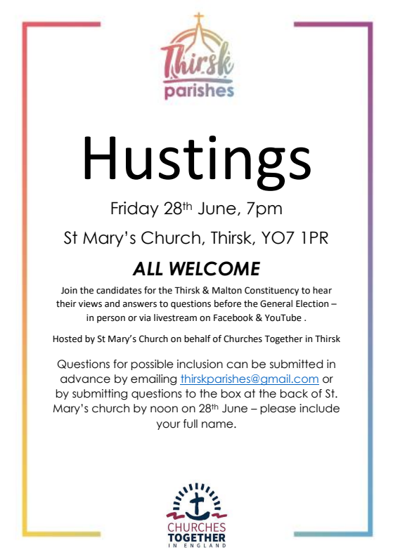
Thirsk Hustings Report
All the candidates were present or sent a representative:
Lisa BANES (Labour) was unable to attend but sent a short video and was represented by Dr John R Gibbins.
Luke BROWNLEE (Yorkshire Party)
Kevin HOLLINRAKE (Conservative Party)
Steve MASON (Liberal Democrat Party)
Richard MCLANE (Green Party)
Mark ROBINSON (Reform UK)
After each candidate had given a short introduction, the first half of the meeting presented two preselected submitted questions to the candidates. The first concerned delays in getting GP appointments and the long delays in waiting lists for hospital treatment. The second was related to tackling low incomes and poverty.
The second half of the meeting covered a variety of topics – providing renewable energy, greening the countryside,food production, affordable housing, education, pollution. Finally, each candidate gave a short summing up of their hopes and aims if successful in the election.
The meeting was well attended by around one hundred people from the Thirsk and Sowerby area. The proceedings were videoed and will be available on St Mary’s Church website. CN.
Bempton Cliffs
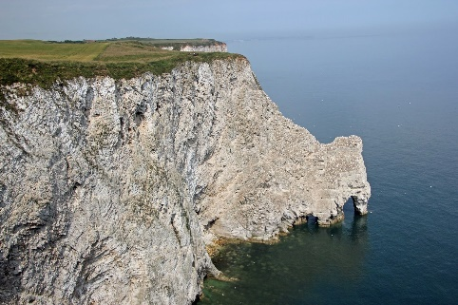
Bempton village is situated about 4 miles north of Bridlington and Bempton Cliffs, which form part of a RSPB reserve, are home to around half a million seabirds which gather here between March and August to raise their families on the towering chalk cliffs overlooking the North Sea.
The height of bird activity is between April and July with Puffins, Gannets, Kittiwakes and Guillemots raising their young. There are more Gannets diving to catch fish here than anywhere else on mainland England.
The reserve is now a tourist destination but until just after the second world war the seabird eggs were a source of food and income for the local inhabitants. From medieval times cliff climbing or ‘climming’ as it was known was practiced by local groups of men and even a few women to collect the eggs of sea birds.
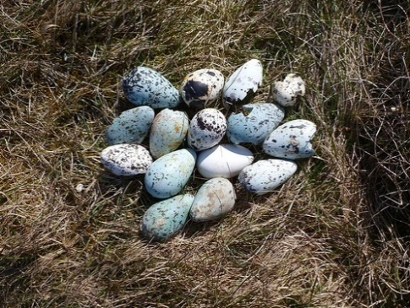
Working in gangs, one person was lowered down the cliffs, using ropes. It was a dangerous activity using primitive equipment on cliffs, some of which had a sheer drop of more than 400 feet. It relied on the ‘climmers’ having a great deal of skill and trust in each other. But it was also a real community event in which villagers and families worked together.
Despite the dangers, it was a highly popular community event as whole families would get involved. It was banned in 1954 over concerns about declining bird numbers.
As well as being a cheap source of nutrition for local families, some of the eggs were sold as food and large hotels in London even bought them as a delicacy. In addition, some were bought by collectors to add to their collections at a time when egg collecting was still legal and some were used in the patent leather industry.
In the second world war the eggs were collected to help the war effort. The ‘climmers’ were collecting eggs which could be used for food at a time when supplies of fresh hen eggs were very short.
After the war many of the ‘climmers’ used military surplus equipment to improve safety but within 10 years of the war ending, in 1954, the egg collecting was banned. With declining bird numbers, attitudes and the law had changed and egg collecting ceased to give the sea birds better protection.
Richard Byas

The Lost Bible

One day a vicar lost his favourite Bible while he was at a spiritual retreat in the mountains. He was devastated and began to lose his faith. Three weeks later, a dog walked up to him after a church service, carrying the Bible in its mouth. The preacher couldn't believe his eyes.
He took the precious book out of the dog's mouth, raised his eyes heavenward and exclaimed, "It's a miracle!"

"Not really," said the dog. "Your name is written inside the cover."

Patronal Festival Sermon at St Columba’s, Topcliffe,
Sunday 9th June 2024
Today, 9th June, is the day on which the Church commemorates St Columba – the saint to whom your parish church is dedicated. One of your Kempe windows has an image of Columba; more about stained glass windows in a moment.
First, some biographical details about your patron saint. Columba was born in Ireland in about the year 521. He was trained as a monk, and subsequently founded several monasteries himself. In 563 he left Ireland with twelve companions and settled on the island of Iona, off the west coast of Scotland. He spent the rest of his life in Scotland, most of it at Iona.
From a life of Columba, written by Adomnan (627-704), Abbot of Iona for much of Columba’s time there, Columba emerges as a scholar, poet and diplomat, with a charismatic personality. He is portrayed as someone who was able and ardent, and sometimes harsh – but whose harshness mellowed with age. In the last four years of his life, when his health was failing, Columba transcribed books of the gospels to be taken out from Iona and used in the growing number of Christian communities. Evidence of his work as a scribe can be seen in a late 6th century psalter which is the oldest surviving example of Irish majuscule writing. He died on this day in 597 – the same summer when Augustine and his monks landed in Kent.
From its dedication and its location in the north of England, this church is believed to have been founded by one of Columba’s disciples during their conversion of the north in the 7th century.
Saint Columba. I wonder what sort of picture you have of a saint? I suspect that the picture which many have is of someone who lived a long time ago, and who possessed great holiness; someone who attained heights of sanctity which we feel we could not hope to scale; someone who seems very remote from us and our world. But I think such a view is wrong.
There is a story of a bishop who, during a sermon at a Confirmation, asked those to be confirmed: ‘What is a saint?’ One of the candidates happened to glance up at one of the church’s stained glass windows; in the window was the figure of a saint. In a burst of inspiration and brilliance, the candidate said to the bishop: ‘A saint is someone through whom the light shines.’ Someone through whom the light shines.
One of the reasons why I have a Christian faith is that, during the course of my life, I have been deeply affected by a few Christian people who, through the quality of their lives, spoke to me of the reality and love of God. It’s not just that they were good people – though they were. It’s more that they possessed a sanctity, a holiness, which was almost tangible.
Rowan Williams, the former Archbishop, says of this experience that it leads us to say: ‘the way they live is a way I want to live, perhaps can imagine myself living in my better or more mature moments. The world they inhabit is one I’d like to live in.’ (Tokens of Trust p21)
Bishop Williams says of these people that they enable us to make a connection between humanity and God – a connection which argument and speculation cannot make. He says: ‘You won’t be surprised to hear that I haven’t yet found the decisive new argument that will prove once and for all that there really is a God.’ (p20) And he quotes, approvingly, St Ambrose, the great fourth century Bishop of Milan, who said: ‘[I]t did not suit God to save his people by arguments.’ So if people are not persuaded into belief by intellectual argument, ‘what is it’, asks Bishop Williams, ‘that shifts [their] imagination and vision and hope?’ (p21)
Bishop Williams suggests that what shifts imagination, vision and hope is the experience of holy lives. He says: ‘We may be uncertain, still racked by doubt and inner anguish, we may be unable to give any very satisfactory account intellectually of what we believe; but somehow in our horizon there are people who make the connection. Never mind that such people may themselves often be almost as anguished or struggling as we are: the point is that what we see is someone who is a native of the world in which we want to belong.’ (p26)
From the earliest days of the Christian Church, ‘saint’ was a term used to refer to Christian people. St Paul, for example, writing to the Christians in Rome, begins his letter with these words: ‘To all God’s beloved in Rome, who are called to be saints.’ (Romans 1:7) Bishop Williams reminds us of the responsibility which we all have to help others to make the connection with God – to lead them to the point where they say: ‘I want to live in the same world as them; I want to know what they know and to drink from the same wells.’ (p28)
Called to be saints. It is, of course, the business of a lifetime: a continuing process of being open to and seeking to be transformed by the grace of God – through prayer and worship, through bible reading and the sacraments, through our fellowship with, and mutual encouragement of, each other in the Christian community of which we are part.
On this patronal festival of this church, we give thanks for St Columba – one of those saints through whom, down the ages, the light has shone; one of those who, in the words of today’s Gospel, were dressed for action and had their lamps lit (Luke 12.35). We give thanks, too, for those through whom the light shines today; those who are natives of God’s new world; those whose lives speak of the reality and love of God; those who inspire and encourage us on our Christian journey. And in giving thanks for Columba and for them, we are reminded of our vocation to be open to the transforming grace of God: so that we may live as natives of God’s new world, shine as lights in the world, and be saints for others – that they may come to see and know for themselves the reality and love of God for them and for the whole creation. Amen.
The Revd Canon Steven Harvey
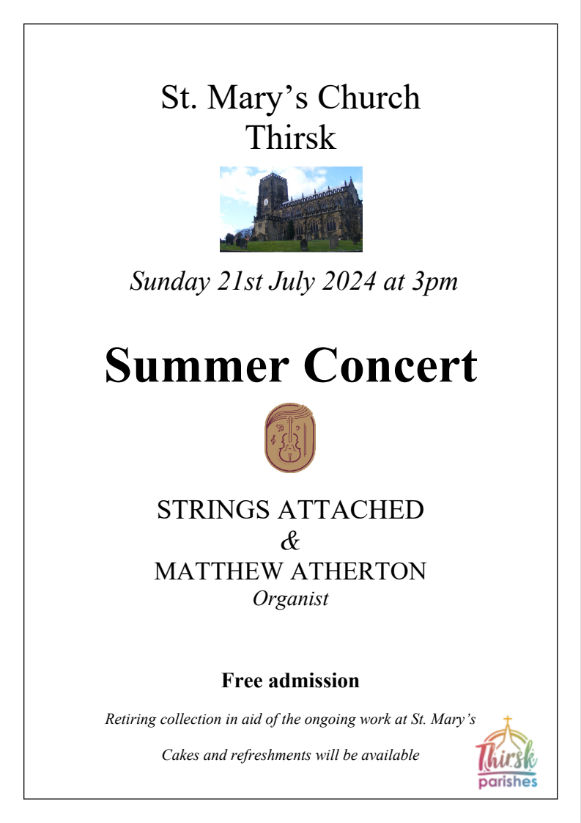

Baldersby St. James Church

Coffee and Chat
We meet every Tuesday morning in church at 10.00am for coffee and chat – just drop in and make a drink. At 9.00am Michelle is in church to pray with anyone who would like to join her prior to our coffee chat.
Book Sale
SATURDAY 7th & SUNDAY 8th SEPTEMBER 10.00am to 5pm. We welcome help putting out books on Wednesday/Friday and most importantly for tidying up books on Sunday at 4pm.
Please leave donations of any books in the church porch. Everyone is being very generous with donations of books which is great.
Junction 50 Concert
Sadly our first concert on 4th July coincided with the church being used as a Voting Station for the General Election. For our concert at 7pm on Thursday 19th September we look forward to welcoming everyone to “Ad Libitum” a husband and wife Accordian and Violin duo, who we are very pleased to welcome to church. Tickets are available from the Good Food Shop or on the door.
Harvest Festival
Sunday 8th October at 10.45am with Bring and Share Lunch.
Church Spire
As some of you may have noticed our tall spire has a Buddleia growing near the top! During the summer “Stonetech” will be putting ladders to the top of the spire to remove the offending interloper! Hopefully securing the slates before any damage is done.
Church Heating
Our new Church Boiler is installed and paid for, which is brilliant, as along with the extra radiators we are able to increase the heating in church. It has a wonderful automatic system so our Church Warden does not have to turn it on at 7am! The walls along the radiators have been repainted so we are looking very tidy. Terry has kindly made an extra floor over the cellar so we can safely store our mowers.

PARISH DIRECTORY
The Parishes of Topcliffe, Baldersby with Dishforth and Skipton on Swale, and Dalton.
There is currently no Vicar of the parishes. Until one is appointed, please contact our Area Dean,
Rev’d Mary Rolls, mob: 07877 213327 email: revmaryrolls@gmail.com.

BALDERSBY with DISHFORTH and SKIPTON-ON-SWALE - PCC Secretary: Mrs Jennifer Wharton wharton370@btinternet.com

DALTON - PCC Secretary: Mrs Hannah Bissett tel: 07739 382831 spannerb79@gmail.com

TOPCLIFFE – PCC Secretary: Mrs Roz Norris RozNorris@aol.com

