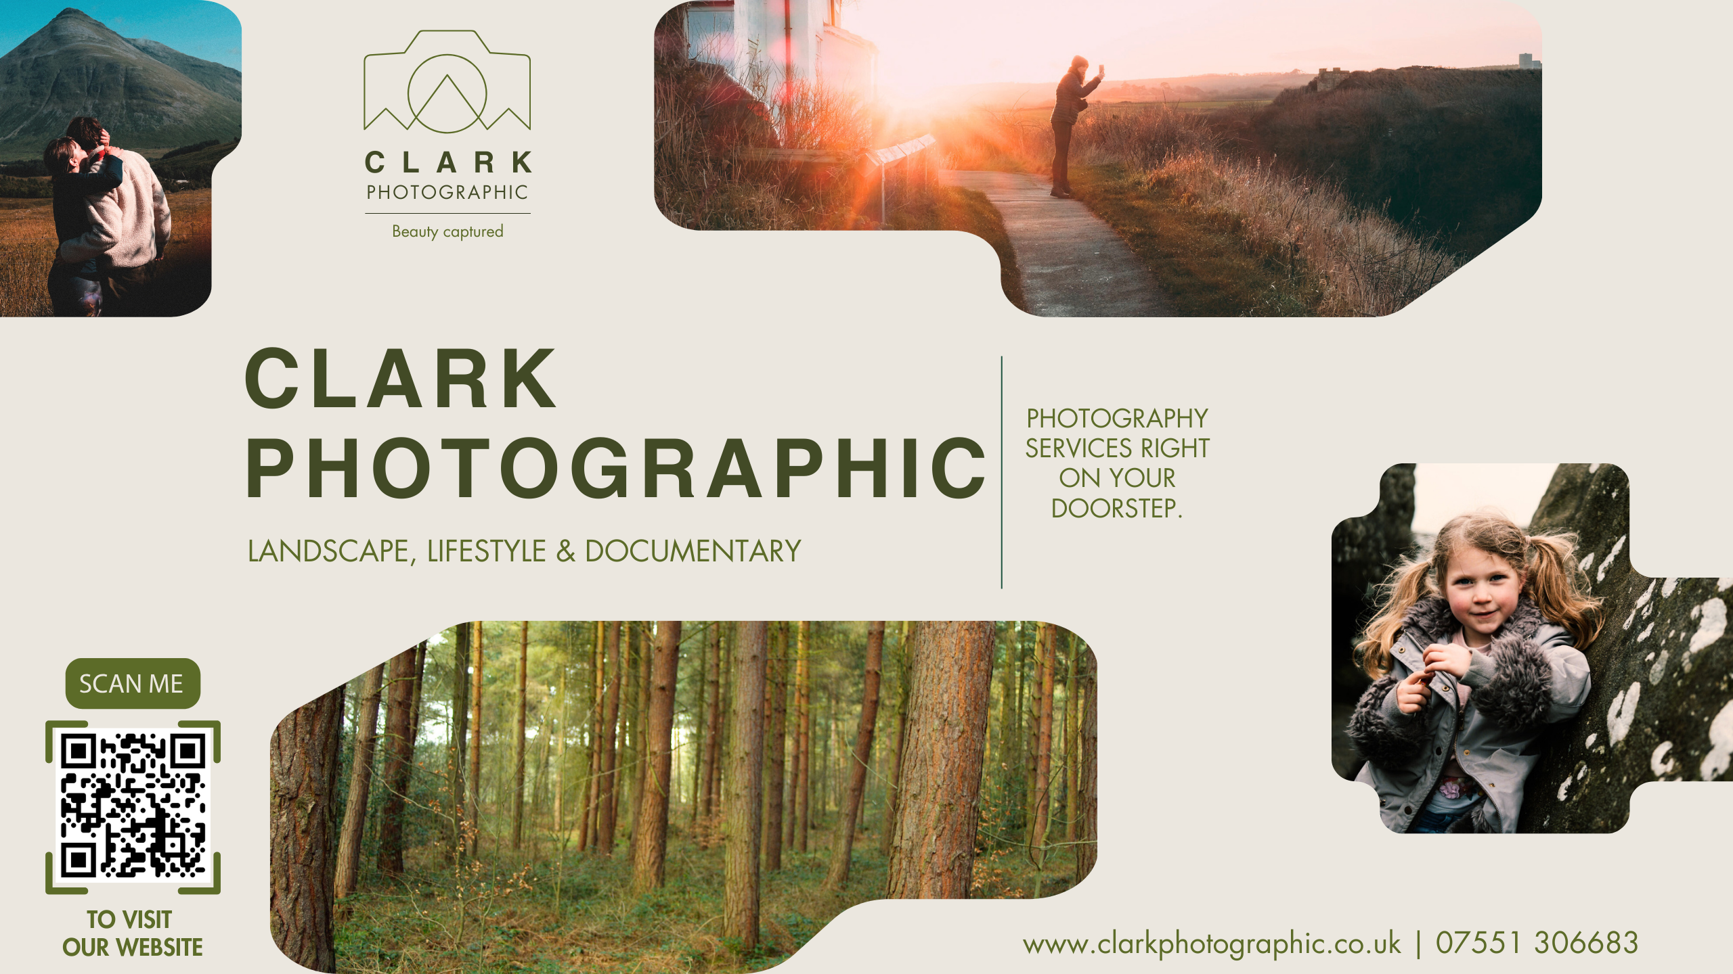
Adam Clark, is a landscape, lifestyle and documentary photographer living in Topcliffe.

Adam is available for a range of photography projects including:

- Natural and informal family shoots
- Aerial photography
- Interiors & exteriors
- Travel & tourism
- Landscape & adventure
- Product
- Corporate, small & local businesses
- Commissions & prints are available

So perhaps, you’re after fresh family photo’s for your wall, or social media OR, maybe your business would benefit from some new marketing images. Contact Adam to discuss how he can assist you.

For further information please visit Adam’s website www.clarkphotographic.co.uk | email adam@clarkphotographic.co.uk | Phone 07551 306683

