Benefice Online Magazine

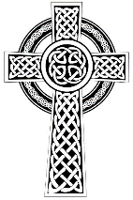
for the Parishes of Topcliffe, Baldersby with Dishforth and Skipton on Swale, and Dalton
Cross Talk
June 2024
Cross Talk is published monthly by email. To receive a copy please contact kitnorris@live.co.uk
Cross Talk contains the weekly Collect and Readings together with details of Church services in the Benefice and news and items of interest supplied by our readers. The magazine will also be available on the web sites: www.achurchnearyou.com/church/3447 and baldersbychurch.com.

CHURCH SERVICES

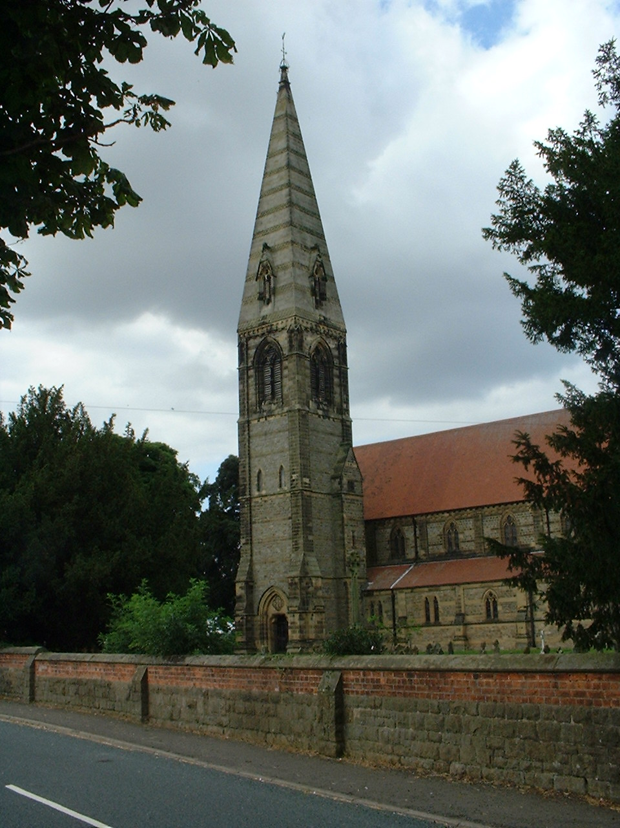
St. James’ Church, Baldersby St. James with Dishforth, Rainton
and Skipton on Swale
Sunday 2nd June, 10.45am Holy Communion followed by refreshments

Sunday 9th June, 9.30am Breakfast Service
with Coffee and Croissants

Sunday 16th June, 10.45am Holy Communion followed by refreshments

Sunday 23rd June, 9.30am Morning Prayer

Sunday 30th June No Service

St. Columba’s Church, Topcliffe
Corporate Member of the Prayer Book Society
Sunday 2nd June, 6.30pm Choral Evensong
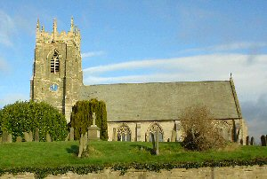
Sunday 9th June, 10.45am Columba Festival Service
led by Rev’d Canon Steven Harvey
Missa Secunda by Hans Leo Hassler
1.15pm Barbecue with wine
6.00pm Compline (for full details of Festival see p.7)
Sunday 16th June, 10.45am Sung Matins

Sunday 23rd June, 10.45am Holy Communion led by Rev’d Robert Williamson

Sunday 30th June No Service
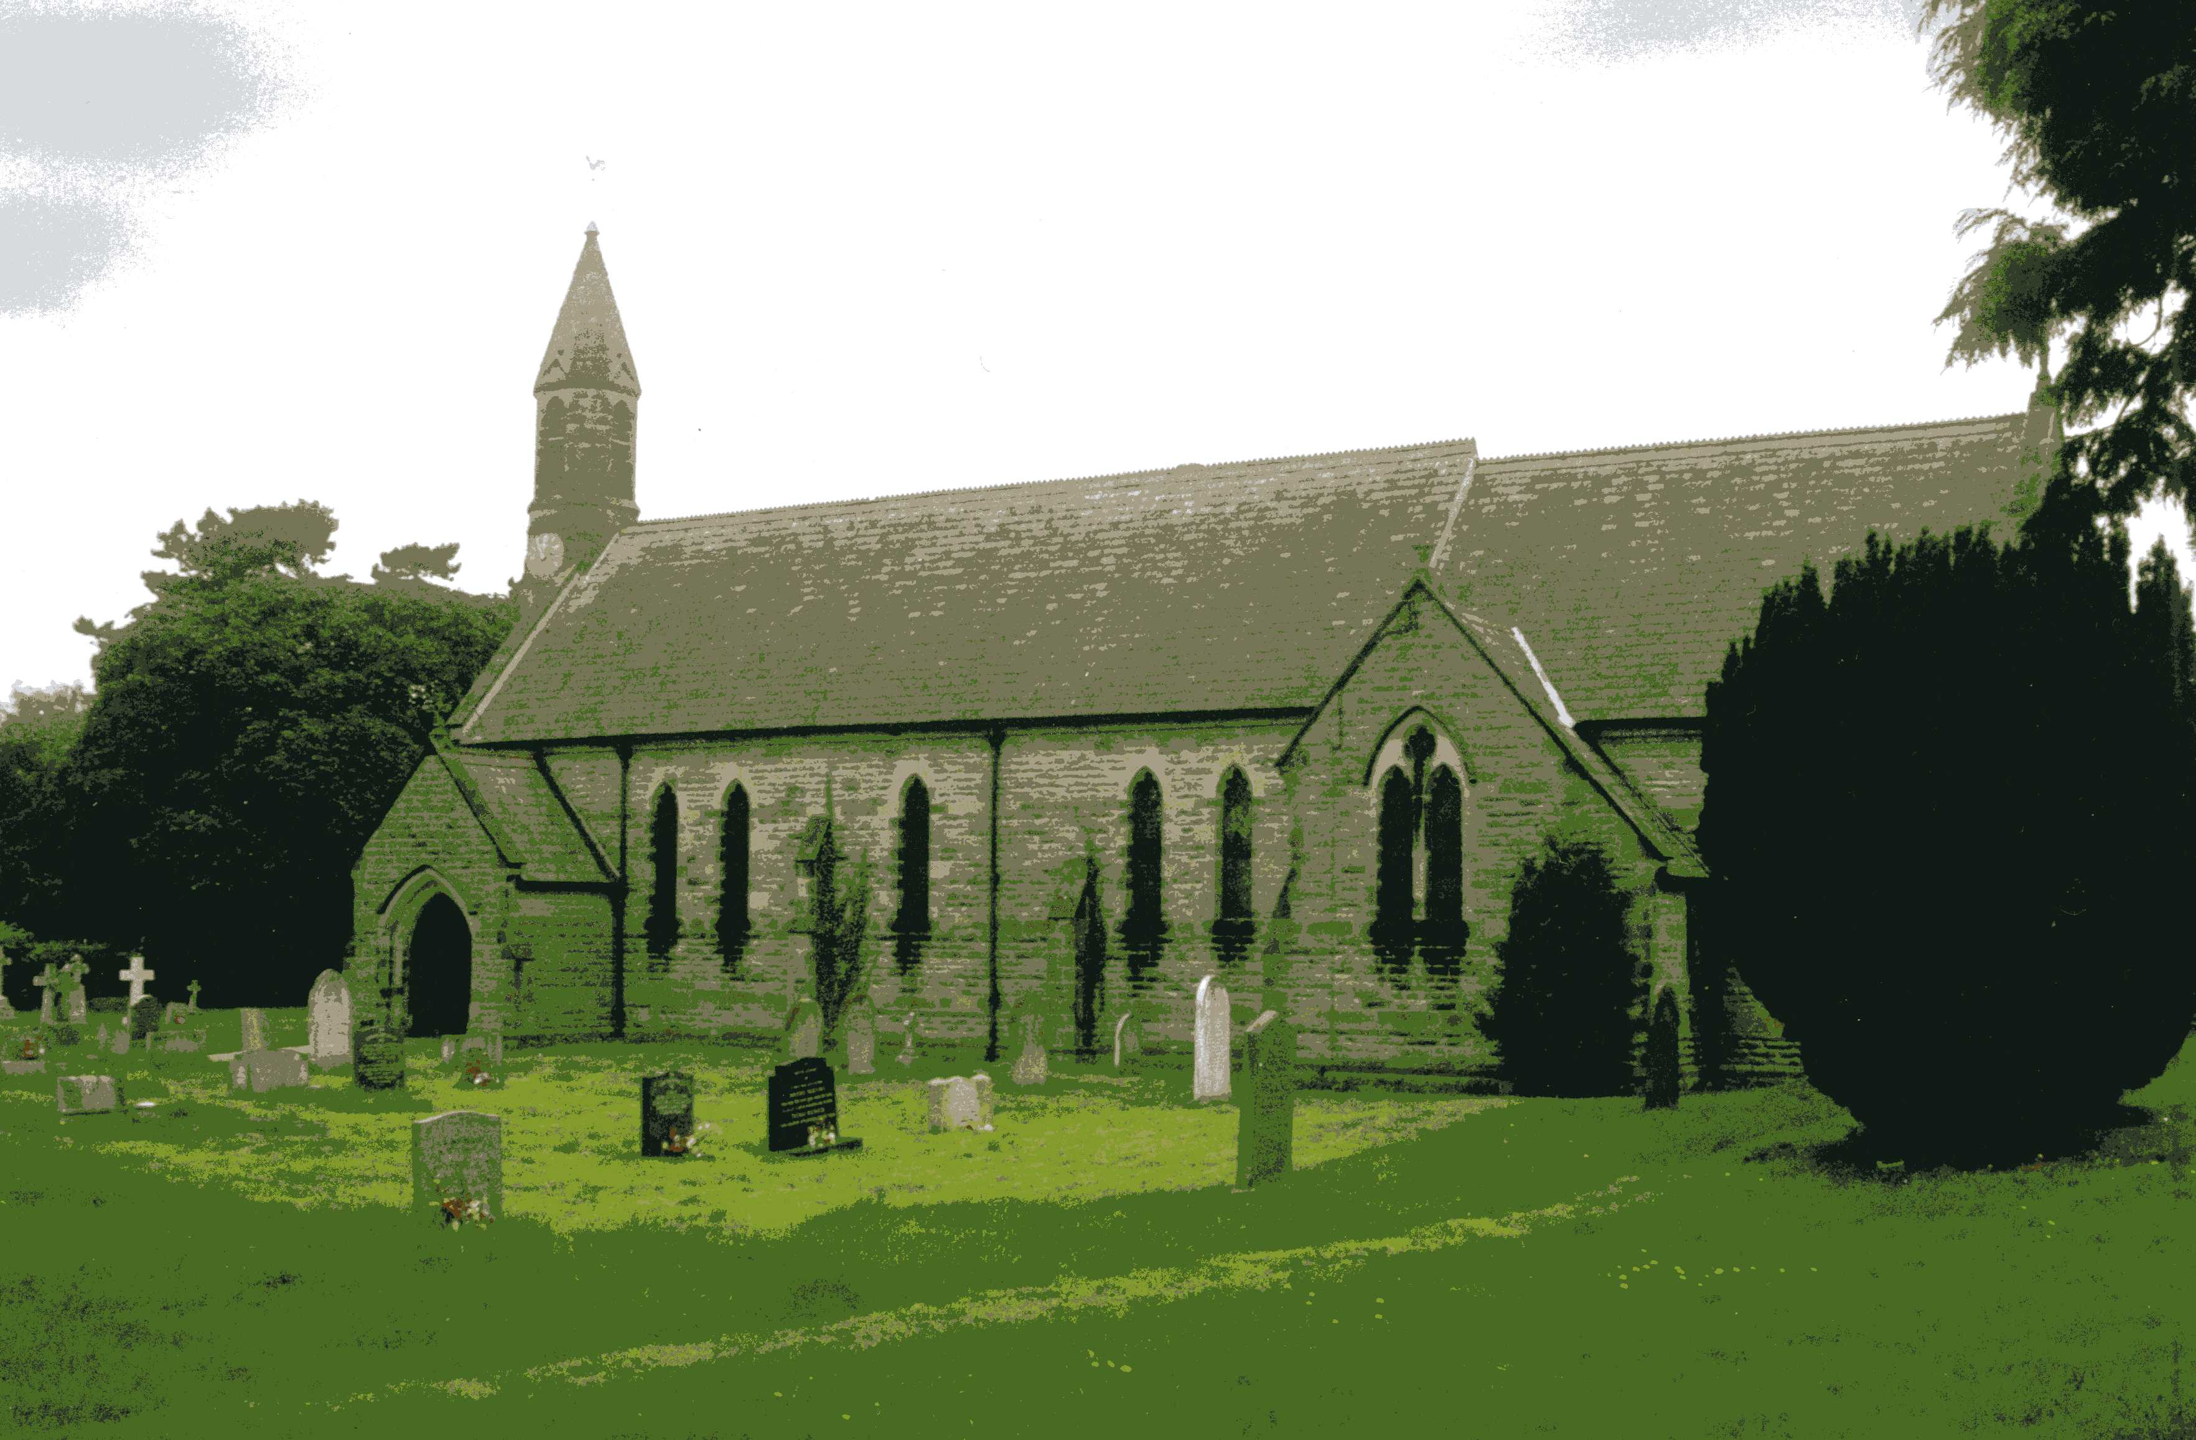
St John the Evangelist Church, Dalton
Sunday 2nd June, 11am Holy Communion
Sunday 16th June, 11am Family Service

Everyone is very welcome to the services and coffee and biscuits afterwards.

Village Events see page 7-8
Readings for the 1st Sunday after Trinity to the 5th Sunday after Trinity
(Page numbers refer to the Common Worship Lectionary.)

Sunday 3rd June, The 1st Sunday after Trinity
Collect
O God, the strength of all those who put their trust in you,
mercifully accept our prayers
and, because through the weakness of our mortal nature
we can do no good thing without you,
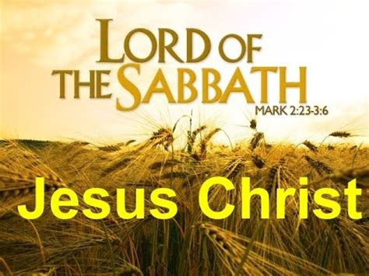
grant us the help of your grace,
that in the keeping of your commandments
we may please you both in will and deed;
through Jesus Christ your Son our Lord,
who is alive and reigns with you,
in the unity of the Holy Spirit,
one God, now and for ever.

Readings Proper 4 Related (p588)
Deuteronomy 5.12-15
Psalm 81.1-10
2 Corinthians 4.5-12
Gospel: Mark 2.23-3.6

Sunday 9th June, The 2nd Sunday after Trinity
Collect
Lord, you have taught us
that all our doings without love are nothing worth:
send your Holy Spirit
and pour into our hearts that most excellent gift of love,
the true bond of peace and of all virtues,
without which whoever lives is counted dead before you.
Grant this for your only Son Jesus Christ’s sake,
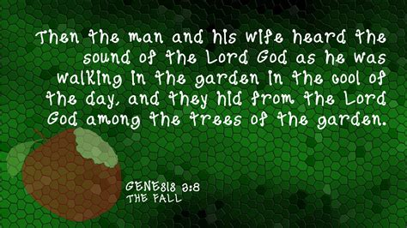
who is alive and reigns with you,
in the unity of the Holy Spirit,
one God, now and for ever.

Readings Proper 5 Related (p593)
Genesis 3.8-15
Psalm 130
2 Corinthians 4.13-5.1
Gospel: Mark 3.20-35

Sunday 16th June: The 3rd Sunday after Trinity
Collect
Almighty God,
you have broken the tyranny of sin
and have sent the Spirit of your Son into our hearts
whereby we call you Father:
give us grace to dedicate our freedom to your service,
that we and all creation may be brought
to the glorious liberty of the children of God;
through Jesus Christ your Son our Lord,
who is alive and reigns with you,
in the unity of the Holy Spirit,
one God, now and for ever.
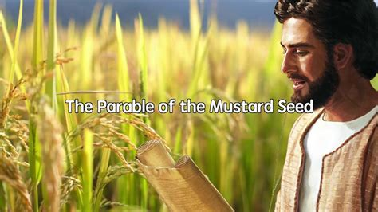
Readings Proper 6 Related (p598)
Ezekiel 17.22-24
Psalm 92.1-4, 11-14 or Psalm 92.1-7
2 Corinthians 5.6-10, [11-13,] 14-17
Gospel: Mark 4.26-34

Sunday 23rd June : 4th Sunday after Trinity
Collect
O God, the protector of all who trust in you,
without whom nothing is strong, nothing is holy:
increase and multiply upon us your mercy;
that with you as our ruler and guide
we may pass through things temporal
that we lose not our hold on things eternal;
grant this, heavenly Father,
for our Lord Jesus Christ’s sake,
who is alive and reigns with you
in the unity of the Holy Spirit,

one God, now and for ever.

Readings Proper 7 Related (p.606)
Job 38.1-11
Psalm 107.[1-3,] 23-32
2 Corinthians 6.1-13
Gospel: Mark 4.35-41

Sunday 30th June : 5th Sunday after Trinity
Collect
Almighty and everlasting God,
by whose Spirit the whole body of the Church
is governed and sanctified:
hear our prayer which we offer for all your faithful people,
that in their vocation and ministry
they may serve you in holiness and truth
to the glory of your name;
through our Lord and Saviour Jesus Christ,
who is alive and reigns with you
in the unity of the Holy Spirit,
one God, now and for ever.
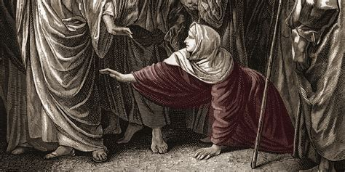
Readings Proper 8 Related (p.611)
Wisdom 1.13-15; 2.23-24
Lamentations 3.22-33 or Psalm 30
2 Corinthians 8.7-15
Gospel: Mark 5.21-43

Reflection June 2024
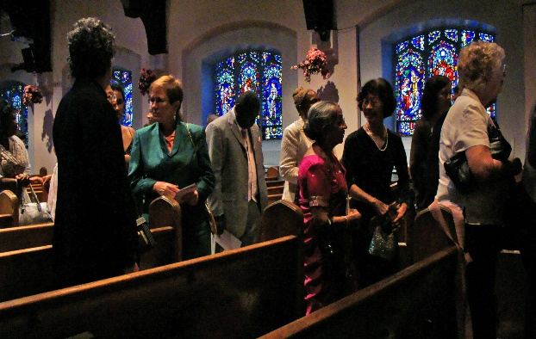
The headline news from the Church of England this past month has been that average weekly attendance at Church of England services rose by almost five per cent in 2023 - the third year of consecutive growth. These are preliminary results with the full Statistics for Mission report due to be published in the autumn.
The figures suggest that attendance by children was up by almost six per cent last year, with overall, all-age weekly attendance showing an increase of 4.7 per cent.
Both the Archbishop of Canterbury and Archbishop of York have welcomed the news whilst being cautious not to claim that this growth is a trend that they necessarily expect to continue.
Counting numbers of people attending church however in no way reflects the activities of churches in their communities. For most people church attendance accounts for little over an hour a week and it is what Christians are doing for the rest of the week that has the most impact on their communities. As we read in the letter of James ‘What good is it, my brothers and sisters, if you say you have faith but do not have works? Can faith save you? If a brother or sister is naked and lacks daily food, and one of you says to them, ‘Go in peace; keep warm and eat your fill’, and yet you do not supply their bodily needs, what is the good of that? So, faith by itself if it has no works, is dead.’ (James 2: 14-17)
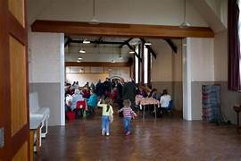
The basic figures do not tell us why more people are attending church – is it as the church suggests due to the church’s ‘focus on reaching more people with the good news of Jesus, establishing new Christian communities, wherever they are, revitalising our parishes, and seeking to become a younger and more diverse church, making everyone feel welcome’? The figures alone do not confirm this analysis. It may be true, but it could just as easily be that in the unstable world in which we are now living with wars, mass migrations of people and environmental changes that we do not seem to be able to control, people are being prompted by the Holy Spirit to come to church to find a degree of certainty in their lives. And it is also just as likely in some places that it is the work of Christians in their communities supporting people after Covid and during the recent difficult winters that has encouraged the people they have helped to start attending church. There may be as many reasons for the increase in church attendance as there are new church attendees.
In addition, the raw figures do not tell us which churches have seen the greatest growth. It would be good if the increased attendance was uniformly seen across all churches be they cathedrals, town centre churches or village churches and across all types of worship from traditional to charismatic. Hopefully we will have more information when the full Statistics for Mission report is published in the autumn.
Total attendance is still however below 2019 levels, the last year before the Covid-19 lockdowns. A number of people who started to attend services on-line during Covid may have continued to do so and will not be included in the figures so the figures may actually underestimate the number of active Church of England members.
So, whilst the church may be encouraged by the figures as, for the first time in a long time, we have seen a noticeable growth in church attendance, we must recognise that the Sunday or weekday service, whilst central to the worship of many Christians is only a fraction of the way that Christians express their faith. It is how Christians express their faith, either individually or through church activities in their communities which will connect with the people who at present do not attend church.

We, as Christians, have something that everyone needs: the forgiveness that Jesus brings and the gift of the Spirit that binds us together. But those who are not members of the Church also have something we need. Because the Church is a body where every part is valued and necessary, and when some people feel excluded for whatever reason, or where some people don’t have an opportunity to hear the gospel or they are driven away by our failings, then the whole body suffers.
We want people to come to know Jesus because we know that the love and compassion they find in Jesus is what they and the world needs.
Richard Byas

Newburgh Priory and Oliver Cromwell.
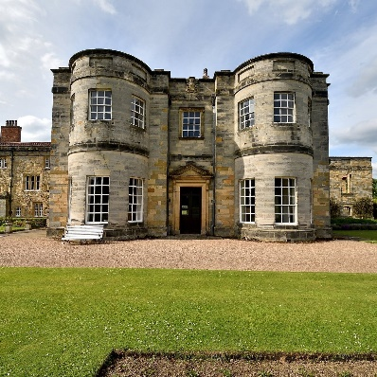
Newburgh Priory began as an Augustinian Priory and was originally founded in 1145 on land granted to Robert de Mowbray by William the Conqueror. The Mowbrays continued to support the priory, as Roger's grandson, William de Mowbray, was also a benefactor and was buried there in about 1222. Little is known of the Priory from its founding until the dissolution of the monasteries by Henry VIII in 1538 except that Margaret Tudor stayed a night there on 17th July 1503 as a guest of the prior during her progress to meet her husband James IV of Scotland.
It was sold for £1,062 by Henry VIII in 1549 to Anthony de Bellasis, a royal chaplain, and it became a home to the Bellasis family. After converting the Priory to a private residence, apart from alterations between 1720 and 1760, the priory remains very similar today to how it was in the Tudor period. The house was the home of the Bellasis family and the seat of the Earls of Fauconberg until the death of Lady Charlotte Bellayse in 1825, when the property passed to the Wombwell family via the eldest son of her sister, Sir George Wombwell, 3rd Baronet and is still in the care of her descendants. A descendant of Anthony de Bellasis, Thomas, married Oliver Cromwell's daughter, Mary, and was created Earl Fauconberg in 1689. This connection to Mary has led to the story that Newburgh Priory is the alleged final resting place for the body of Oliver Cromwell - minus his head!
In August 1658, Oliver Cromwell contracted malaria and was taken to London with the intention of living in St. James’s Palace. But he died in Whitehall on September 3rd, the anniversary of two of his greatest victories. Cromwell was then buried privately without ceremony, according to contemporary sources, in a vault at the east end of Henry VII's chapel in Westminster Abbey. According to the Directory of Publique Worship of God (which replaced the Book of Common Prayer at this period) a burial was to take place without ceremony, so this accorded with the religious feelings of Cromwell and his family. A lifelike effigy of him was placed on a magnificent hearse for the lying-in-state at Somerset House, as though he had been a king. The hearse with the effigy was taken in an elaborate procession to the Abbey on 23rd November for the state funeral service. It remained until the fall of the Protectorate and abdication of Richard Cromwell in May 1659 when it was broken up.
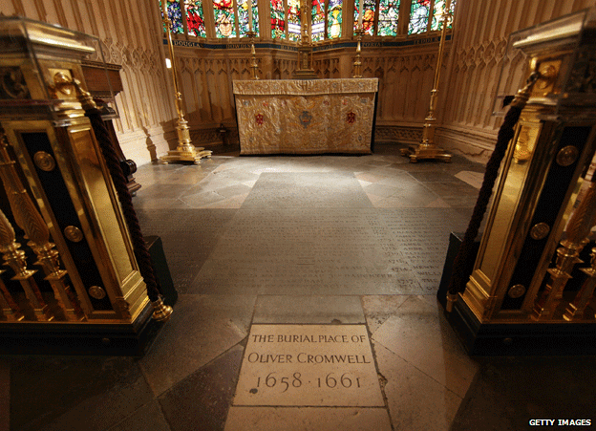
However, Cromwell did not lie in the Abbey for very long. When Charles II was restored to the throne, the House of Commons voted on 4th December 1660 that the coffins of regicides Oliver Cromwell, Henry Ireton and John Bradshaw should be dug up from the Abbey, drawn on a hurdle to Tyburn and the bodies hung up on the gallows there. So, on 26th January 1661 Cromwell and Ireton were removed and taken to the Red Lion Inn at Holborn, where they were joined a few days later by Bradshaw's coffin. On 30th January, the anniversary of the execution of Charles I, the hangings took place and then the heads were cut off and stuck on spikes outside Westminster Hall. The bodies were buried under Tyburn gallows (near the modern Marble Arch). Cromwell's head is believed to be buried at Sidney Sussex College.
Many people have questioned whether the body mutilated at Tyburn and the head seen on Westminster Hall were actually Cromwell's. These doubts arose because it was assumed that Cromwell's body was reburied in several places between his death in September 1658 and the exhumation of January 1661, in order to protect it from vengeful royalists. Various stories suggest that his bodily remains are buried in London, Cambridgeshire, Northamptonshire, or Newburgh Priory, Yorkshire each claiming that they may be the site of his burial.
The present house at Newburgh Priory was built in the late 16th century, substantially remodelled by 4th Viscount Fauconberg 1725-45 and further restored in the 1960s. The 40 acres of grounds contain a water garden, walled garden, topiary yews and woodland walks.
The house, gardens and parkland are open to the public on limited days in April, May and June and on August Bank Holiday. Full details are on the Newburgh Priory website.

Richard Byas

A Vicar was preaching on the Demon Drink, saying whiskey can kill but water can’t.
To prove it he had a glass of each. He dropped a worm into the water and it wiggled about. He dropped a worm into the whiskey, it shrivelled and died.
And what does this show us? asked the vicar.
If you’ve got worms drink whiskey came the reply from the old farmer at the back of the church.


Baldersby St. James Church
“The Average Angel” (One Woman Play) in church on Friday 28th June at 7pm for 7.30pm start. Tickets £6.00.
Junction 50 Concert. Sadly our first concert on 4th July is cancelled as it coincides with the church being used as a Voting Station for the General Election.
Book Sale on 7th & 8th September. Please leave donations of any books you spare in church. Many thanks to everyone who is donating books.

Dalton News
130 Club results for May:
£15 - Sheila Bird (No.32); £10 - Sharon Spence (No.48); £6 - Jean Brockhill (No.44).

Pop-Up Cafe
There will be a pop-up cafe in the village hall on Saturday 1st June from 9.30 til 11am. Sausage, bacon and sausage/bacon sandwiches will be on sale, as will toasted teacakes. Everyone is welcome to come along and enjoy a bite to eat and a chat with friends and neighbours.

Dalton Fest
This year’s Dalton Fest will be held on Saturday 22nd June at the village hall and the playing field. Gates open at 2pm, music starts at 4pm. The Black Bears will be headlining, along with many other bands. There will be pizzas and fish and chips on sale, along with ice cream. Picnics are welcome but no barbecues please. The bar will be open, where candy floss, sweets and novelties can also be purchased. A great day out for all the family. Tickets are available from Eleanor on 07841 036340 and are priced at £12 for adults, £6 for children (up to 16 years of age). A family ticket (2 adults and 2 children) is £28.

St. Columba’s Church, Topcliffe

St. Columba Festival Sunday 9th June
10.45am St Columba Festival Service
led by Revd Canon Steven Harvey
set to the Missa Secunda by Hans Leo Hassler (1564-1612)
followed by light refreshments in church
1.15pm Barbecue in the Churchyard with wine and soft drinks
(but please notify John Phillips 01845 577034 for catering numbers)
from 2pm Guided Tours of the Church, Church Tower and Churchyard
(We regret the church tower is not accessible to children under 10 years
due to safety hazards)
6pm Closing Service of Compline (join us for a peaceful end to the day)
Everyone is most Welcome to join us for any or all events

Invitation
As last year, all volunteers, along with all other villagers, will be most welcome to attend the village BBQ in the churchyard on the Sunday 9 June as part of the St Columba's Weekend celebrations.

PARISH DIRECTORY
The Parishes of Topcliffe, Baldersby with Dishforth and Skipton on Swale, and Dalton.
There is currently no Vicar of the parishes. Until one is appointed, please contact our Area Dean,
Rev’d Mary Rolls, mob: 07877 213327 email: revmaryrolls@gmail.com.

BALDERSBY with DISHFORTH and SKIPTON-ON-SWALE - PCC Secretary: Mrs Jennifer Wharton wharton370@btinternet.com

DALTON - PCC Secretary: Mrs Hannah Bissett tel: 07739 382831 spannerb79@gmail.com

TOPCLIFFE – PCC Secretary: Mrs Roz Norris RozNorris@aol.com

