Benefice Online Magazine

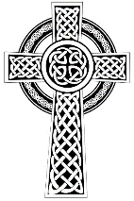
for the Parishes of Topcliffe, Baldersby with Dishforth and Skipton on Swale, and Dalton
Cross Talk
May 2024
Cross Talk is published monthly by email. To receive a copy please contact kitnorris@live.co.uk
Cross Talk contains the weekly Collect and Readings together with details of Church services in the Benefice and news and items of interest supplied by our readers. The magazine will also be available on the web sites: www.achurchnearyou.com/church/3447 and baldersbychurch.com.

CHURCH SERVICES

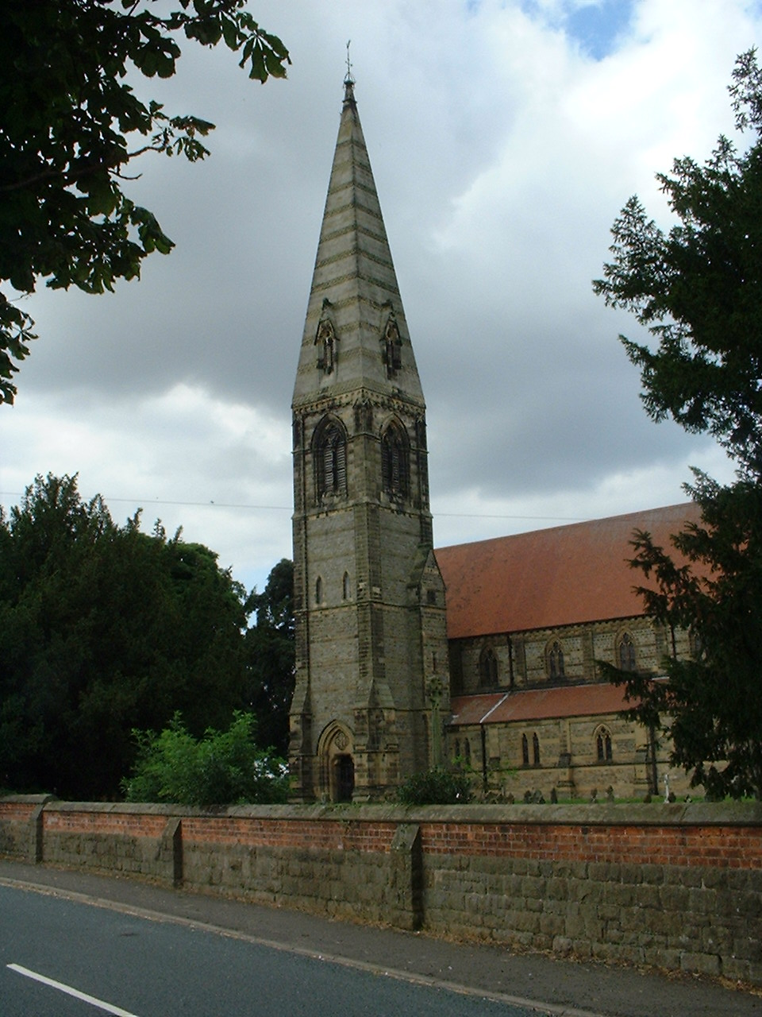
St. James’ Church, Baldersby St. James with Dishforth, Rainton
and Skipton on Swale
Sunday 5th May, 10.45am Rogation Sunday Holy Communion
followed by Bring and Share Lunch

Sunday 12th May, 9.30am Breakfast Service
join us for Coffee and Croissants

Sunday 19th May, 10.45am Holy Communion followed by Coffee

Sunday 26th May, 9.30am Morning Service followed by Coffee

St. Columba’s Church, Topcliffe
Corporate Member of the Prayer Book Society
Sunday 5th May, 6.30pm Choral Evensong
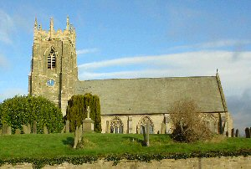
Sunday 12th May, 10.45am Holy Communion led by
Rev’d Robert Williamson
Sunday 19th May, 10.45am Sung Matins

Sunday 26th May, 10.45am Holy Communion led by Rev’d Robert Williamson

Monday 20th May at 7pm APCCM in church. All welcome.
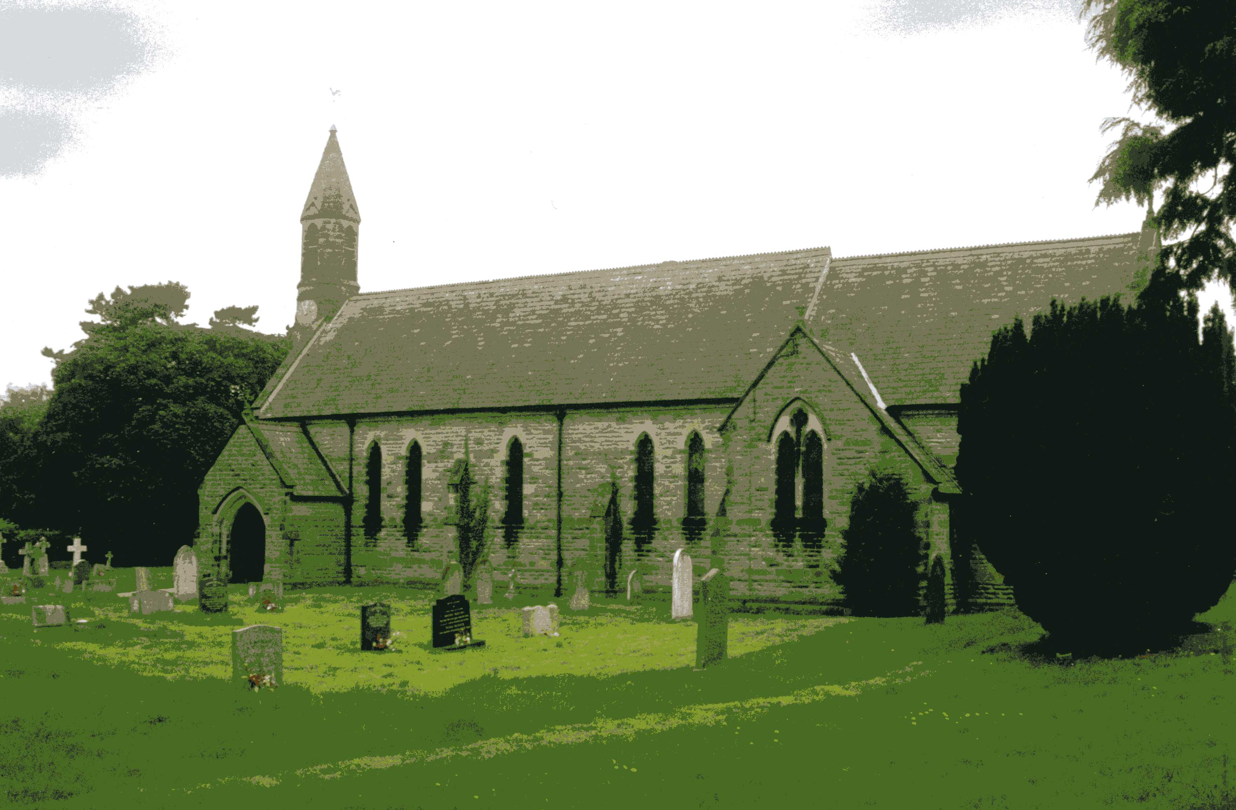
St John the Evangelist Church, Dalton
Sunday 5th May, 11am Holy Communion
Sunday 19th May, 11am Family Service

Thursday 30th May at 7pm APCCM in church.
The Annual Meetings for St John the Evangelist church.
All welcome – please come along and support our church and hear about, and be part of, plans for the future.
NEW MEMBERS
If you would like to join the PCC and help us to keep Dalton church going, then please get in touch. We are always happy to welcome new members and are a friendly bunch; please contact Hannah or Gary or come to one of our services on 1st and 3rd Sunday each month.
Hannah Bissett, Secretary spannerb79@gmail.com tel: 07739 382831
Gary Vale (Vice Chair) gary58GV@gmail.com tel: 07532 222901
Readings for the 6th Sunday of Easter (Rogation Sunday) to Trinity Sunday
(Page numbers refer to the Common Worship Lectionary.)

Sunday 5th May, The 6th Sunday of Easter (Rogation Sunday)
Collect
God our redeemer,
you have delivered us from the power of darkness
and brought us into the kingdom of your Son:
grant, that as by his death he has recalled us to life,
so by his continual presence in us he may raise us
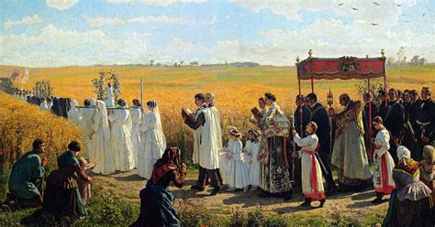
to eternal joy;
through Jesus Christ your Son our Lord,
who is alive and reigns with you,
in the unity of the Holy Spirit,
one God, now and for ever.

Readings (p549)
Acts 10.44-48
Psalm 98
1 John 5.1-6
Gospel: John 15.9-17

Thursday 9th May, Ascension Day
Collect
Grant, we pray, almighty God,
that as we believe your only-begotten Son
our Lord Jesus Christ
to have ascended into the heavens,

so we in heart and mind may also ascend
and with him continually dwell;
who is alive and reigns with you,
in the unity of the Holy Spirit,
one God, now and for ever.

Readings (p552)
Acts 1.1-11 or Daniel 7.9-14
Psalm 47 or Psalm 93
Ephesians 1.15-23 or Acts 1.1-11
Gospel: Luke 24.44-53

Sunday 12th May, The 7th Sunday of Easter (Sunday after Ascension Day)
Collect
O God the king of glory,
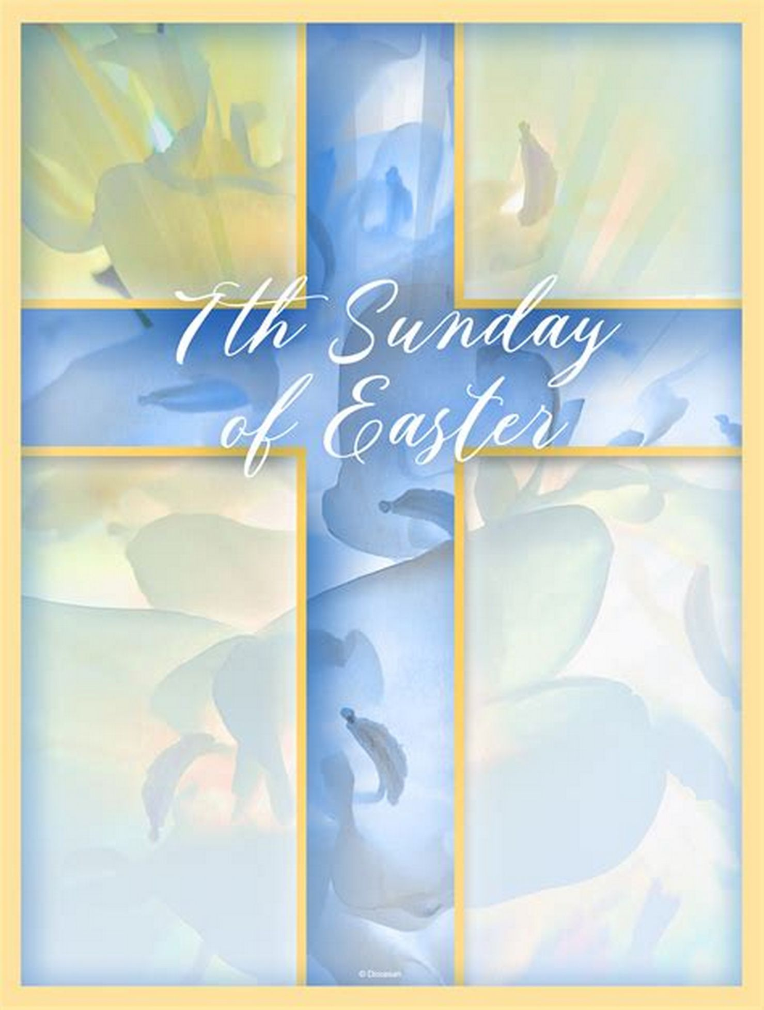
you have exalted your only Son Jesus Christ
with great triumph to your kingdom in heaven:
we beseech you, leave us not comfortless,
but send your Holy Spirit to strengthen us
and exalt us to the place
where our Saviour Christ is gone before
who is alive and reigns with you,
in the unity of the Holy Spirit,
one God, now and for ever.
Readings (p557)
Acts 1.15-17, 21-26
Psalm 1
1 John 5.9-13
Gospel: John 17.6-19

Sunday 19th May: Day of Pentecost (Whit Sunday)
Collect
God who as at this time
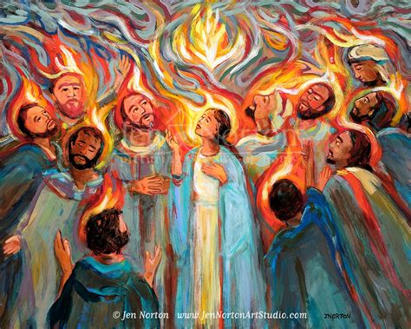
taught the hearts of your faithful people
by sending to them the light of your Holy Spirit:
grant us by the same Spirit
to have a right judgement in all things
and evermore to rejoice in his holy comfort;
through the merits of Christ Jesus our Saviour,
who is alive and reigns with you,
in the unity of the Holy Spirit,
Acts 2.1-21 or Ezekiel 37.1-14
Psalm 104.25-35, [36,] 37
one God, now and for ever.

Readings (p560)
Romans 8.22-27 or Acts 2.1-21
Gospel: John 15.26-27; 16.4b-15

Sunday 26th May : Trinity Sunday
Collect
Almighty and everlasting God,
you have given us your servants grace,
by the confession of a true faith,
to acknowledge the glory of the eternal Trinity
and in the power of the divine majesty to worship the Unity:

keep us steadfast in this faith,
that we may evermore be defended from all adversities;
through Jesus Christ your Son our Lord,
who is alive and reigns with you
in the unity of the Holy Spirit,
one God, now and for ever.

Readings (p.565)
Isaiah 6.1-8
Psalm 29
Romans 8.12-17
Gospel: John 3.1-17

Reflection May 2024
At the Passover celebration and before his crucifixion we read in John’s Gospel that Jesus told his disciples ‘If you love me, keep my commands. And I will ask the Father, and he will give you another advocate to help you and be with you forever - the Spirit of truth’.

This year we celebrate Pentecost Sunday on 19th May, and in Acts Chapter 2 we are told that the disciples of Jesus "were all together in one place" on the "day of Pentecost". They would be together because fifty days after Passover the Jews would be celebrating Shavuot (a harvest festival that is celebrated seven weeks and one day after the first day of Passover).
I wonder what the disciples would have been feeling as they met together. A lot had happened since Jesus’ crucifixion. They had just recently experienced the Ascension when Jesus had told the disciples to remain in Jerusalem and await the coming of the Holy Spirit. I like to think that they would have remembered the prayer that Jesus had taught them and would have prayed the prayer we know as The Lord’s prayer together. Maybe they saw the events of Pentecost as a working out of their prayer ‘Thy kingdom come, thy will be done’ as their wait for the promised Holy Spirit was fulfilled.
As we pray the same prayer, I wonder what each of us expects as we say the same words. Each week in Church we pray - Thy kingdom come, thy will be done. This is surely one of the riskiest prayers that we can ever pray, because it means acknowledging that we are not in charge, God is, and that maybe God has a better idea of what is good for His creation than we do. In this prayer we acknowledge that God is at the centre of creation, not us. It is therefore a prayer that has huge implications for how we live from day to day.

There is a story told that a King of Spain in the seventeenth century remarked that he hadn’t heard from one of his ambassadors in South America for two years. He said, ‘If I don’t hear from him this year, I shall write him a letter’. Clearly the role of Kings has changed a lot in the last four hundred years, but the trust placed in ambassadors to represent their government remains unchanged.

‘Thy kingdom come, thy will be done’ acknowledges that our role is not that of King, but rather that of God’s ambassador. God places his trust in each one of us to live out the Kingdom of God in our daily lives; to be those who bring justice, reconciliation and hope to our communities.
The challenge, of course, is to work out what it means to be a faithful ambassador of God. As any reading of the history of the Church will show, we don‘t get it right all of the time - or indeed most of the time! However, God doesn’t give up on us, and continues to invite us to be His ambassadors acting in His name, and learning each day what it means to live more fully as part of the Kingdom of God.
When we pray ‘Thy Kingdom come, thy will be done’, God invites us to be part of making this prayer come true in our communities. Our job as God’s ambassadors will be different for each of us and whilst our prayer reminds us that we don’t get to be King, to be God’s ambassadors in our communities is surely not a bad job title to have!
Richard Byas
The Bar Convent, York.
On 1st October 2016 the York City of Sanctuary became officially recognised as part of the National group of Cities of Sanctuary. In the twentieth century York provided help to many refugees fleeing persecution in their own countries:
In the late 1930’s the York Refugee Committee found work, housing, and school places for dozens of Jewish families fleeing persecution in Europe.
In the 1970’s and 1980’s, a small number of Asian families expelled from Kenya and Uganda found refuge in York. Many now play a significant part in the local business and commercial world.
In the 1990’s, York provided accommodation for refugees from the atrocities unfolding in Bosnia and the surrounding Balkan States.
However, in years gone by, York was noted more for intolerance. From the massacre of the Jewish population in 1190 (driven by religious intolerance and the greed of those who owed the leading Jewish money-lenders money) to the persecution of Catholics in later centuries. The persecution of Catholics led to the death of Margaret Clitherow on 25th March 1586. She was pressed to death for refusing to enter a plea to the charge of harbouring Catholic priests. Her house and shrine, now open to the public, is located on the Shambles. The campaign against Catholics continued over the next hundred years and it was in 1686 that a woman going by the name of Mrs Long bought a house on Blossom Street, just outside Micklegate Bar in York. To the outside world, Mrs Long and her simply dressed companions were widows who kept to themselves. To those in the know, Mrs Long's real name was Mother Bedingfield - and she had just founded an illegal Catholic convent.
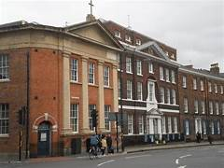
At a time when the Catholic faith was still punishable by death, Mother Bedingfield risked her life by operating a secret school for girls. It is the oldest surviving Catholic convent in the British Isles. The laws of England at this time prohibited the foundation of Catholic convents and as a result of this, the convent was both established and operated in secret.
The nuns continued to maintain a school on the site until 1985, when control was handed over to the Middlesbrough diocese and it was renamed as All Saints School.
By December 1768, eighty years after its foundation, the property was completely rebuilt and the then Mother Superior, Mother Aspinal, presided over the construction of what is described in the building licence as, ‘A new front wall to her house’. What Mother Aspinal built was an entire extra level to the house, a Georgian Facade that added an extra set of rooms to the front of the property.
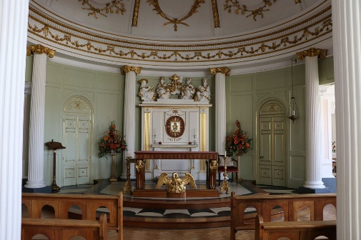
The most significant addition to the new Convent was a Chapel. Mother Aspinal initially wanted the design to reflect Roman churches and hired Thomas Atkinson, the architect responsible for the Neo Gothic additions to Bishopthorpe Palace to do the work. However, due to the continuing hostility to Catholicism, Atkinson took the decision to modify the initial design, incorporating it into the structure of the house itself.
Instead of the dome Mother Aspinal intended, the dome was concealed beneath a slate roof, meaning it was hidden from the street. Atkinson also built eight different escape routes from the Chapel to ensure that, if the building was stormed, the worshippers would be able to escape. The Chapel was completed in 1769.
The passing of the First Catholic Repeal Act in 1778 made life easier for the Convent as it allowed them to practise their faith and run the school legally. This led to a new climate of religious freedom within Britain that allowed the nuns to wear their religious habit for the first time since the creation of the Convent. The passing of the Roman Catholic Relief Act 1791 in turn led to the Bar Convent being granted a licence to act as a public place of worship for the first time in its history.
Today the Bar Convent is open to the public and attracts visitors from all over the world. In addition to exhibits detailing the history of the convent, the chapel is also open, and the convent also has an excellent café to delight weary visitors.
Richard Byas

For the first time, a little boy in church watched as the sides people passed around the offertory plates.
When they came near his pew, the boy said loudly,
“Don’t pay for me, Daddy; I’m under five


Baldersby St. James Church
Drop in and Chat Every Tuesday from 10.00am to 12.00am in Church.
Rogation Sunday 5th May at 10.45am
Rogation Sunday is a traditional service devoted to asking for God’s blessing on agriculture, especially all who work on the land and sea, and to grant us a good harvest. To mark this special Sunday Service we are having our popular “Bring and Share Lunch”.

Events in Church during May
Wednesday 8th May – Music and Drama from 6.30 to 8.30pm
Wednesday 22nd May – Music and Drama from 6.30 to 8.30pm

Friday 10th May – COUNTRY AND WESTERN with Cathy Ryan, who entertained us all with her 40’s music last year, which was great fun. 7.00pm for 7.30pm. Tickets - £6.00. Refreshments and Raffle. All Welcome.

Wednesday 15th May – TEA DANCE from 2pm to 4pm

GOOD NEWS
Our new central heating boilers are now installed in church along with the extra radiators that were put in church last year. Our last boiler lasted over 60 years, but for the last few years it was very unreliable and frustrating. So we are all thrilled and amazed that we have achieved this. As we have services every week and lots of other events it is a great relief not to worry about how our old boiler was feeling!

Dalton News
Domino Drive
There will be a Domino Drive in the village hall on Saturday 26th May at 7pm. There will be tea and biscuits in the interval and also a raffle. Everyone welcome.

Jumble Sale
A jumble sale will be held in the village hall on Saturday 11th May from 10am until 1pm. Come along and bag a bargain! There will also be tea, coffee and cake on sale and a tombola. Proceeds to the village hall.

St. Columba’s Church, Topcliffe
St Columba's churchyard maintenance
Volunteers are being sought to help get St Columba’s churchyard into shape for summer. The first working party will meet up on Saturday 4 May starting at 9.30 through to about 12.30pm. Then on the following Saturdays in May, weather permitting.
Volunteers don’t have to be there for the whole time: they can simply pop along and do what they can to give their support. There’ll be some tools and lawnmowers available, but if people can bring whatever they might have to help - rakes, trowels, spades, forks, extra mowers etc. - that would be wonderful. Refreshments will be served.
Village BBQ
As last year, all volunteers, along with all other villagers, will be welcome to attend the village BBQ in the churchyard on the Sunday 9 June as part of the St Columba's Weekend celebrations.

Annual Parochial Church Council Meeting on 20th May 2024
The meeting is open to members of the Church of England and other Anglican churches on the Electoral Roll. Being on the church electoral roll provides the opportunity to select who runs the church and how it functions by voting in the Annual Parochial Church Council Meeting, which this year will be held on Monday 20th May at 7pm.

Church Electoral Roll
Application for enrolment on St Columba’s church electoral roll can be made to Kit Norris, Electoral Roll Officer, kitnorris@live.co.uk [Cote House, Burrill, Bedale, DL8 1TR], by 5th May, 2024. Membership on the Roll allows one to participate in the meeting on 20th May 2024. Application forms are available in church or from Kit Norris.

Topcliffe Academy Newsletter
Please see the attached file – 26.04.24 Newsletter.pdf

Rainton Garden Club
Our friendly gardening club has started its new season. Anyone wishing to join can do so in May for £25. Everyone is welcome. Meet at Rainton Village Hall at 7.30pm

Calendar of Events March 2024 to February 2025
Tuesday 19th March – Talk given by Faith Douglas, Curator at Thorp Perrow Arboretum
Tuesday 16th April – Talk given by Peter Williams – Wonderful Weeds
Tuesday 21st May – Visit to Cliff Bank Nursery, hosted by Ben Preston
Tuesday 18th June – Visit to ‘Sasha in the Garden’, York
Tuesday 16th July – Visit to Birstwith Hall, hosted by Lady Aykroyd
Tuesday 13th August – A late afternoon visit to RHS Harlow Carr
Tuesday 20th August – A visit to Ouseburn Flower Farm
Saturday 24th August - Rainton Village Produce Show
Tuesday 17th September – Talk given by Ben Braithwaites of Braithwaites Garden Centre
Tuesday 15th October – Talk given by Peter and Helleentje Walker from Wacks
Wicked Plants
Tuesday 19th November – Talk given by Louise Wickham from the Yorkshire Garden
Trust - Georgian Gardens - Studley Royal and Hackfall: their influence on 18th
century garden design
Tuesday 17th December – Gardening Club Christmas Social 2025
Tuesday 21st January – Talk given by Barrie Roberts from the Alpine Garden Society
Tuesday 18th February – Talk given by Michael Myers

Any queries please contact Sue Squelch, Rainton, Coordinator: suesquelch4@gmail.com 07851 169 858

PARISH DIRECTORY
The Parishes of Topcliffe, Baldersby with Dishforth and Skipton on Swale, and Dalton.
There is currently no Vicar of the parishes. Until one is appointed, please contact our Area Dean,
Rev’d Mary Rolls, tel: 01845 400480 email: revmaryrolls@gmail.com.

BALDERSBY with DISHFORTH and SKIPTON-ON-SWALE - PCC Secretary: Mrs Jennifer Wharton wharton370@btinternet.com

DALTON - PCC Secretary: Mrs Hannah Bissett tel: 07739 382831 spannerb79@gmail.com

TOPCLIFFE – PCC Secretary: Mrs Roz Norris RozNorris@aol.com

