Benefice Online Magazine


for the Parishes of Topcliffe, Baldersby with Dishforth and Skipton on Swale, and Dalton
Cross Talk
March 2024
Cross Talk is published monthly by email. To receive a copy please contact kitnorris@live.co.uk
Cross Talk contains the weekly Collect and Readings together with details of Church services in the Benefice and news and items of interest supplied by our readers. The magazine will also be available on the web sites: www.achurchnearyou.com/church/3447 and baldersbychurch.com.

CHURCH SERVICES


St. James’ Church, Baldersby St. James with Dishforth, Rainton
and Skipton on Swale
Sunday 3rd March, 10.45am Holy Communion refreshments

Wednesday 6th March, 7.00pm Compline

Sunday 10th March, 9.30am Mothering Sunday Breakfast
Service. Posies and candles.

Wednesday 13th March, 7.00pm Compline

Sunday 17th March, 10.45am Holy Communion
followed by refreshments
Sunday 24th March, 9.30am Morning Service followed by refreshments

Sunday 31st March, 9.30am Easter Sunday Communion Service
followed by refreshments

St. Columba’s Church, Topcliffe
Corporate Member of the Prayer Book Society
Sunday 3rd March, 6.30pm Choral Evensong
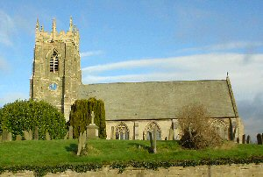
Wednesday 6th March, 7pm Lent Compline

Sunday 10th March, 10.45am Mothering Sunday
Holy Communion led by
Rev’d Robert Williamson
Wednesday 13th March, 7pm Lent Compline

Sunday 17th March, 10.45am Sung Matins

Wednesday 20th March, 7pm Lent Compline

Sunday 24th March, 10.45am Holy Communion led by
Rev’d Robert Williamson
Wednesday 27th March, 7pm Lent Compline

Saturday 30th March, 7pm Easter Eve Service

refreshments after the morning services

St John the Evangelist Church, Dalton

Sunday 3rd March, 11am Family Service
Sunday 17th March, 11am Holy Communion

Sunday 31st March, 11am Easter Day Service

Village News see page 8.

Readings for the 3rd Sunday of Lent to Easter Day
(Page numbers refer to the Common Worship Lectionary.)

Sunday 3rd March, The 3rd Sunday of Lent
Collect
Almighty God,
whose most dear Son went not up to joy
but first he suffered pain,
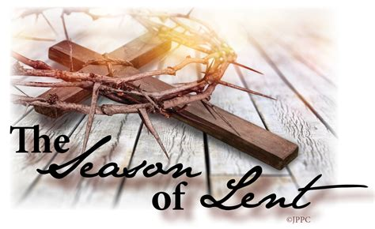
and entered not into glory before he was crucified:
mercifully grant that we, walking in the way of the cross,
may find it none other than the way of life and peace;
through Jesus Christ your Son our Lord,
who is alive and reigns with you,
in the unity of the Holy Spirit,
one God, now and for ever.

Readings (p464)
Exodus 20.1-17
Psalm 19.[1-6,] 7-14
1 Corinthians 1.18-25
Gospel: John 2.13-22

Sunday 10th March, Mothering Sunday
Collect
God of compassion,
whose Son Jesus Christ, the child of Mary,
shared the life of a home in Nazareth,
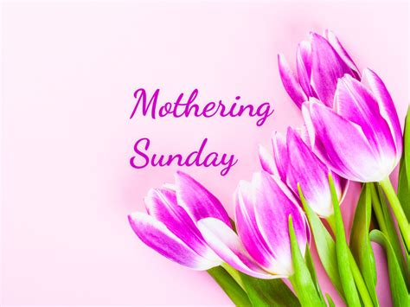
and on the cross drew the whole human family to himself:
strengthen us in our daily living
that in joy and in sorrow
we may know the power of your presence
to bind together and to heal;
through Jesus Christ your Son our Lord,
who is alive and reigns with you,
in the unity of the Holy Spirit,
one God, now and for ever.

Readings (p470)
Exodus 2.1-10 or 1 Samuel 1.20-28
Psalm 34.11-20 or Psalm 127.1-5
2 Corinthians 1.3-7 or Colossians 3.12-17
Gospel: Luke 2.33-35 or John 19.25b-27

Sunday 17th March: 5th Sunday of Lent
Collect
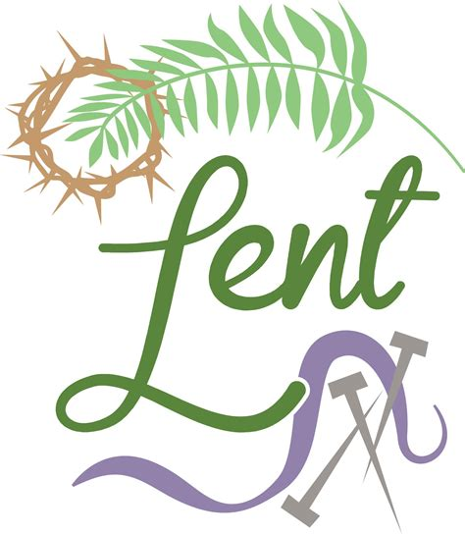
Most merciful God,
who by the death and resurrection of your Son Jesus Christ
delivered and saved the world:
grant that by faith in him who suffered on the cross
we may triumph in the power of his victory;
through Jesus Christ your Son our Lord,
who is alive and reigns with you,
in the unity of the Holy Spirit,
one God, now and for ever.

Readings (p474)
Jeremiah 31.31-34
Psalm 51.1-13 or Psalm 119.9-16
Hebrews 5.5-10
Gospel: John 12.20-33

Sunday 24th March : Palm Sunday
Collect
Almighty and everlasting God,
who in your tender love towards the human race
sent your Son our Saviour Jesus Christ

to take upon him our flesh
and to suffer death upon the cross:
grant that we may follow the example
of his patience and humility,
and also be made partakers of his resurrection;
through Jesus Christ your Son our Lord,
who is alive and reigns with you
in the unity of the Holy Spirit,
one God, now and for ever.

Readings (p.477)
Isaiah 50.4-9a
Psalm 31.9-16, [17-18] or Psalm 118.[1-2,] 19-24
Philippians 2.5-11
Gospel: Mark 11.1-11 or John 12.12-16

Friday 29th March : Good Friday
Collect
Almighty Father,
look with mercy on this your family
for which our Lord Jesus Christ
was content to be betrayed
and given up into the hands of sinners
and to suffer death upon the cross;
who is alive and glorified
with you and the Holy Spirit,
one God, now and for ever.

Readings (p502)

Isaiah 52.13-53.1
Psalm 22.1-11 or 1-20
Hebrews 10.16-25 or Hebrews 4.14-16; 5.7-9
Gospel: John 18.1-19.42

Saturday 30th March : Easter Eve
that we who are baptized into the death
of your Son our Saviour Jesus Christ
may continually put to death our evil desires
and be buried with him;
and that through the grave and gate of death
we may pass to our joyful resurrection:
through his merits, who died and was buried
and rose again for us,
your Son Jesus Christ our Lord.

Readings (p.510)
Job 14.1-14 or Lamentations 3.1-9
Psalm 31.1-4, 15-16 or Psalm 34.1-5
1 Peter 4.1-8
Gospel: Matthew 27.57-66 or John 19.38-42

Saturday 30th March : Easter Vigil
Collect as for Easter Day
Readings (p514)
A minimum of three Old Testament readings should be chosen. The reading from Exodus 14.10-31; 15.20-21, along with its associated Canticle (Exodus 15.1b-13, 17-18), the reading from Romans 6.3-11, Psalm 114, and the Gospel (Mark 16.1-8) should always be used.

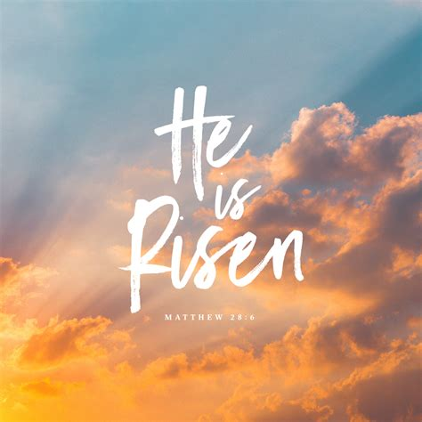
Sunday 31st March : Easter Day
Collect
Lord of all life and power,
who through the mighty resurrection of your Son
overcame the old order of sin and death
to make all things new in him:
grant that we, being dead to sin
and alive to you in Jesus Christ,
may reign with him in glory;
to whom with you and the Holy Spirit
be praise and honour, glory and might,
now and in all eternity.

Readings (p.533)
Acts 10.34-43 or Isaiah 25.6-9
Psalm 118.[1-2,] 14-24
1 Corinthians 15.1-11 or Acts 10.34-43
Gospel: John 20.1-18 or Mark 16.1-8
Reflection March 2024

Mothering Sunday, the fourth Sunday in Lent this year falls on 10th March, and it has traditionally been a time for a momentary celebration during the period of Lent. In bygone days it was also known as Refreshment Sunday, Mid-Lent Sunday or Laetare Sunday, a medieval term which referred to the introit at the beginning of the Mass which included the words ‘Rejoice ye with Jerusalem’ which suggested that worshippers could temporarily relax their penitential disciples in anticipation of the celebrations of Jesus entering Jerusalem.
Traditionally on this day worshippers would do three things:
they would perhaps visit their local cathedral as the mother church of their diocese from which their parish was a growing child, they would visit their own mother on this day and take her flowers and gifts, and they would remember the words of the traditional epistle, Galatians 4:26 which talks of the heavenly Jerusalem which is free and is taken figuratively as our mother.
All of these facets give a cause for celebration, for kindness and tenderness in the past and the anticipation of future joy, kindness and pleasure – ‘for a mother’s work is never done.’ Mothering Sunday stands out as the one day in Lent, which embraces the celebratory rejoicing of Easter Day.
The church calls it Mothering Sunday, the secular world calls it Mother’s Day and I think the secular ‘Mother’s Day’ tag is rather limiting because we’re encouraged to concentrate only on one person with cards, flowers and gifts. If you’re a mum, you’re in and if not you’re out. That is increasingly the view of the secular material world with the adverts all wanting us to buy into this mythical happy family of Mum, Dad and 2.5 children, all heavily into encouraging us to buy whatever they want to sell.
In addition, the in / out implication of Mother’s Day may be distressing for many people. We are only too aware of those who do not have children, the hurt of couples who would have loved to have children but for whatever reason could not; those who are single without children, the divorced who may have difficult access problems with their children, the lone dads doing their best to be both Mum and Dad, the children who have lost their Mum and the Mums who have lost their children. Whatever the message from society, the church will not be ignoring all these people on Mothering Sunday. We need to remember that many people will have a real feeling of loss or emptiness as they watch the many adverts depicting mothers and children.
The church’s preference for ‘Mothering Sunday’ implies, I think a far more inclusive approach, allowing for the possibility that mothering may be – and frequently is - more than simply a biological relationship. Mothering, in a loving, caring, nurturing sense is something all Christians should be doing.
‘Mothering’ is part of the verb ‘to mother’ and the reason that servants were allowed home all those years ago, was so that each family group could attend their local mother church, to pray for it and to celebrate its role in the benefice and diocese. The role of the church, after its primary function of worshipping God, is the cure or care of all those within its boundaries. And in doing this, the church, hopefully, does its best to reflect the love of God, the Father, in sending Jesus his Son for the redemption of the world.
The most obvious mother in the Bible is Mary the mother of Jesus. In reality of course we know very little about Mary; she's mentioned by name less than 20 times in the entire Bible. We can deduce though that being the mother of God's Son was very testing and that Mary, like Hannah centuries before her with her longed-for son Samuel, trustingly committed her Son into God’s hands.

In Luke’s Gospel, we read that when Mary brought her infant son to be presented in the Temple, she was warned that a sword would pierce her soul. Mothering is frequently painful; it demands sacrificial love and both Mary and Hannah show by their examples that mothering at its best should not be smothering. In order to allow others to achieve their potential in life, to fulfil their own calling under God, we eventually have to let them go. We may have to abandon our cherished ambitions for them and our own ideas about how others’ lives will unfold. They, and their values may not be quite the mirrors of ourselves that we had hoped for.
The second model of motherhood we’re offered as Christians is that of the mother church, which is defined in the Oxford Dictionary as “The Church, considered as a mother in its functions of nourishing and protecting the believer”. To understand the church as mother is to reinvent our whole idea of family, because the church consists of that wonderful variety of people who hold in common their worship of God the Father, through his only Son, in the power of the Holy Spirit. At its best, the church as mother offers the hope that nurture, compassion and loving acceptance are not the exclusive domain of one gender or one age group or one culture.

At its best, the model of the church as mother ensures that no one is excluded from the task of making disciples, because we’re all called to use our gifts to enable the flourishing of those who are our future. But as we all know this idealised concept of church as the perfect example of nurture is far from the truth. We fail because we find it unpalatable to let go of our conviction that we hold the monopoly over truth. We obsess destructively about numbers, decline, sexuality, and relationships.
So what should Mothering Sunday mean to us today?
We are Christ’s hands and feet here on earth. We are the church, the church is not the building however beautiful it may look in the bright spring sunlight.
We may at times despair of our material, celebrity loving society, but we can all do our bit to mother those around us who need our time and attention and in this overfed society, we can buy a little extra food to go in the Foodbank to meet others’ needs.
It is so easy to be busy, self-centred and forget others.
Whether we have children or not, let us make this Mothering Sunday a time of renewing our mothering skills when we can try to emulate the mothering love of God and go out to reflect it in our community. Pastoral care is not the sole province of clergy. Our mothering may be but a pale reflection of God’s love for his world, but we can all do our best.
Richard Byas

The Battle of Towton
On 29th March 1461 – Palm Sunday - the armies of two disputing Kings of England, Henry VI of the House of Lancaster and Edward IV of the House of York, fought all day on a plateau of land situated between South Milford to the south and Tadcaster to the north. It is likely that up to seventy-five thousand men fought and as many as twenty-eight thousand died in the battle itself and in the rout and massacres that followed.
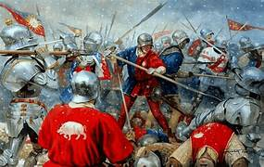
The weather that day was atrocious with howling wind, driving sleet and snow. The magnitude of the battle was reflected by the proportion of the population involved: Professor Charles Ross has estimated that of all Englishmen and Welshmen eligible to fight (those aged between sixteen and sixty) one-tenth were present on the battlefield.
The background to the battle was that it was the bloody culmination of a campaign of seven military engagements over the preceding eighteen months and the final and decisive battle in the first of a series of English civil wars, collectively known as the Wars of the Roses, that took place between 1455 and 1487. The Lancastrians had failed to seize London after their victory at the Second Battle of St. Albans on February 17th 1461, and were forced to retreat before the converging armies of Edward and Richard Neville, the earl of Warwick. The Yorkists swiftly pursued them, crossed the River Aire on March 28th, and attacked the following day. The two sides had been battling for 10 hours in a raging snowstorm when the arrival of fresh troops under John Mowbray, 3rd Duke of Norfolk, broke the Lancastrians’ morale and dispersed their ranks. The fugitives were slaughtered mercilessly by the pursuing Yorkists. The numbers of men engaged in the battle and the numbers killed were far greater than in any other battle of the Wars of the Roses.
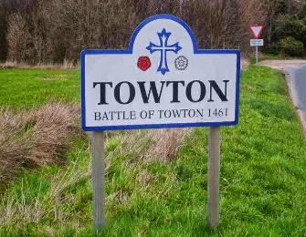
By Towton, the two armies had become regional in nature: the Lancastrians being stronger in the North, whilst the Yorkists had found it easier to recruit in the South, the West and Wales. They had one thing in common: the soldiers now demonised their opponents as alien, different, even sub-human. A struggle of factions had become a race war overlaying a civil war. Thus, when one side, finally and after many hours of fighting, broke in flight and found itself trapped on the battlefield, there was little chance of escape and none of surrender. That, taken with the killing power of the medieval longbow at the onset of the battle helps to explain such extraordinary casualty figures; it also explains the resonant names of places on the battlefield today – names such as Bloody Meadow and the Bridge of Bodies.

Today there is a walking trail that takes you through the site of what is alleged to be the largest and bloodiest battle ever fought on English soil. The history of the location lends intrigue and gravity to the wonderful views of the North Yorkshire countryside. You can learn much more about the history and see artefacts at the Visitor’s Information Centre in the grounds of the Crooked Billet pub.
In 1929, the Towton Cross was erected on the battlefield and you will see it on the trail. The walk is a signposted circuit of the battlefield beginning in Towton Village. Head west on Old London Road and then following the signs for the Towton Battlefield Trail. Follow the trail and you will come across information signs detailing the history of the land. It may be muddy this time of year so bring your walking boots!
Richard Byas

A 96-year-old mother was being interviewed about her long life and how she felt about being a mother all those years.
‘I feel just wonderful,’ was her reply. ‘For the first time since I became a mother, I no longer have to worry about my children.’
‘How is that?’
‘They’re both in nursing homes’.

Richard Byas

Dalton News
120 Club January Draw
£15 John Hall (No.54); £10 G & R Balderson (No.10); £6 Nick Atkinson (No.97).
The 6 monthly draw for February will be drawn on Saturday 3rd March. Results in the next Cross Talk.

Pop Up Cafe
There will be a pop-up cafe on Saturday 2nd March from 9.30am to 11am. Bacon or sausage sandwiches and toasted teacakes on sale, and tea or coffee. Come along and have breakfast and a chat with friends and neighbours. All welcome.

Baldersby St. James Church
Compline 6th March and 13th March at 7pm in church.

Coffee and Chat Every Tuesday from 10.00am to 12.00am in church.

Uganda. Sheilagh is collecting for her families in Uganda as she is going out to visit them this spring. This year they would like to receive -- towels, Pashmina type scarves, tablets of soap, small umbrellas, school pens, pencils etc. We would be very grateful if you would leave donations on the table at the back of church.

St. Columba’s Church, Topcliffe
Northallerton Male Voice Choir performs a concert of a wide and varied repertoire of traditional and more modern songs at St. Columba’s Church on Saturday 16th March at 7.00pm. Doors open from 6.00pm. Tickets £10 include a glass of wine or soft drink and light refreshments after the concert. (Price for children £5). All proceeds to St Columba’s Fabric Fund (building repairs). Tickets/reservations from:
John Phillips johnphillips05@gmail.com / 07831188819 or
Liz Green liz@lizgreen.me.uk

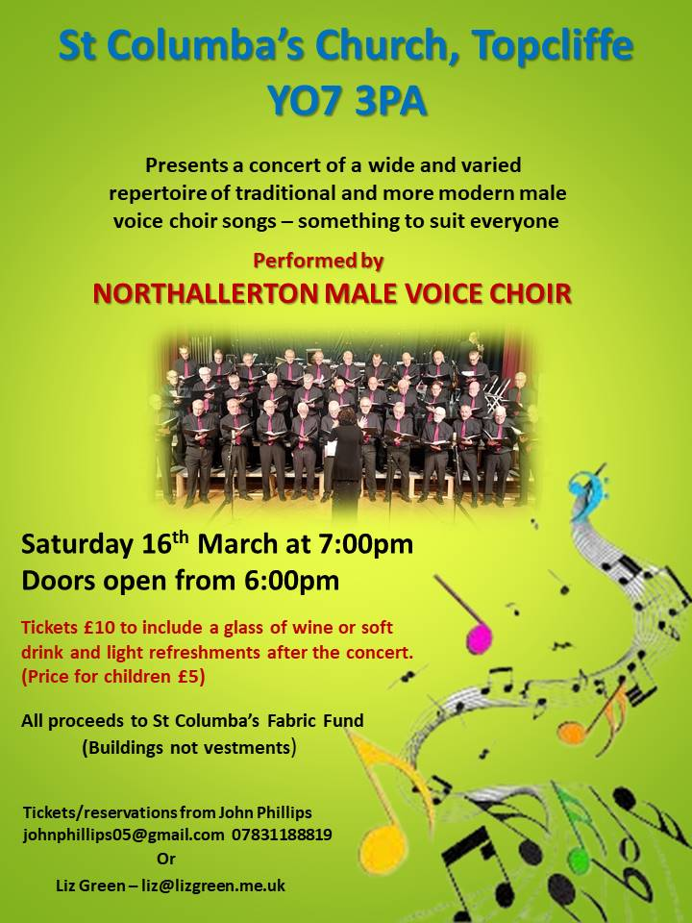

PARISH DIRECTORY
The Parishes of Topcliffe, Baldersby with Dishforth and Skipton on Swale, and Dalton.
There is currently no Vicar of the parishes. Until one is appointed, please contact our Area Dean,
Revd Mary Rolls, tel: 01845 400480 email: revmaryrolls@gmail.com.

BALDERSBY with DISHFORTH and SKIPTON-ON-SWALE - PCC Secretary: Mrs Jennifer Wharton wharton370@btinternet.com

DALTON - PCC Secretary: Mrs Hannah Bissett tel: 07739 382831 spannerb79@gmail.com

TOPCLIFFE – PCC Secretary: Mrs Roz Norris RozNorris@aol.com

