Benefice Online Magazine

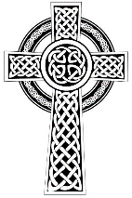
for the Parishes of Topcliffe, Baldersby with Dishforth and Skipton on Swale, and Dalton
Cross Talk
February 2024
Cross Talk is published monthly by email. To receive a copy please contact kitnorris@live.co.uk
Cross Talk contains the weekly Collect and Readings together with details of Church services in the Benefice and news and items of interest supplied by our readers. The magazine will also be available on the web sites: www.achurchnearyou.com/church/3447 and baldersbychurch.com.

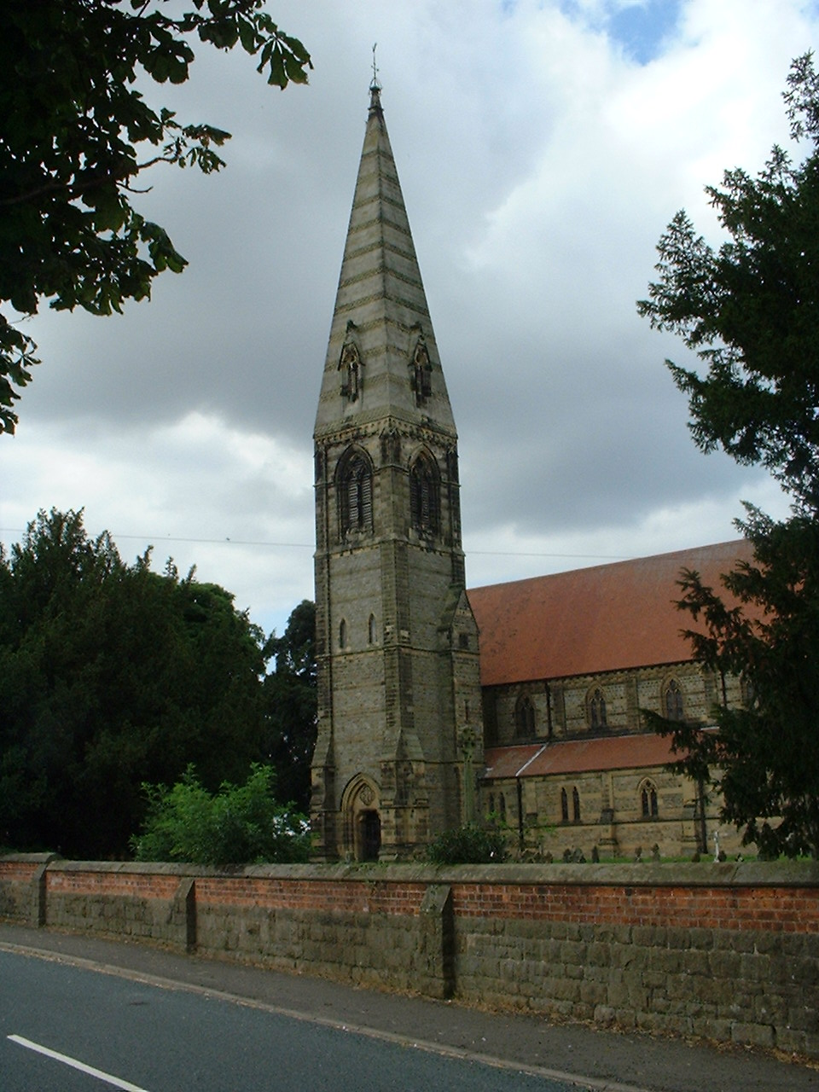
CHURCH SERVICES

St. James’ Church, Baldersby St. James with Dishforth, Rainton
and Skipton on Swale
Sunday 4th February, 10.45am Holy Communion
followed by refreshments
Sunday 11th February, 9.30am Prayer Breakfast
with Coffee and Croissants
Sunday 18th February, 10.45am Holy Communion
followed by refreshments
Sunday 25th February, 9.30am Morning Service
followed by refreshments

St. Columba’s Church, Topcliffe
Corporate Member of the Prayer Book Society
Sunday 4th February, 6.30pm Choral Evensong
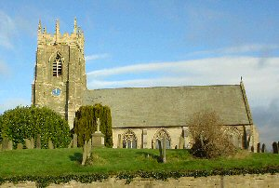
Sunday 11th January, 10.45am Holy Communion led by
Rev’d Robert Williamson
Sunday 18th February, 10.45am Sung Matins
Wednesday 21st February, 7pm Lent Compline

Sunday 25th February, 10.45am Holy Communion led by
Rev’d Robert Williamson
Wednesday 28th February, 7pm Lent Compline

refreshments after the morning services

St John the Evangelist Church, Dalton
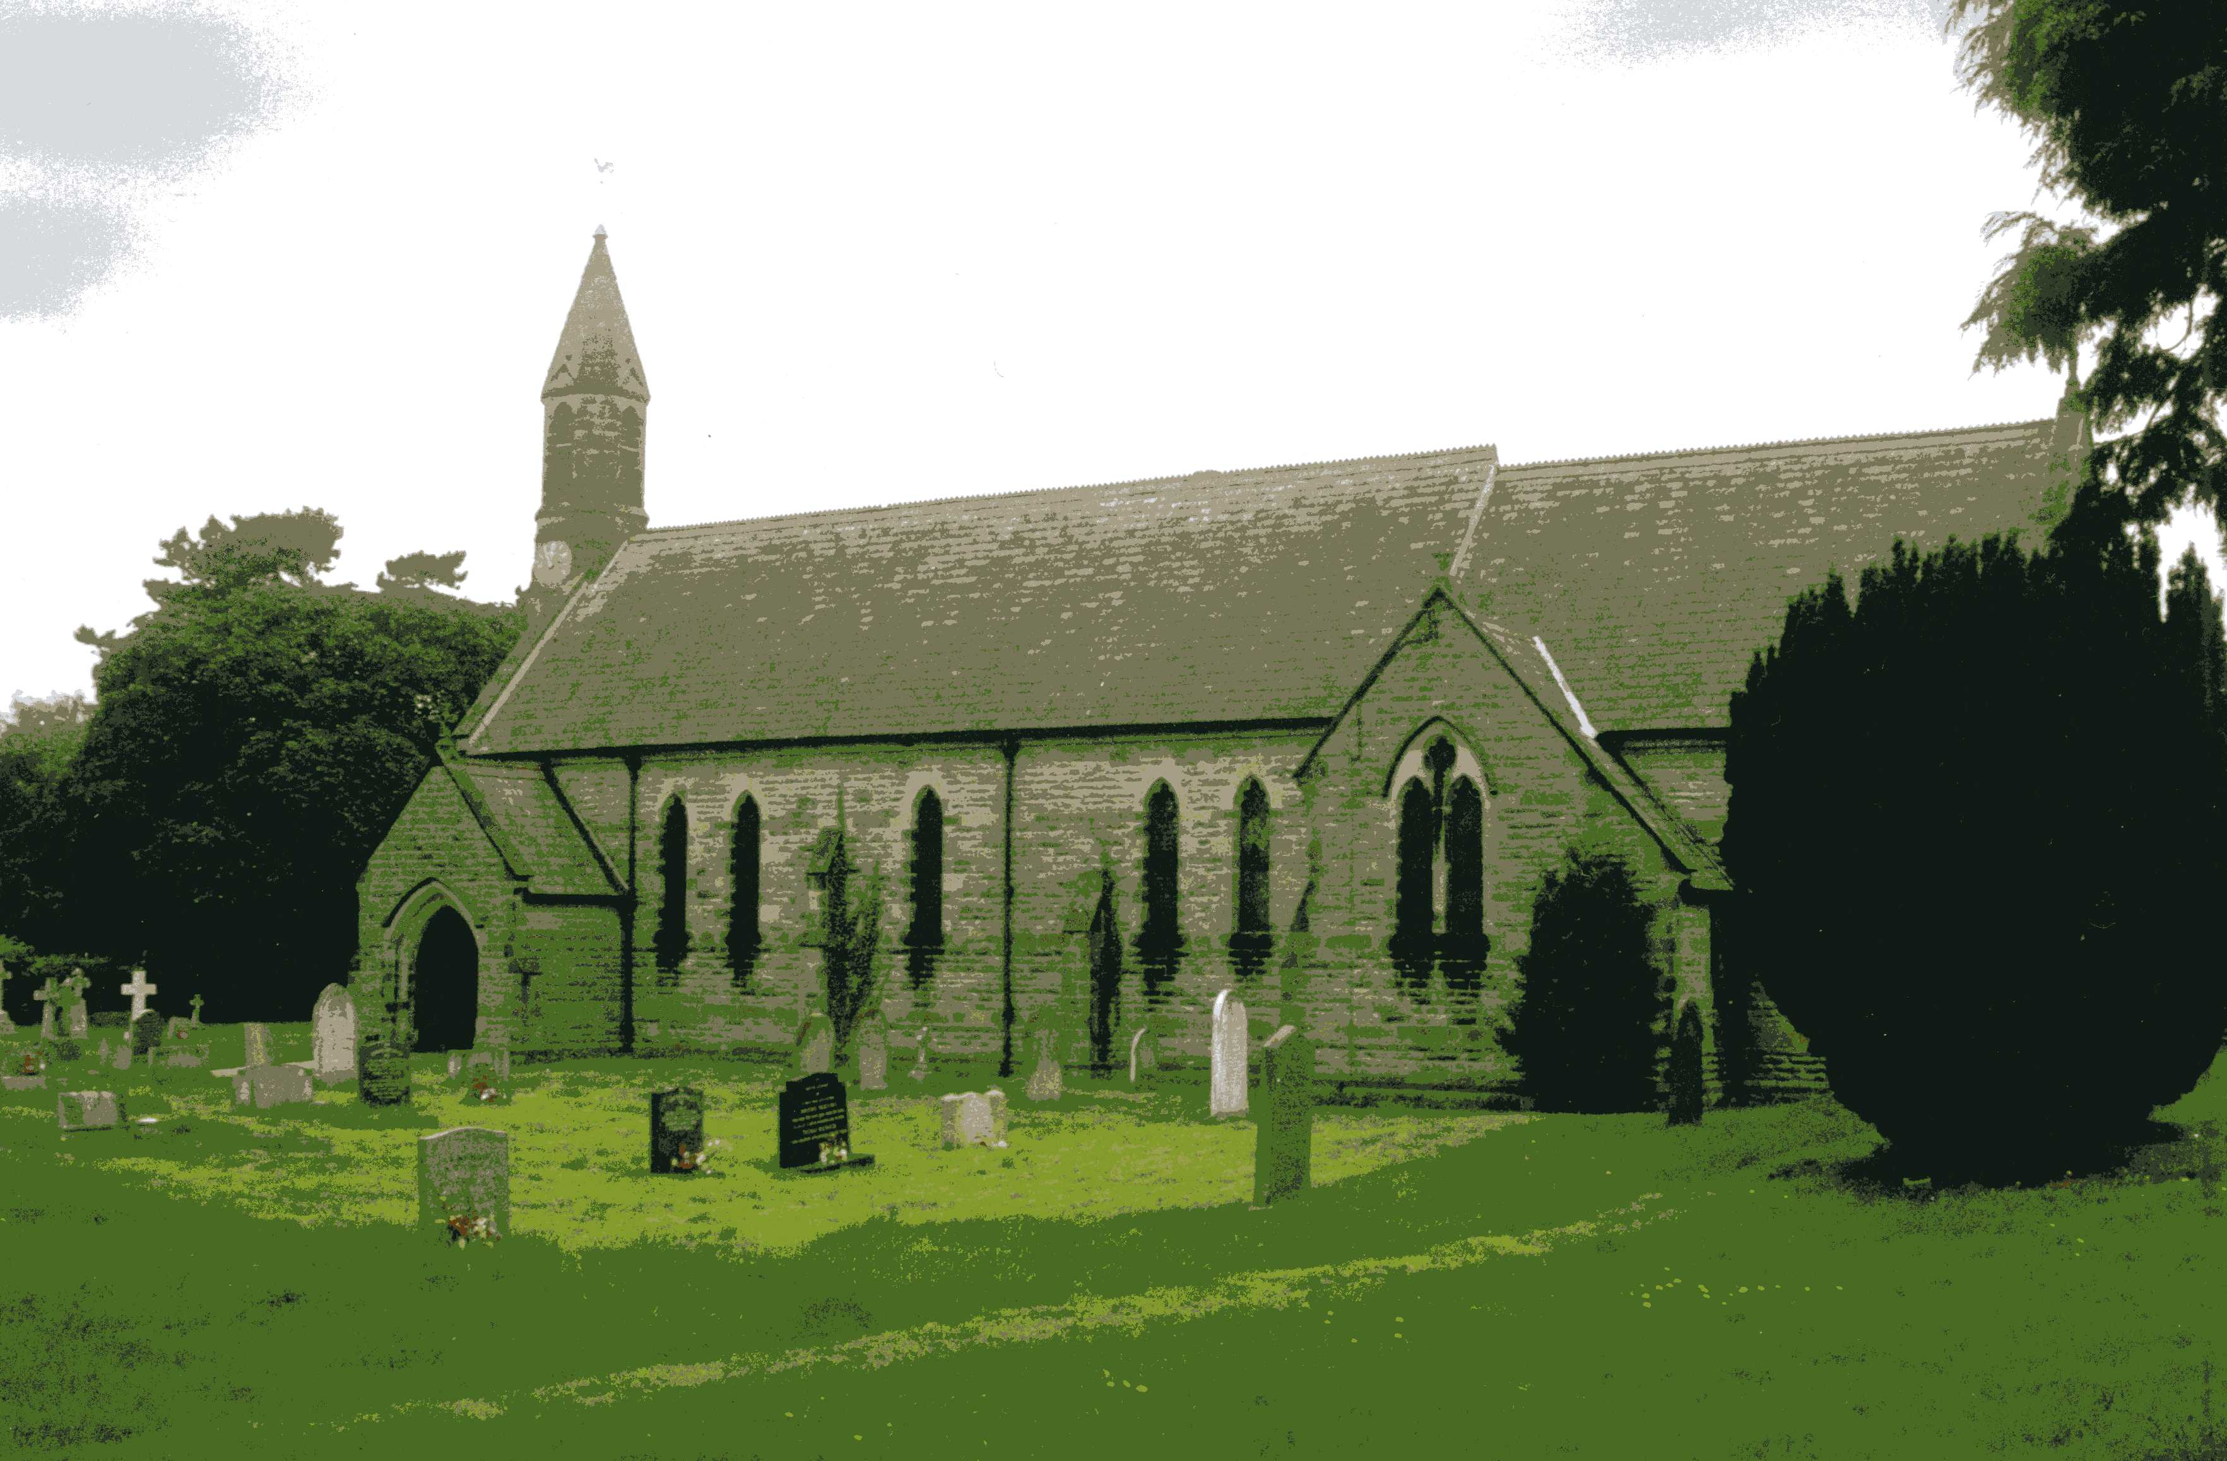
Sunday 4th February, 11am Family Service
Sunday 18th February, 11am Holy Communion

Baldersby news is listed on page 7.

Dalton social events are listed on page 7

St. Columba’s Church, Topcliffe news is listed on page 7
Readings for the Presentation of Christ (Candlemas) to 1st Sunday of Lent
(Page numbers refer to the Common Worship Lectionary.)

Friday 2nd February, The Presentation of Christ in the Temple (Candlemas)
Collect
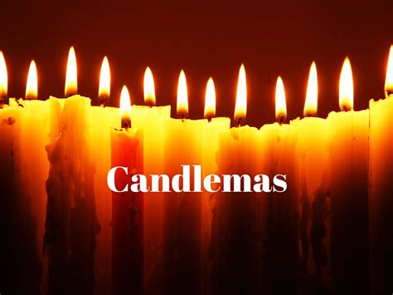
Almighty and ever-living God,
clothed in majesty,
whose beloved Son
was this day presented in the Temple,
in substance of our flesh:
grant that we may be presented to you
with pure and clean hearts,
by your Son Jesus Christ our Lord,
who is alive and reigns with you,
in the unity of the Holy Spirit,
one God, now and for ever.

Readings (p430)
Malachi 3.1-5
Psalm 24.[1-6,] 7-10
Hebrews 2.14-18
Gospel: Luke 2.22-40

Sunday 4th February, 2nd Sunday before Lent
Collect
Almighty God,
you have created the heavens and the earth
and made us in your own image:
teach us to discern your hand in all your works
and your likeness in all your children;
through Jesus Christ your Son our Lord,
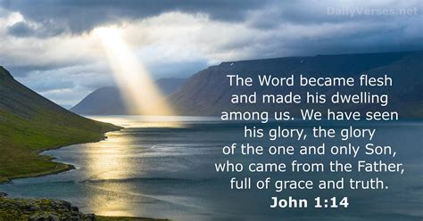
who with you and the Holy Spirit
reigns supreme over all things,
now and for ever.

Readings (p446)
Proverbs 8.1, 22-31
Psalm 104.25-37
Colossians 1.15-20
Gospel: John 1.1-14

Sunday 11th February: The Sunday next before Lent
Collect
Almighty Father,
whose Son was revealed in majesty
before he suffered death upon the cross:
give us grace to perceive his glory,
that we may be strengthened to suffer with him
and be changed into his likeness, from glory to glory;
who is alive and reigns with you,
in the unity of the Holy Spirit,
one God, now and for ever.
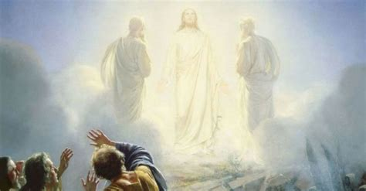
Readings (p449)
2 Kings 2.1-12
Psalm 50.1-6
2 Corinthians 4.3-6
Gospel: Mark 9.2-9

Wednesday 14th February : Ash Wednesday
Collect
Almighty and everlasting God,
you hate nothing that you have made
and forgive the sins of all those who are penitent:
create and make in us new and contrite hearts
that we, worthily lamenting our sins
and acknowledging our wretchedness,
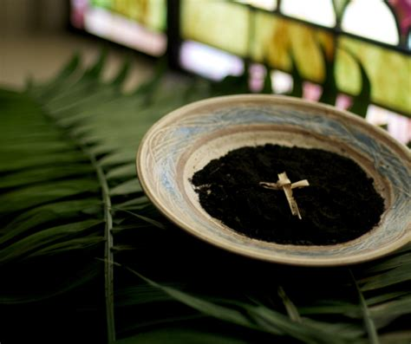
may receive from you, the God of all mercy,
perfect remission and forgiveness;
through Jesus Christ your Son our Lord,
who is alive and reigns with you
in the unity of the Holy Spirit,
one God, now and for ever.

Readings (p.452)
Joel 2.1-2, 12-17 or Isaiah 58.1-12
Psalm 51.1-18
2 Corinthians 5.20b-6.10
Gospel: Matthew 6.1-6, 16-21 or John 8.2-11

Sunday 18th February : 1st Sunday of Lent
Collect
Almighty God,
whose Son Jesus Christ fasted forty days in the wilderness,
and was tempted as we are, yet without sin:
give us grace to discipline ourselves
in obedience to your Spirit;
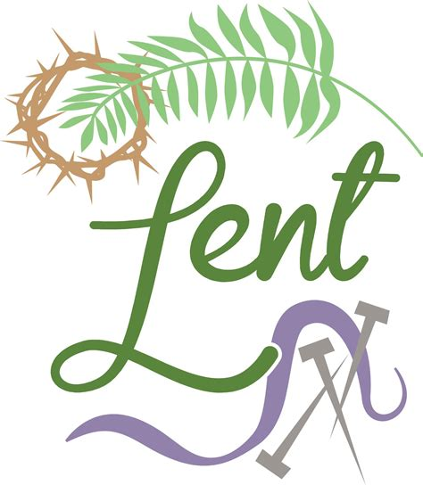
and, as you know our weakness,
so may we know your power to save;
through Jesus Christ your Son our Lord,
who is alive and reigns with you,
in the unity of the Holy Spirit,
one God, now and for ever.

Readings (p.458)
Genesis 9.8-17
Psalm 25.1-9
1 Peter 3.18-22
Gospel: Mark 1.9-15

Sunday 25th February : 2nd Sunday of Lent
Collect
Almighty God,
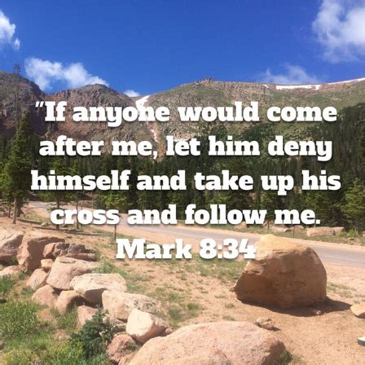
you show to those who are in error the light of your truth,
that we may return to the way of righteousness:
grant to all those who are admitted
into the fellowship of Christ’s religion,
that they may reject those things
that are contrary to their profession,
and follow all such things as are agreeable to the same;
through our Lord Jesus Christ,
who is alive and reigns with you,
in the unity of the Holy Spirit,
one God, now and for ever.

Readings (p.461)
Genesis 17.1-7, 15-16
Psalm 22.22-30
Romans 4.13-25
Gospel: Mark 8.31-38

Reflection February 2024
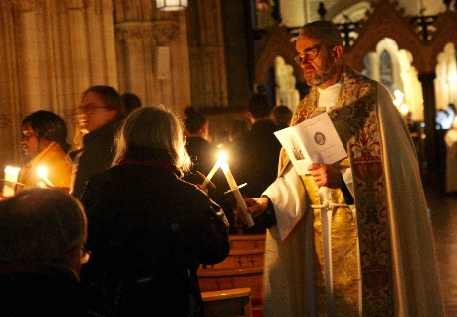
Candlemas, which is celebrated on 2nd February, used to be an important date in the Christian calendar but now is usually relegated to being celebrated on the nearest Sunday if it is celebrated at all. Officially it is the Feast of the Purification and the Presentation of Christ in the Temple. By the middle of the 5th century the custom of observing the festival with lighted candles had been introduced, and the name Candlemas developed from this custom. In the Western church, Pope Sergius I (687–701) instituted the festival in Rome.
In popular culture Candlemas was also the time when the daylength was getting noticeably longer and the days had grown light enough to do most ‘inside work’ without candles hence the rhythm ‘Candlemas Day, plant beans in the clay, put candles and candlesticks all away’.
Candles have been used in Christian religious ceremonies for centuries, and they hold a special significance in the faith. Their use dates back to the early days of Christianity when believers were forced to hold their worship services in secret to avoid persecution. During these clandestine gatherings, candles were used to light the way and symbolize the presence of God in the midst of their struggles. Over time, candles became an important part of public Christian worship services and were used to symbolize various aspects of the faith.
After Christianity became the official religion of the Roman Empire, candles continued to play a significant role in religious worship. Candles were lit during services to symbolize the presence of Christ, who is referred to as the “light of the world” and became an integral part of religious ceremonies.
By the Middle Ages, in addition to often being the only source of lighting, especially during the long, dark winter months, candles continued to be an essential in Christian worship and to mark significant events in the Christian calendar.
Until the liturgical reforms of the late 1960s, every Candlemas, Catholics around the world would bring candles to their Church to be blessed during the traditional Blessing of Candles. This all changed after Vatican II, but there are signs of the restoration of the traditional candle blessing in some churches.
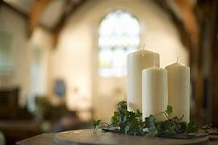
Lighting Candles in Christian Worship is a practice still prevalent today in various denominations, and it is viewed as a means of drawing closer to God. The lighting of a candle symbolizes the illumination of the Holy Spirit in one’s life and represents a prayer being lifted up to God. It is a visual reminder of Christ’s presence in the world and the hope that he brings.
Today, candles are used in various Christian ceremonies, including baptism, confirmation, and funerals, to symbolize the light of Christ and his presence in the world. The lighting of the candles on the Advent wreath is an important tradition during Advent. Each week, an additional candle is lit to symbolize the increasing anticipation and preparation for the arrival of Jesus. The light from the candles represents the light of Christ coming into the world.
Candles are not only used in churches, but many people will also use them at home as part of Christian prayer and meditation.
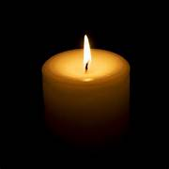
If you’re looking for ways to connect with God, a candle can be a powerful tool. Here are three ways to use candles in your spiritual practice:
Pray: Light a candle and say a prayer. Focus your thoughts and intentions on your connection with God. Ask for guidance and support.
Meditate: Sit quietly with a lit candle and meditate on a verse of scripture. Allow the flame to represent the presence of God and the light that it brings to your life.
Reflect: Use a candle as a tool for reflection. As you light the candle, think about your relationship with God and how you can strengthen it. Consider what changes you can make in your life to bring you closer to Him.
Remember, the act of lighting a candle can be a simple but meaningful way to connect with God. Use it as a reminder of the light that shines within you and the divine presence that surrounds you.
(I had hoped to find a short paragraph to remind people to be careful when using candles. If you go to www.fireservice.co.uk you will find a list of 12 Do’s and Dont’s to use candles safely. Most are very obvious suggestions but are still worth time reading.)
Richard Byas

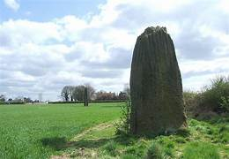
The Devil’s Arrows, Boroughbridge.
We are very fortunate in North Yorkshire to have a number of ‘Ancient Monuments’. Some are older than others and among the oldest is the ancient monument known as Devil's Arrows situated near where the A1 road crosses the River Ure at Boroughbridge and dating to the prehistoric era.
Legend states that the site's name derives from an account of the Devil trying to fire arrows at the nearby Christian settlement at Aldborough from Howe Hill, the arrows fell short and landed in a line in the field.
The stones are composed of millstone grit, the most likely source of which is Plumpton Rocks two miles south of Knaresborough and about nine miles from where the stones stand.
It is believed that the alignment originally included up to five stones that stood in a southeast to northwest alignment and dating from either the late Neolithic or early Bronze Age. One of these was situated near to the central stone and is believed to be the one recorded as standing by the antiquary John Leland in the early part of the sixteenth century. About thirty years later, the Elizabethan antiquarian and historian William Camden refers to four stones in his Britannia, which was published in 1586 in which he recorded that "one was lately pulled downe by some that hoped, though in vaine, to finde treasure." One was apparently displaced during a failed 'treasure hunt' during the eighteenth century and later used as the base for a nearby bridge over a river.
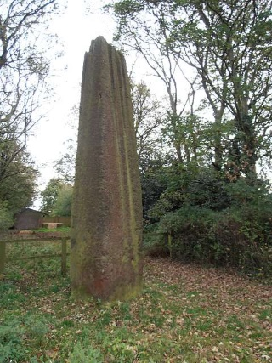
The tallest stone stands at 22 feet 6 inches high, making it the tallest menhir in Britain after the Rudston Monolith in the East Riding of Yorkshire which measures 25 feet in height. This stone stands at the southern end of the alignment and is partly hidden beneath trees and is in its own fenced enclosure on the south side of a road that leads from Boroughbridge to Roecliffe.
All three surviving stones are heavily weathered and fluted at their peaks with the northern and southern stones having various indentations which could be interpreted as being cup marks. The outer stones are 200 and 370 feet away from the central stone and form an alignment that is almost straight, running NNW-SSE. It is understood that they may have been arranged to align with the southernmost summer moonrise.
The stones are part of a wider Neolithic complex on the Ure-Swale plateau which incorporates the Thornborough Henges, which stand 10 miles to the northwest. Known as the 'The Stonehenge of the North', it is one of the most important ancient sites in Britain. It consists of an unusual prehistoric monument complex which features three aligned henges from which the site derives its name.
In common with other sites, the fair of St. Barnabas was held near the stones on Midsummer's Day until the 18th century.
The arrows can be seen from the A168 and off Roecliffe Lane leading into Boroughbridge.
Richard Byas
The teacher was walking around the classroom and observing the children while they were drawing.
Going up to one child who was drawing diligently, she asked what she was drawing. Without looking up the child replied that she was drawing God.
The teacher paused and said ‘but none of us know what God looks like!
‘No’ said the child ‘but they will when I finish this!’


Dalton News
120 Club December Draw
£15 Sandy Sanders (No.72); £10 Nigel Binks (No.50); £6 Hannah Bissett (No.4).

St John’s Winter Lunch
The Winter Lunch went very well, with everyone enjoying the new format of cottage pie and vegetables followed by lots of scrumptious desserts. The next Lunch will be in the summer. Watch out for details soon.

Band Night
There will be a band night in the village hall on 23rd February, when The Mothers will be playing. Tickets are £10, available from Eleanor on 07841 036340.

Pop Up Cafe
The next pop-up cafe will be on Saturday 2nd March from 9.30am to 11am. Everyone is welcome to come along for bacon or sausage sarnies, toasted teacakes and tea or coffee.

Baldersby St. James Church
Tuesday Coffee and Natter 10.00am to 12.00am in church.
New Boilers – We are waiting to hear from our contractors a starting date to install the two new boilers.
Our recent Plough Service and shared lunch was very popular and in particular the one furrow horse plough which was kindly lent to us. All being well we will have another service next year.

St. Columba’s Church, Topcliffe
A date for your diary. Northallerton Male Voice Choir will be performing at St. Columba’s Church on Saturday 16th March. More details in due course.

PARISH DIRECTORY
The Parishes of Topcliffe, Baldersby with Dishforth and Skipton on Swale, and Dalton.
There is currently no Vicar of the parishes. Until one is appointed, please contact our Area Dean,
Revd Mary Rolls, tel: 01845 400480 email: revmaryrolls@gmail.com.

BALDERSBY with DISHFORTH and SKIPTON-ON-SWALE - PCC Secretary: Mrs Jennifer Wharton wharton370@btinternet.com

DALTON - PCC Secretary: Mrs Hannah Bissett tel: 07739 382831 spannerb79@gmail.com

TOPCLIFFE – PCC Secretary: Mrs Roz Norris RozNorris@aol.com

