Benefice Online Magazine

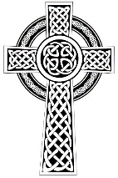
for the Parishes of Topcliffe, Baldersby with Dishforth and Skipton on Swale, and Dalton
Cross Talk
October 2023
Cross Talk is published monthly by email. To receive a copy please contact kitnorris@live.co.uk
Cross Talk contains the weekly Collect and Readings together with details of Church services in the Benefice and news and items of interest supplied by our readers. The magazine will also be available on the web sites: www.achurchnearyou.com/church/3447 and baldersbychurch.com.

CHURCH SERVICES

St. James’ Church, Baldersby St. James with Dishforth, Rainton & Skipton on Swale
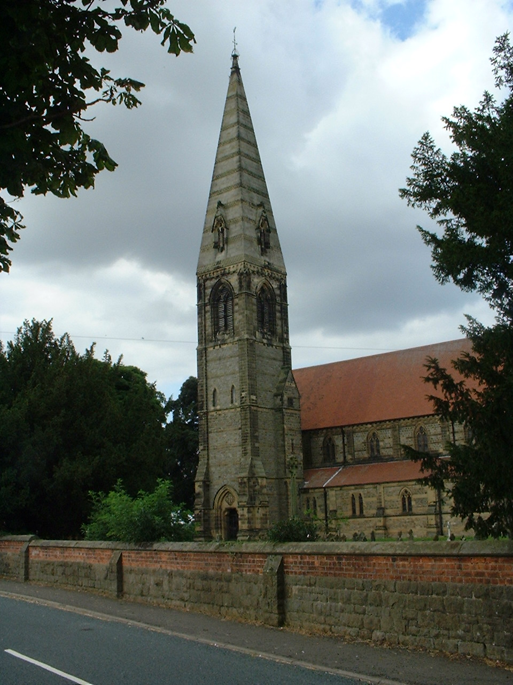
Sunday 1st October, 10.45am Harvest Festival
Sunday 8th October, 9.30am Breakfast Service – Croissants and Coffee
Sunday 15th October, 10.45am Communion Service
Sunday 22nd October, 9.30am Morning Service
Sunday 29th October, 10.45am “All Souls Service” - Communion Service
(Fifth Sunday)

St. Columba’s Church, Topcliffe
Corporate Member of the Prayer Book Society
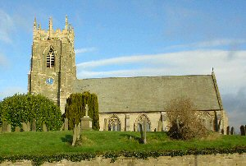
Sunday 1st October, 6.30pm Choral Evensong (BCP)
Anthem: Call to remembrance - Farrant
Sunday 8th October, 10.45am Holy Communion (Neptune Service)

Sunday 15th October, 10.45am Choral Matins (BCP)
Sunday 22nd October, 10.45am Holy Communion
6.30pm Harvest Service and bring & share supper
Sunday 29th October No Service - 5th Sunday
Thursday 2nd November 7pm All Souls Service with Requiem Mass by Victoria (1548-1611)

St John the Evangelist Church, Dalton
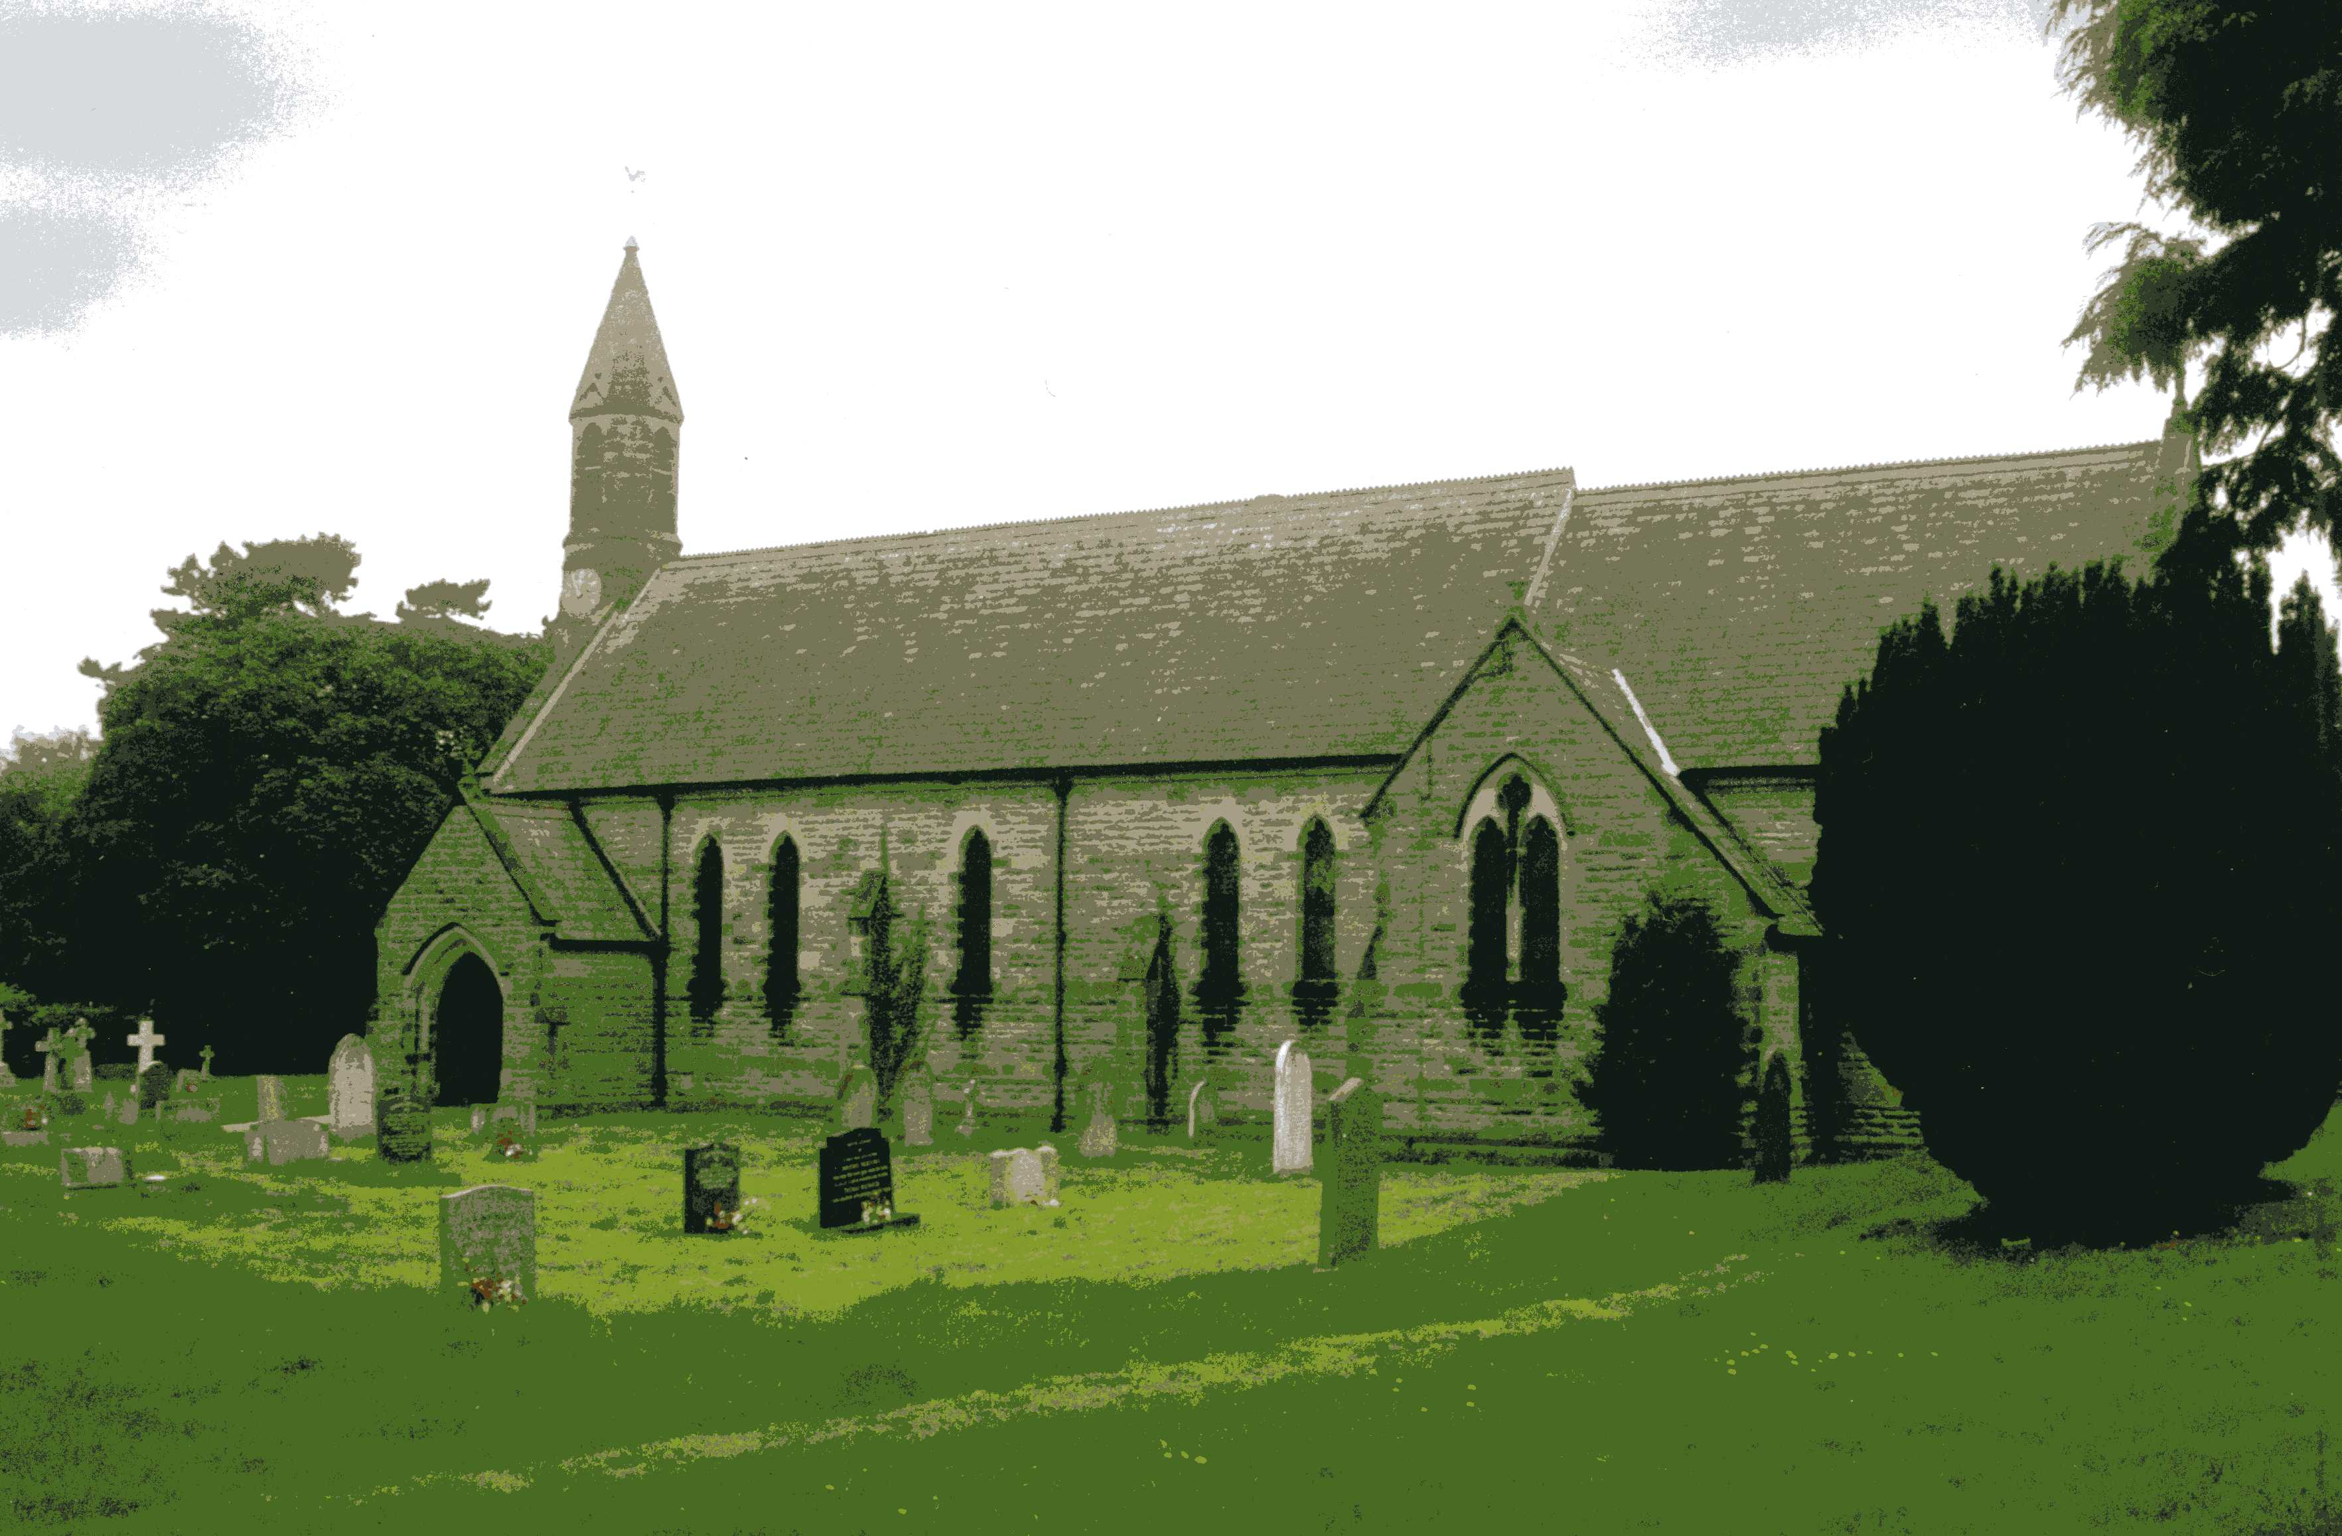
Sunday 1st October, 11am Holy Communion
Sunday 15th October, 11am Family Service

Baldersby Events see page 6

Dalton Events see page 7

Topcliffe Events, see page 6-7

Readings for the 17th Sunday after Trinity to 21st Sunday after Trinity
(Page numbers refer to the Common Worship Lectionary.)

Sunday 1st October: 17th Sunday after Trinity
Collect
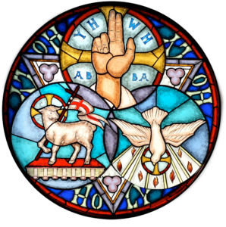
Almighty God,
you have made us for yourself,
and our hearts are restless till they find their rest in you:
pour your love into our hearts and draw us to yourself,
and so bring us at last to your heavenly city
where we shall see you face to face;
through Jesus Christ your Son our Lord,
who is alive and reigns with you,
in the unity of the Holy Spirit,
one God, now and for ever.

Readings (p317 Proper 21 Related)
Ezekiel 18.1-4, 25-32
Psalm 25.1-8
Philippians 2.1-13
Gospel: Matthew 21.23-32

Sunday 8th October: 18th Sunday after Trinity
Collect
Almighty and everlasting God,
increase in us your gift of faith
that, forsaking what lies behind
and reaching out to that which is before,
we may run the way of your commandments
and win the crown of everlasting joy;
through Jesus Christ your Son our Lord,

who is alive and reigns with you,
in the unity of the Holy Spirit,
one God, now and for ever.

Readings (p.323 Proper 22 Related)
Isaiah 5.1-7
Psalm 80.7-14
Philippians 3.4b-14
Gospel: Matthew 21.33-46

Sunday 15th October: 19th Sunday after Trinity
Collect
O God, forasmuch as without you
we are not able to please you;
mercifully grant that your Holy Spirit
may in all things direct and rule our hearts;
through Jesus Christ your Son our Lord,
who is alive and reigns with you,
in the unity of the Holy Spirit,
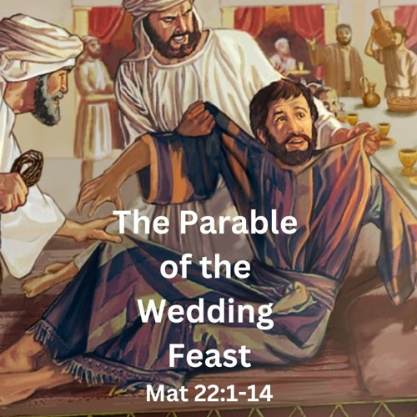
one God, now and for ever.

Readings (p330, Proper 23 Related)
Isaiah 25.1-9
Psalm 23
Philippians 4.1-9
Gospel: Matthew 22.1-14

Sunday 22nd October: 20th Sunday after Trinity
Collect
God, the giver of life,
whose Holy Spirit wells up within your Church:
by the Spirit’s gifts equip us to live the gospel of Christ
and make us eager to do your will,
that we may share with the whole creation
the joys of eternal life;
through Jesus Christ your Son our Lord,
who is alive and reigns with you,
in the unity of the Holy Spirit,
one God, now and for ever.

Readings (p335 Proper 24 Related)
Isaiah 45.1-7
Psalm 96.1-9, [10-13]
1 Thessalonians 1.1-10
Gospel: Matthew 22.15-22

Sunday 29th October: 21st Sunday after Trinity
Collect
Grant, we beseech you, merciful Lord,
to your faithful people pardon and peace,
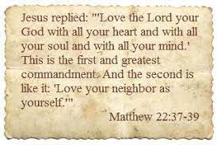
that they may be cleansed from all their sins
and serve you with a quiet mind;
through Jesus Christ your Son our Lord,
who is alive and reigns with you,
in the unity of the Holy Spirit,
one God, now and for ever.

Readings (p340 Proper 25 Related)
Leviticus 19.1-2, 15-18
Psalm 1
1 Thessalonians 2.1-8
Gospel: Matthew 22.34-46

October Reflection, 2023

Suddenly autumn seems to be very much in evidence, leaves on the road, shorter days and most of the summer visiting birds now gone. So, it is time to start wearing warmer clothes and eating more substantial meals.
The word ‘Autumn’ only occurs once in the Bible. In Jude 1:12, false teachers are compared to ‘autumn trees without fruit,’ implying that autumn should be a fruitful season, the most abundant of the year. So, although there are many seasons of harvest depending on the crop being produced, by autumn most of the year’s harvest has been harvested.
Ecclesiastes 3:1 says, ‘To everything there is a season, and a time to every purpose under the heaven.’ In reality, not only in the natural world are there seasons, but our lives are made up of many varied seasons, each just one period in God’s purpose for our lives. Every season is different, and no season is without purpose.
In our fast-moving lives, it is too easy to be constantly planning for the future and miss the blessings of today. Whilst I need to plan for winter - order logs, get the car serviced etc. - it is important gratefully to treasure the current season, knowing that it will soon be gone.
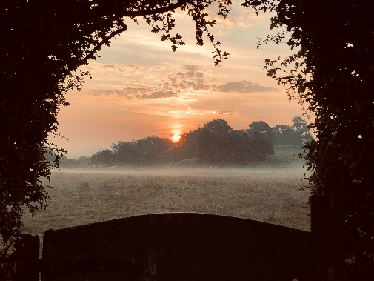
We see signs of autumn in red and golden leaves on the trees, shortening days and misty mornings. Later we will see hoar frosts and some of the most brilliant sunrises and sunsets can be seen in autumn. And if we are lucky, we may see a murmuration of starlings, flocks of geese overhead and winter bird visitors, the fieldfares and redwings, raiding the berries on the bushes in gardens as the weather gets colder. Many days of autumn can be dull, damp and cold but somehow that makes the good days even more precious, and it is just a few months before winter will have come and gone and as springtime arrives, crops will be planted in anticipation for yet another season, autumn and the time of harvest.
And so, with the ‘seasons’ in our lives, as with the natural season, we should gratefully treasure the current season, knowing that it will not last forever. At the same time, we must also keep growing and be sensitive to God’s direction. If we attempt to nostalgically remain forever in the past, we will miss God’s will for us in the future. So how do we strike a balance?
The seasons come and go, so we must focus on God who remains unchanged and unchanging. It often seems as if there is a lot of unwelcome change in our world. Moral and societal changes may bother us when we turn on our television or listen to the latest news. We can be painfully aware of our children and grandchildren growing up in a world far different from the one we knew as children.
But we can be assured that amid all the changes, one thing, one person, never changes— God.
For those in the autumn of life, it can be a good time to focus on God’s many blessings—family, friends, strength, shelter, provision, guidance, care, opportunities to serve, more time to pray and study the Bible. During life’s autumn, we can have a richer perspective and can count more blessings than ever before.
As in nature, each season lays the foundation for the next allowing growth and development, so it is in our own lives. To remain forever in the same season is to become stale and unproductive.

So how can we make the most of whatever season we are in? In order to do so, we must make the most of the opportunities God gives us whilst realizing that even our best efforts are worthless apart from God’s divine blessing. To paraphrase I Corinthians 3, we can plant, water, and till, but only God gives the harvest. Every good thing we enjoy comes from Him alone, undeservedly to us.
And so, while seasons change, we can be grateful that God never does. He is the same, ‘yesterday, today, and forever,’ the fixed anchor amidst life’s peaceful weather and turbulent storms. In every season, we can trust His greater purpose and providence directing our lives. “While the earth remaineth, seedtime and harvest, and cold and heat, and summer and winter, and day and night shall not cease” (Genesis 8:22).
Richard Byas
St. Edward the Confessor.
Edward the Confessor (c. 1003 – 5 January 1066) whose feast day is celebrated on 13th October was an Anglo-Saxon English king and saint. Usually considered the last king of the House of Wessex, he ruled from 1042 until his death in 1066.
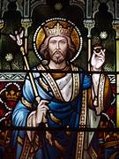
About a century after his death, in 1161, Pope Alexander III canonised the king. Edward was one of England's national saints until King Edward III adopted Saint George (George of Lydda) as the national patron saint in about 1350. Edward is said to have made a vow that if he succeeded to the English throne, he would make a pilgrimage to Rome but when he did succeed in 1042 his position was weak and effective rule required keeping on good terms with the three leading earls of the country, Leofric, Siward and Godwin. Pope Leo released Edward from his pilgrimage vow on condition that he gave the money it would have cost to the poor and build a great abbey at Westminster. This Edward did.
In many ways Edward is an unlikely saint. His nickname reflects the traditional image of him as unworldly and pious.’ Confessor’ reflects his reputation as a saint who did not suffer martyrdom as opposed to his uncle, King Edward the Martyr. However, this image is not actually correct. Edward was a successful king, one who was energetic, resourceful and sometimes ruthless. In 1053, Edward ordered the assassination of the south Welsh prince Rhys ap Rhydderch in reprisal for a raid on England, and Rhys's head was delivered to him.
Edward the Confessor was the only king of England to be canonized by the pope, but he was part of a tradition of (uncanonised) Anglo-Saxon royal saints, such as Eadburh of Winchester, a daughter of Edward the Elder, Edith of Wilton, a daughter of Edgar the Peaceful, and the boy-king Edward the Martyr. With his proneness to fits of rage and his love of hunting, many historians regard his canonisation as political, although his cult started so early that it must have had something credible to build on.
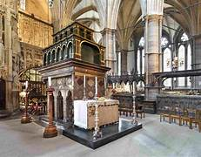
After 1066, there was a subdued cult of Edward as a saint, possibly discouraged by the early Norman abbots of Westminster, but the cult gradually increased in the early 12th century. In 1139, Osbert the prior of Westminster Abbey, went to Rome to petition for Edward's canonisation with the support of King Stephen, but he lacked the full support of the English hierarchy and Stephen had quarrelled with the church, so Pope Innocent II postponed a decision, declaring that Osbert lacked sufficient testimonials of Edward's holiness. However, in 1159, there was a disputed election to the papacy, and Henry II's support helped to secure the recognition of Pope Alexander III. In 1160, a new abbot of Westminster, Laurence, seized the opportunity to renew Edward's claim. This time, it had the full support of the king and the English hierarchy, and a grateful pope issued the bull of canonisation on 7 February 1161, the result of a conjunction of the interests of Westminster Abbey, King Henry II, and Pope Alexander III. He was called 'Confessor' as the name for someone who was believed to have lived a saintly life but was not a martyr. In the 1230s, King Henry III became attached to the cult of Saint Edward, and he constructed a grand new tomb for Edward in a rebuilt Westminster Abbey in 1269.
Richard Byas
A Good Deed
A vicar was walking down the street one day when he noticed a small boy trying to press the doorbell of a house across the street. However, the doorbell was high up and the boy too small to reach it.
The vicar crossed the road, and, placing his hand kindly on the boy’s shoulder, reached up and gave the bell a solid ring.
Crouching down to the child he smiled and asked ‘and now what, my little man?’ To which the boy replied ‘Now we run!’.


Baldersby St James Church
Harvest Festival
Our theme this year is “The Harvest of Land, Hands and Minds” and we encourage everyone to bring along something they have “Grown, Made or Written”. We are having a “Bring and Share Lunch” after the service and Sheilagh, our vicar, is bringing Isaac and Ronald – two boys from the “Pearl of Africa Choir”, who are staying with her, to meet us all.

All Souls Service
The fifth Sunday gives us all a chance to “Remember our Dearly Departed” by lighting a candle during our Communion Service.

Pets Service
On the last Sunday in September we held a Pets Service in church and were thrilled when 30 people came with their very well behaved dogs, a 50-year-old tortoise and Jessica with her hamster! Keep an eye out for our service next year.

St Columba’s Church, Topcliffe
Pearl of Africa Children’s Choir
We were joined by local families with children on Monday 25th September to enjoy a concert of traditional Ugandan songs, dancing and drumming. This was performed with great precision, energy and obvious enthusiasm by the ‘Pearl of Africa’ children’s choir to the delight and enjoyment of the audience. The concert raised £352-79 in donations for the charity, which provides schooling for children in rural Uganda. Many thanks to everyone who worked so hard to make this such a memorable evening, whether by donations, cleaning, providing food and baking, or flower arranging.

Neptune Commemoration
On Sunday 8th October at 10.45am the service of Holy Communion will include our annual Act of Remembrance for the aircrew of RAF Neptune WX545 that flew out of Topcliffe on 10th October 1956 and crashed on the Mull of Kintyre whilst on training exercises.

Harvest Service and Supper
Our Harvest Celebration is on Sunday 22nd October, at 6.30pm followed by a ‘bring and share’ supper. Everyone is most welcome to join us.

All Souls Service
On Thursday 2nd November at 7pm we remember those who have died in the past year together with departed family and friends in our All Souls Service, which will include the beautiful and uplifting music from the Requiem Mass for six voices by Tomás Luis de Victoria (1548-1611), sung by the choir. Those who would like to do so can remember their loved ones by name during the service. Everyone is most welcome to attend. Names of those to be remembered can be added to the list before the start of the service or, if preferred, may be emailed beforehand to John Phillips – johnphillips05@gmail.com or Chris Hewlett – celhewlett@outlook.com .

Dalton Events
Halloween Disco & Children’s Party
We are having an adult Halloween disco, with optional fancy dress, on Friday 27th October, in the village hall, starting at 7.30pm. Tickets are £5 from Eleanor on 07841 036340.
We are also having a children’s Halloween party on Tuesday 31st October in the village hall from 4pm until 6pm. Tickets are £3 from Eleanor which include a hot dog and a drink.

Old Photos of Dalton
We are looking for old photos of Dalton to copy and mount on a plain brick wall in the village hall bar, and would appreciate any contributions. Please contact the village hall by email, villagehalldalton@gmail.com if you are able to help.

Dalton Film Club
The film club is starting up again after the summer break. We will be showing “Hocus Pocus” in the village hall on Sunday 8th October at 3pm. Entry is free of charge but donations towards costs would be gratefully received.

Domino Drive
Domino Drives are held on the 4th Saturday of every month at 7pm in the village hall. Entry is £2, with £1 for raffle tickets. Tea and biscuits are served in the interval. The proceeds go to the church and the village hall in rotation. All ages welcome.
Sylvia Binks

PARISH DIRECTORY
The Parishes of Topcliffe, Baldersby with Dishforth and Skipton on Swale, and Dalton.
There is currently no Vicar of the parishes. Until one is appointed, please contact our Area Dean,
Revd Mary Rolls, tel: 01845 400480 email: revmaryrolls@gmail.com.

BALDERSBY with DISHFORTH and SKIPTON-ON-SWALE - PCC Secretary: Mrs Jennifer Wharton wharton370@btinternet.com

DALTON - PCC Secretary: Mrs Hannah Bissett tel: 07739 382831 spannerb79@gmail.com

TOPCLIFFE – PCC Secretary: Mrs Roz Norris RozNorris@aol.com

