Benefice Online Magazine

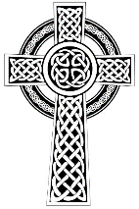
for the Parishes of Topcliffe, Baldersby with Dishforth and Skipton on Swale, and Dalton
Cross Talk
August 2023
Cross Talk is published monthly by email. To receive a copy please contact kitnorris@live.co.uk
Cross Talk contains the weekly Collect and Readings together with details of Church services in the Benefice and news and items of interest supplied by our readers. The magazine will also be available on the web sites: www.achurchnearyou.com/church/3447 and baldersbychurch.com.

CHURCH SERVICES

St. James’ Church, Baldersby St. James with Dishforth, Rainton & Skipton on Swale
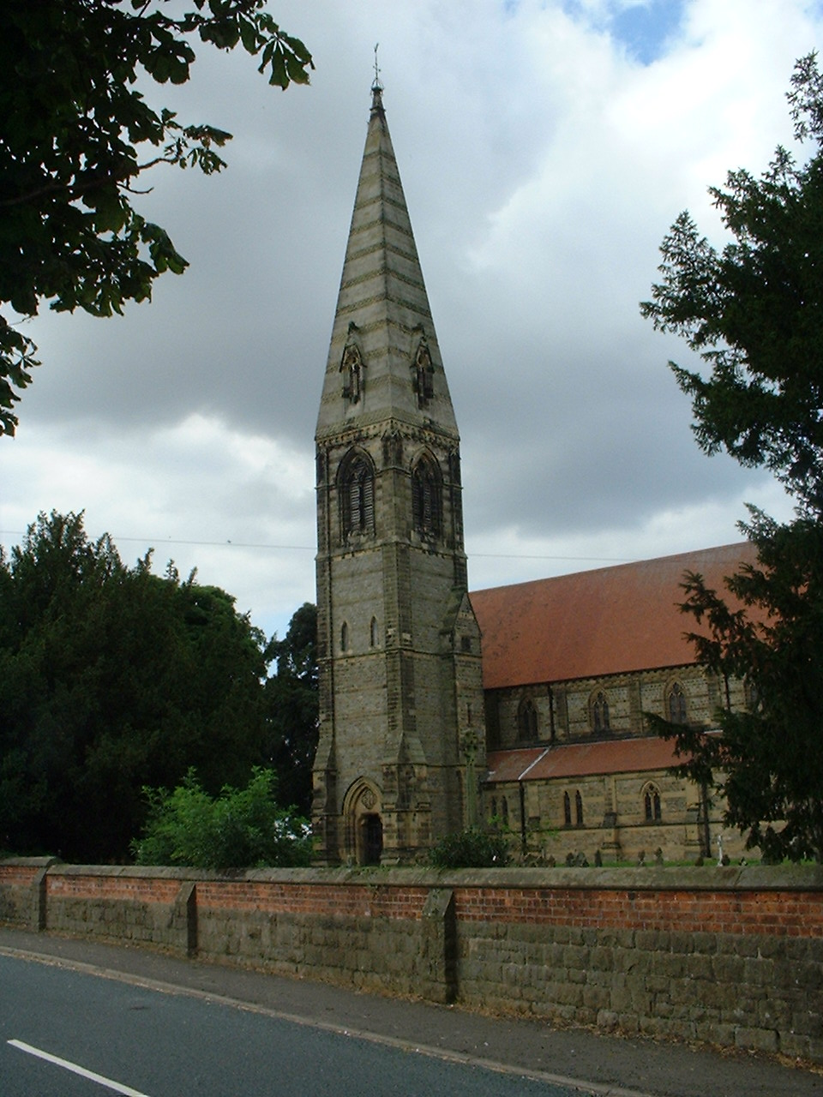
Sunday 6th August, 10.45am Holy Communion followed by coffee
Sunday 13th August, 9.30am Breakfast Service with Coffee and Croissants
Sunday 20th August, 10.45am Holy Communion followed by coffee
Sunday 27th August, 9.30am Morning Prayer followed by coffee

St. Columba’s Church, Topcliffe
Corporate Member of the Prayer Book Society
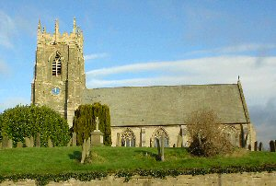
Sunday 6th August, 6.30pm Choral Evensong (Book of Common Prayer)
Anthem: Cantique de Jean Racine – Fauré
with Matthew Atherton, organ
Sunday 13th August, 10.45am Holy Communion led by
Rev’d Robert Williamson
Sunday 20th August, 10.45am Choral Matins (BCP)
Sunday 27th August, 10.45am Holy Communion led by
Rev’d Robert Williamson

St John the Evangelist Church, Dalton
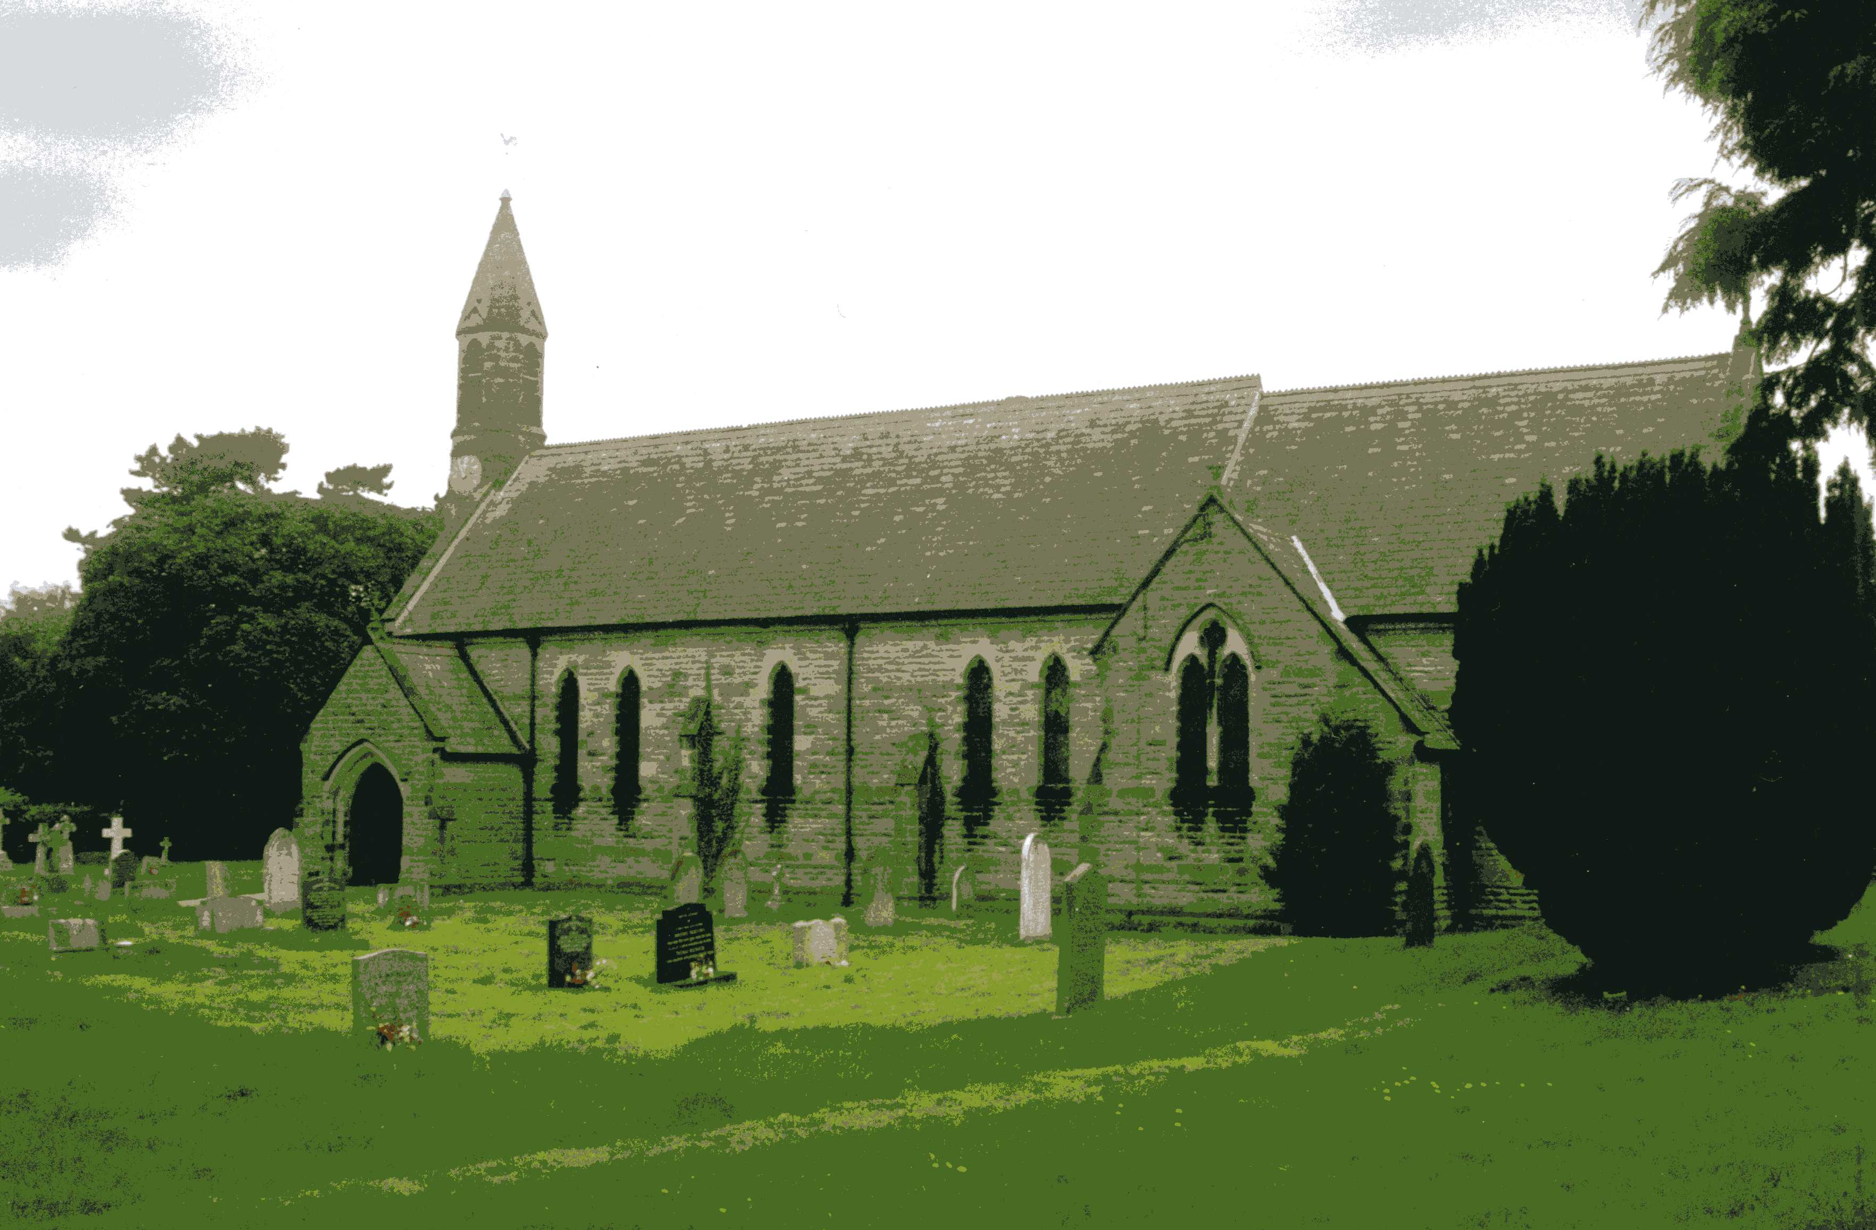
Sunday 6th August, 11am Holy Communion
Sunday 20th August, 11am Family Service

Baldersby News and Events see page 6

Dalton News see page 6

Readings for the 9th Sunday of Trinity to 12th Sunday of Trinity
(Page numbers refer to the Common Worship Lectionary.)

Sunday 6th August : 9th Sunday after Trinity
Collect
Almighty God,
who sent your Holy Spirit
to be the life and light of your Church:
open our hearts to the riches of your grace,
that we may bring forth the fruit of the Spirit
in love and joy and peace;
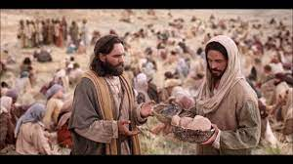
through Jesus Christ your Son our Lord,
who is alive and reigns with you,
in the unity of the Holy Spirit,
one God, now and for ever.

Readings (p.273 Proper 13 Related)
Isaiah 55.1-5
Psalm 145.[8-9,] 15-22
Romans 9.1-5
Gospel: Matthew 14.13-21 The feeding of the five thousand

Sunday 13th August: 10th Sunday after Trinity
Collect
Let your merciful ears, O Lord,
be open to the prayers of your humble servants;
and that they may obtain their petitions
make them to ask such things as shall please you;
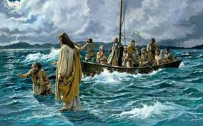
through Jesus Christ your Son our Lord,
who is alive and reigns with you,
in the unity of the Holy Spirit,
one God, now and for ever.

Readings (p279, Proper 14 Related)
1 Kings 19.9-18
Psalm 85.8-13
Romans 10.5-15
Gospel: Matthew 14.22-33

Sunday 20th August: 11th Sunday After Trinity
Collect
O God, you declare your almighty power
most chiefly in showing mercy and pity
mercifully grant to us such a measure of your grace,
that we, running the way of your commandments,
may receive your gracious promises,
and be made partakers of your heavenly treasure;
through Jesus Christ your Son our Lord,
who is alive and reigns with you,
in the unity of the Holy Spirit,
one God, now and for ever.

Readings (p283 Proper 15 Related)
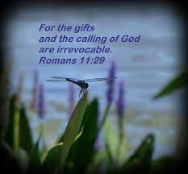
Isaiah 56.1, 6-8
Psalm 67
Romans 11.1-2a, 29-32
Gospel: Matthew 15.[10-20,] 21-28

Sunday 27th August: 12th Sunday after Trinity
Collect
Almighty and everlasting God,
you are always more ready to hear than we to pray
and to give more than either we desire or deserve:
pour down upon us the abundance of your mercy,
forgiving us those things of which our conscience is afraid
and giving us those good things
which we are not worthy to ask

but through the merits and mediation
of Jesus Christ your Son our Lord,
who is alive and reigns with you,
in the unity of the Holy Spirit,
one God, now and for ever.

Readings (p289 Proper 16 Related)
Isaiah 51.1-6
Psalm 138
Romans 12.1-8
Gospel: Matthew 16.13-20

August Reflection, 2023
‘For everything there is a season and a time for every matter under heaven’ (Ecclesiastes 3:1). But as DM Deamer of Monkgate, York wrote in the York Press recently ‘The year 2023 is turning out to be a very strange one, with the seasons and the natural environment out of kilter….. The seasons have gone to pot, and I wonder what the late Bill (William) Foggitt, the Thirsk Amateur weather forecaster, would make of the changing seasons’.
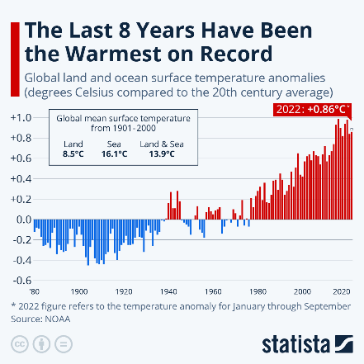
I suppose many of us see the past through rose-tinted spectacles but I’m sure as a child the seasons were more consistent; always some snow in winter, summers generally warm and dry but not with the excessive heat we had in June this year and certainly better than the wet cool July we have experienced.
At Deanery Synod on 18th July, The Revd Johannes Nobel, the Green Ambassador for the Diocese of York and also Priest-in-Charge of Osbaldwick with Murton gave a presentation on ‘Living Christ’s story in a time of climate crisis’ and talked about the reality of climate change with a graph showing rising global temperatures since 1850 with all the higher temperatures within the last 30 years. This affects us directly with more severe weather events including the recent period of high temperatures (but not as bad as the temperatures affecting the countries around the Mediterranean Sea and the southern states of the USA).
The indirect effect on us is that food crops are affected; this year we are told that the harvest of olives from southern Europe for olive oil has been significantly reduced. It is of course not only humans that are affected but also wildlife – birds, mammals, insects and plants. The butterflies and bumblebees in certain areas of the UK have not fared well this year; they came to life during the few unnaturally warm early days of February and simply perished as there was no food available for them at that time.
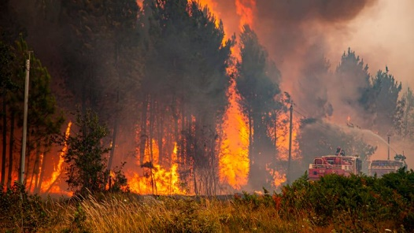
Revd Johannes reminded us that, as Christians, we are called to respond to human need by loving service, and climate change, loss of biodiversity and concern about the future, create human need. This can range from those who are unable to produce a harvest, or who have lost their homes to floods and wildfires around the world, to those who are suffering from climate anxiety, mourning the loss of countryside and species. He reminded us that the ecological issues we face today are justice issues. The global poor are disproportionately affected and those countries which have benefited least from our exploitation of the Earth’s resources bear a disproportionate amount of the cost.
As the crisis worsens it is anticipated that competition for increasingly scarce resources will make peace even harder to achieve.
However, Johannes did not leave us feeling helpless. We recognize that we can’t solve the whole climate problem either as individuals, as a church or even as a country (the UK is responsible for only just over 1% of the global CO² emissions). It is something for all humankind to solve. This does not mean that we do not need to be part of the solution and, in love for all creation, to do whatever we can to alleviate the problem both in the UK and abroad.
As Christians we proclaim a ‘new creation’ in word and deed. And as individuals we can make small changes to our lives that will mean that we are helping control the problem rather than adding to it. The same is true of our churches. As Pope Francis in an Encyclical Letter has said ‘Everything is connected. Concern for the environment thus needs to be joined to a sincere love for our fellow human beings and an unwavering commitment to resolving the problems of society’.
‘For everything there is a season and a time for every matter under heaven’. Now is as good a time as any for us to honestly reflect about where we, as individuals, can contribute to help reduce the problem of climate change – can we adjust what we eat, how we travel and how we use energy and other resources in our homes and businesses to reduce our personal impact on climate change? Now is also the time for churches to reflect upon how they can respond to the Diocese of York Net Zero 2030 principles by using less energy, sourcing energy from cleaner sources, developing congregations that are travelling sustainably and offsetting only what we cannot reduce.
National CofE data suggest that around 80% of the net carbon emissions come from the 33% highest emitting churches and less than 1% of the total net carbon emissions come from the 25% lowest emitting churches. As the Green Ambassador for the Diocese of York, The Revd Johannes Nobel is available to give advice to churches on moving towards Net Zero, recognizing the situation in every church is different.
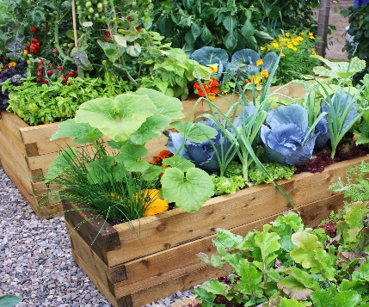
However, despite global difficulties, this coming August is a gift from God for us to enjoy. In the natural world it is the season of growth and harvest, of grain, vegetables, flowers and fruit. There are still the sounds of summer; lawnmowers, strimmers, outdoor events, celebrations and children enjoying their summer break from school. It is also the month when we notice the days beginning to shorten, the swifts will have returned to Africa and the swallows and house martins will be preparing to follow them. We will become aware of signs of autumn and the changing of the season but whilst summer is still here let us enjoy it, give thanks to God for it and then look forward to the blessings and joys that autumn brings.

Yorkshire Day
Yorkshire Day is a yearly celebration on 1st August to promote the historic county of Yorkshire. It was first celebrated by the Yorkshire Ridings Society in 1975, initially in Beverley, as "a protest movement against the local government re-organisation of 1974".
The decision to mark Yorkshire Day with an annual civic gathering of Mayors, Lord Mayors, their attendants and other dignitaries ‘in full costume and regalia’ was taken at a meeting of Local Authorities within the boundary of the old county of Yorkshire i.e., the three ridings and York and The Yorkshire Society at County Hall, Wakefield, on 29 June 1985. The Yorkshire Society was then charged with guardianship of the idea and organising the annual event, which now forms the centrepiece and focal point for the celebrations undertaken across the whole region.
1st August was chosen for Yorkshire Day as having Yorkshire links; on 1st August 1834 the Slavery Abolition Act was passed, which William Wilberforce, a Yorkshire MP, had campaigned for.
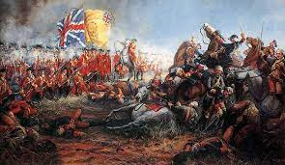
The day was already celebrated by the Light Infantry, successors to the King's Own Yorkshire Light Infantry, as Minden Day, after the battle of Minden. Together with five other infantry regiments of the British Army, a rose is permitted to be worn in the headdress. In the case of the Light Infantry, the rose is white. The Battle of Minden was a major engagement during the Seven Years' War, fought on 1st August 1759. An Anglo-German army under the overall command of Prussian Field Marshal Ferdinand of Brunswick defeated a French army commanded by Marshal of France, Marquis de Contades.
The ‘Official Yorkshire Day Civic Celebration’ now adds pomp and circumstance to a day of pride for a region which is like a nation within a nation: having its own flag, own anthem (almost) and its own culture. It is undoubtedly the biggest gathering of ‘first citizens’ and civic leaders in the UK.
The Official Yorkshire Day Civic Celebration is now a catalyst for the host town or city, providing an opportunity to boost the local economy, capture the attention of the world and connect with its citizens. The host town or city has the honour and prestige of being the official Yorkshire Day town or city for a full calendar year. This is marked with the handing over of the Yorkshire Day flag from council to council on the day, each council adding its coat of arms to the flag to record their year.
On Yorkshire Day, members of the society read a "Declaration of Integrity":
"I, [Name], being a resident of the [West/North/East] Riding of Yorkshire [or City of York] declare:
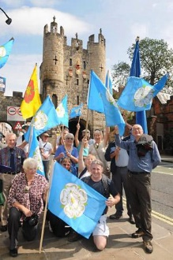
That Yorkshire is three Ridings and the City of York, with these Boundaries of (Current Year minus 875, so for 2023, 1148) years' standing; That the address of all places in these Ridings is Yorkshire; That all persons born therein or resident therein and loyal to the Ridings are Yorkshiremen and women; That any person or corporate body which deliberately ignores or denies the aforementioned shall forfeit all claim to Yorkshire status.
These declarations made this Yorkshire Day [Year]. God Save the King!"
In York the Declaration is made four times by the Yorkshire Ridings Society, once for each Riding and once for the City of York. The traditional boundaries of the Three Ridings run up to the ancient city walls, so by processing out of three of the bars the Society can make the Declaration in each Riding, followed by reading the Declaration within a fourth bar inside the city.
A Yorkshireman goes to a goldsmith and asks, "Can tha mek us a gold statue o'me whippet?"
The goldsmith says he can, then asks: "Do you want it 18 carat?"
The man replies: "Nay lad, chewin' a bone'll do fine."


Baldersby News and Events
Church Repairs
Our church ceiling repairs are starting early in August and will take two weeks because the specialist plaster of lime and horsehair will need to dry between coats. We will all be pleased to have the church open again for visitors and services. At the moment we are overflowing the seats in the Lady Chapel on the right hand side every week! The total cost will be in the region of £8,000 to cover the Architect, Builder and hire of a Cherry Picker to reach into the apex of the roof.
As we have just finished installing our new radiators (which are brilliant) at a cost of £20,000 we are going to have to raise the cost of the ceiling with an appeal. Sadly our insurance does not cover this, so we are appealing for donations – however small – to help with the cost. We have never done this before but it was unexpected by everyone. Until our Just Giving Page is live, if you would like to help, could you please send any cheques to our treasurer: Mrs Jennifer Wharton, Briar Dene, Topcliffe, Thirsk, YO7 3RW.
If you wish to make a bank payment please ring Jennifer (0771 545 8215) for our bank details – many thanks.

Junction 50 Recital
Saturday 2nd September at 2.30pm. Mary Reid, who has visited many times before playing her harp, is joined by her colleague Scottish folk singer, Ainsley Hamill, to give a lovely afternoon recital with “afternoon tea”. There is no charge but a donation box will be available to help defray costs. We look forward to seeing everyone for a relaxing time!

Book Sale 9th and 10th September
10.00am to 5pm each day. Entrance is free, refreshments available. Please come and browse our many, many books. If you still have books to donate, please leave them in the church porch while we are closed.

Dalton Events
120 Club Results
July: £15 – Maggie Hovvels (No.98); £10 – Charlotte Hudson (No.110); £6 – Matthew Spence (No.49)

PARISH DIRECTORY
The Parishes of Topcliffe, Baldersby with Dishforth and Skipton on Swale, and Dalton.
There is currently no Vicar of the parishes. Until one is appointed, please contact our Area Dean,
Revd Mary Rolls, tel: 01845 400480 email: revmaryrolls@gmail.com.

BALDERSBY with DISHFORTH and SKIPTON-ON-SWALE - PCC Secretary: Mrs Jennifer Wharton wharton370@btinternet.com

DALTON - PCC Secretary: Mrs Hannah Bissett tel: 07739 382831 spannerb79@gmail.com

TOPCLIFFE – PCC Secretary: Mrs Roz Norris RozNorris@aol.com

