Benefice Online Magazine

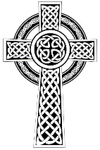
for the Parishes of Topcliffe, Baldersby with Dishforth and Skipton on Swale, and Dalton
Cross Talk
June 2023
Cross Talk is published monthly by email. To receive a copy please contact kitnorris@live.co.uk
Cross Talk contains the weekly Collect and Readings together with details of Church services in the Benefice and news and items of interest supplied by our readers. The magazine will also be available on the web sites: www.achurchnearyou.com/church/3447 and baldersbychurch.com.

CHURCH SERVICES

St. James’ Church, Baldersby St. James with Dishforth, Rainton & Skipton on Swale
Unfortunately, St James Church has had a fall of masonry from the roof inside church large enough for us to need to lock up the church until we can investigate the cause and ensure it is safe. Our services on 4th, 11th, and 18th June will be held in Rainton Village Hall. It is a good venue with all facilities so please come along and join us. If we can open the church before then we will let everyone know.
Sunday 4th June, 10.45am Communion Service
Sunday 11th June, 9.30am Breakfast Service with Coffee and Croissants
Sunday 18th June, 10.45am Communion Service
Sunday 25th June, 10.45am Pet Service in church – All pets welcome, with owners!
(No Morning Service)

St. Columba’s Church, Topcliffe
Corporate Member of the Prayer Book Society
St Columba’s Festival Weekend 3rd and 4th June (details on page 8)
Sunday 4th June, 11am Sung Matins (Book of Common Prayer)
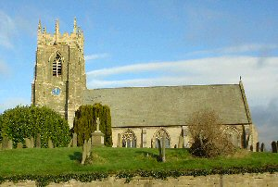
6.30pm Choral Evensong (Book of Common Prayer) followed by Wine and refreshments

Sunday 11th June, 10.45am Holy Communion led by
Rev’d Robert Williamson
Sunday 18th June, 10.45am Choral Matins
Sunday 25th June, 10.45am Holy Communion led by
Rev’d Robert Williamson

St John the Evangelist Church, Dalton
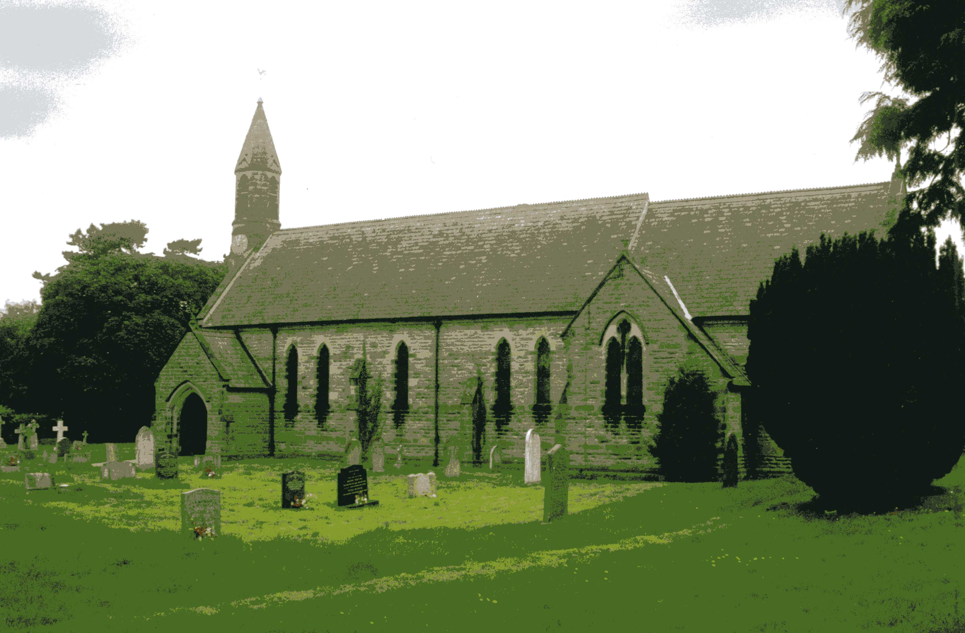
Sunday 4th June No Service
Sunday 18th June, 11am Family Service

Baldersby News and Events see page 6
Dalton News see page 6
Topcliffe C of E Academy News see page 6
Topcliffe St Columba Festival see page 7
Readings for the 1st Sunday of Trinity to 4th Sunday of Trinity
(Page numbers refer to the Common Worship Lectionary.)

Sunday 4th June: 1st Sunday after Trinity
Collect
O God,

the strength of all those who put their trust in you,
mercifully accept our prayers
and, because through the weakness of our mortal nature
we can do no good thing without you,
grant us the help of your grace,
that in the keeping of your commandments
we may please you both in will and deed;
through Jesus Christ your Son our Lord,
who is alive and reigns with you,
in the unity of the Holy Spirit,
one God, now and for ever.

Readings (p221 Proper 4 Related)
Deuteronomy 11.18-21, 26-28
Psalm 31.[1-5,] 19-24
Romans 1.16-17; 3.22b-28, [29-31]
Gospel: Matthew 7.21-29

Sunday 11th June: 2nd Sunday after Trinity
Collect
Lord, you have taught us

that all our doings without love are nothing worth:
send your Holy Spirit
and pour into our hearts that most excellent gift of love,
the true bond of peace and of all virtues,
without which whoever lives is counted dead before you.
Grant this for your only Son Jesus Christ’s sake,
who is alive and reigns with you,
in the unity of the Holy Spirit,
one God, now and for ever.

Readings (p227 Proper 5 Related)
Hosea 5.15-6.6
Psalm 50.7-15
Romans 4.13-25
Gospel: Matthew 9.9-13, 18-26

Sunday 18th June: 3rd Sunday after Trinity
Collect
Almighty God,
you have broken the tyranny of sin
and have sent the Spirit of your Son into our hearts
whereby we call you Father:
give us grace to dedicate our freedom to your service,
that we and all creation may be brought
to the glorious liberty of the children of God;
through Jesus Christ your Son our Lord,
who is alive and reigns with you,
in the unity of the Holy Spirit
one God, now and for ever.

Or Psalm 69.14-20Readings (p.233 Proper 6 Related)
Exodus 19.2-8a
Psalm 100
Romans 5.1-8
Gospel: Matthew 9.35-10.8, [9-23]

Sunday 25th June : 4th Sunday after Trinity
Collect
O God, the protector of all who trust in you,

Without whom nothing is strong, nothing is holy:
Increase and multiply upon us your mercy;
That with you as our ruler and guide
we may so pass through things temporal
that we lose not our hold on things eternal;
grant this, heavenly Father,
for our Lord Jesus Christ’s sake,
who is alive and reigns with you,
in the unity of the Holy Spirit,
one God, now and for ever.

Readings (p.239 Proper 7 Related)
Jeremiah 20.7-23
Psalm 69.8-11, [12-17,] 18-20 or Psalm 69.14-20
Romans 6.1b-11
Gospel: Matthew 10.24-39

June Reflection, 2023

June Reflection – Cross Talk
Trinity Sunday is the first Sunday after Pentecost in the Western Christian liturgical calendar, so it is a moveable feast day depending upon the date of Easter and this year it falls on 4th June. Trinity Sunday celebrates the Christian doctrine of the Trinity, the three Persons of God: the Father, the Son and the Holy Spirit.
In the early Church, no special day was assigned for the celebration, but Sundays were traditionally dedicated to the Holy Trinity. Thomas Becket (1118–1170) was consecrated Archbishop of Canterbury on the Sunday after Pentecost, and his first act was to ordain that the day of his consecration should be held as a new festival in honour of the Holy Trinity. This observance spread from Canterbury throughout the whole of western Christendom.
The Anglican communion marks the day with special prayers and usually a sermon on the centrality of The Trinity to our faith. Cynics would say that the only ‘tradition’ within the Church of England on Trinity Sunday is that the vicar will get the curate to preach the sermon!
The more we contemplate the doctrine of the Holy Trinity the more difficult the idea can become if we get caught up on trying to define the relationship between the Father, the Son and the Holy Spirit. However, celebrating the Holy Trinity is more than looking for arguments to prove that there are Three Persons in One God. Proof or no proof will not change the reality of the Trinity. Instead, we should focus more on the lessons we can learn: the sense of community, being responsible in our Christian faith, and being ready and willing to work with others.
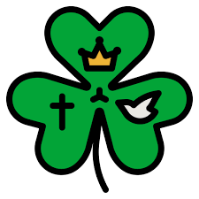
One Irish folklore about St. Patrick says that around the Fourth Century AD, he used the shamrock to describe the Trinity to the pagans while telling them about the Christian faith. Notably, the shamrock leaf has three distinct parts so it can be imagined how St. Patrick could have described the relationship between God the Father, God the Son, and God the Holy Spirit using the three leaves combined into one leaf. While the shamrock may give a mental image about the Trinity, it cannot fully explore the depth of the Holy Trinity, which remains a mystery beyond human comprehension.
The major limitation of the shamrock analogy is that, unlike the Trinity, each of the parts of the shamrock leaf is not fully a shamrock leaf. In the Trinity, the Father is fully God, just as is the Son, and the Holy Spirit, yet there are not three Gods but One God; one essence, will, and power.
One of the problems we have in the world today comes from our inability to reflect the Holy Trinity in our lives. If we are created in the image and likeness of God, who is a diversified unity, we need to adopt that Trinitarian model in our own lives by learning the lessons that the Trinity teaches us:
Community: The word community is not just an idea; it is more of an invitation to act. The Trinity is a community of three persons in One God and we are called to live and work in community with our fellow Christians. So, the Trinity challenges us to Come and Unite and not to Come and Divide. The sense of community helps us understand that diversity is a gift, and that co-existence is a basic divine condition.
Responsibility: The word responsibility means the ability to respond to some expectations or duty. Each person of the Trinity has a dedicated function. The scriptures give us insights into the ability of the various person of the Trinity to respond to their roles. The just and merciful God the Father summoned creation, the redeemer God the Son brought our salvation, while the Helper, God the Holy Spirit, sanctifies us with divine gifts and fruits.
Collaboration: As the old saying goes, no man is an island; this means we will always need others. The same principle applies to the Persons of the Trinity. Therefore, there is an eternal collaboration in the Trinity. That is why you hear God the Father say, “let us”.
The Feast of the Holy Trinity reveals to us that God is a living relationship of love, being three persons but still One God. God shows us how to love. The Father loves the Son, and the Son loves the Father and the love between them is so real, it is another Person, the Spirit. Through this mystery, we learn of love and then want to imitate the Three Divine Persons in our own lives.
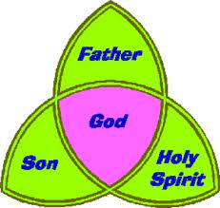
Finally, the mystery of the Trinity also makes it easier for us to access and relate to God in the way that suits each of us best. For those who relate best to God as a parent, God revealed himself as the Father, one in control of life, doing wonderful deeds and protecting and providing for us his children. For those of us who need a brother, a best friend, a close companion who knows our human experience, God the Son entered into our world as Jesus Christ. And there is that other part of God that is so unlike us, so powerful and invincible that we end up acknowledging that in the end, God is an unfathomable Mystery to us, who does things on His own terms. This is God in the person of the Holy Spirit, who supernaturally empowers us to live the Christian life and call God our Father.
Richard Byas
The Yorkshire Dales in Summer.
With longer days and (hopefully) better weather, now is a good time to visit the dales and enjoy the wildlife to be seen there. The Yorkshire Dales are home to: Red & black grouse, Redshank, Curlew, Snipe, Lapwing, Golden Plover, Dunlin, Merlin, Yellow Wagtail, Skylark, Swaledale and Wensleydale sheep, Northern Brown Argus butterflies, red squirrels and longhorn cattle.
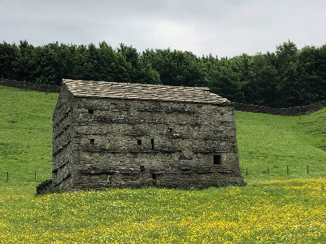
Many people find turning to nature brings relief from the hustle and bustle of daily life. There’s a growing number of scientific studies showing that green spaces are good for human well-being. Feeling calm and serene helps reduce stress. Research shows that anxiety can be reduced simply by looking out on to pleasant scenery and taking note of the changing seasons and small details in nature. Patients in hospitals with nature views stay in for less time and require less medication. Natural sounds such as bird song have calming effects.
There are numerous natures reserves managed by the Yorkshire Wildlife Trust which you can visit which offer a variety of habitats and scenery: The peaceful wetland beside scenic Semer Water, near Marsett is a haven for waders, wildfowl, and nesting birds. Brae Pasture, South House Pavement, and Southerscales are amazing examples of our rare limestone grasslands and limestone pavements. There are stunning traditional hay meadows at Leyburn Old Glebe, Wensleydale and Yellands Meadow, Muker busy with bees and butterflies in summer. There is the beautiful ancient ash woodland Grass Wood, near Grassington, and tiny Globe Flower Wood, near Malham, which bursts into life with colourful globeflowers in June.
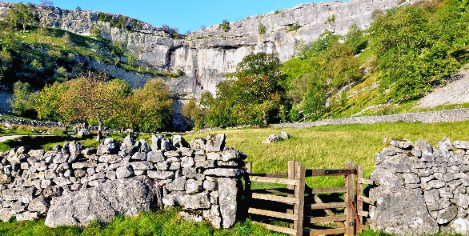
And there is the Malham Cove Peregrine Watch - see nesting peregrines! Peregrine falcons are the fastest bird in the world when hunting their prey, and a family of these beautiful birds have been nesting and raising young successfully at Malham Cove in the Yorkshire Dales since 1993.

And for those who are not able to get to the dales we have plenty of interest in our own villages where we can see and hear a wide variety of wildlife which can improve our wellbeing if we take time to appreciate the birds, insects and animals that share our gardens and surrounding fields.
Richard Byas
Wet Floor
A police officer called the station on his radio. “I need back up here. The Vicar’s wife shot her husband for stepping on the floor that she had just mopped.”
“Have you arrested the woman?”
“Not yet, Sarge. The floor’s still wet!”


Baldersby Events
Church Services
A reminder that the church services on 4th, 11th, and 18th June will be held in Rainton Village Hall. If we can open the church before that we will let everyone know.

Music at Junction 50
On Thursday 29th June at 7pm our first concert of the year is by accordionist Paul returning to Baldersby accompanied by Michael playing violin and saxophone in a wide ranging concert featuring many different styles of music from around the world. Wine and Refreshments. Tickets £12 from tel: 01765 640398 or mob: 0770 620897, collect from the Good Food Shop in Baldersby, or just come along and pay at the door.

Coffee and Chat
Due to the closure of the church, the popular Coffee and Chat on Tuesdays from 10am to 12 noon will temporarily move to the Mission Room in Baldersby village until we can ensure that the church is safe.

Tea Dances
The Musical Afternoon Tea Dances that would have taken place in church on the 1st and 3rd Thursdays have had to be temporarily suspended due to the closure of the church.

Book Sale 9th and 10th September
A reminder of the popular Annual Book Sale in Baldersby St James church, which we hope will be able to be held as usual in church. An announcement will be made nearer to the time.

Dalton Events
Pop up cafe
Saturday 11th June 9.30 until 11.30. Bacon, sausage or bacon and sausage sandwiches, tea and coffee. Come along and have breakfast and a chat with friends and neighbours.
Dalton Fest
Saturday 24th June. 2 pm until 11 pm. Ticket only. Check Dalton Facebook page for details. A variety of bands will be playing throughout the day, with The Mothers headlining. Fish and chip van and pizza van available for food. Bar will be open. A great family day out. Face painting for the kids.

Topcliffe C of E Academy News
The Ash Class sponsored walk for the Madagasca Smile Project for a permanent water supply for the La Montagne Antanamonpera school in Madagasca. The children completed 55 laps of the Topcliffe school playing field (7km) and raised £700. The children have a pen pal link with the Madagasca school children who have to walk 7km to get clean water every day, and Ash Class wanted to experience how this would feel!

Maple Class enjoyed a wonderful circus skills afternoon to complete their learning about forces. They all learned new skills using flower sticks, circus poise, plate spinning, joggling and balancing on a slackline, while at the same time thinking about the way the forces work, that allow them to achieve the different skills. Everyone managed to do something new and had lots of fun.

On the afternoon of Tuesday, 23rd May, the whole school enjoyed a visit from the Mishra Collective Trio, part of Music for Life. The Trio performed a selection of UK folk music and Indian classical music.

St Columba’s Church, Topcliffe
St Columba’s Weekend Events
‘A Rabble of Gentility?’
Topcliffe in the time of the English Civil War

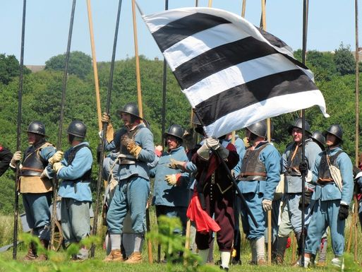
Saturday 3rd June
1pm+ Look out for members of Sir Thomas Lunsford’s Regiment passing through Asenby and Topcliffe.
2-3pm Displays and drills on the Playing Field
3pm March to church
3.30pm Talk in church with demonstration of weapons, with small versions for children to handle.
Followed by Refreshments.

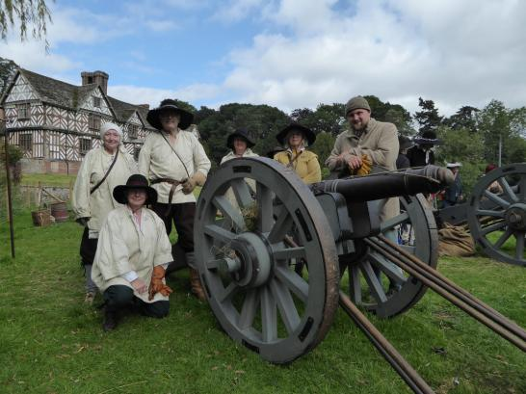
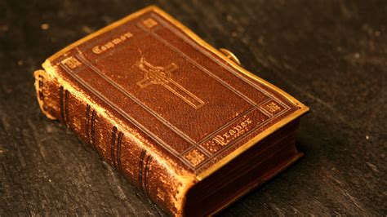

Sunday 4th June
A celebration of the beauty, poetry and majesty of the Book of Common Prayer restored in 1662 after the Restoration of the Monarchy with King Charles II.
11am Sung Matins (Book of Common Prayer) followed by coffee/lunch.
In church during the afternoon:
displays of 17th century and Civil War items, exhibitions, and tours up the tower and
further drills by Sir Thomas Lunsford’s Regiment in the Playing Field.

3.30pm Talk ‘1662 and all that: the origins and development of the Book of Common Prayer’ by Iain Milne, a trustee of the Prayer Book Society.

4.30pm tea.

6.30pm Choral Evensong (Book of Common Prayer) followed by reception with wine.

N.B. Exact programme subject to amendment

PARISH DIRECTORY
The Parishes of Topcliffe, Baldersby with Dishforth and Skipton on Swale, and Dalton.
There is currently no Vicar of the parishes. Until one is appointed, please contact our Area Dean,
Revd Mary Rolls, tel: 01845 400480 email: revmaryrolls@gmail.com.

BALDERSBY with DISHFORTH and SKIPTON-ON-SWALE - PCC Secretary: Mrs Jennifer Wharton wharton370@btinternet.com

DALTON - PCC Secretary: Mrs Hannah Bissett tel: 07739 382831 spannerb79@gmail.com

TOPCLIFFE – PCC Secretary: Mrs Roz Norris RozNorris@aol.com

