St Columba’s Church, Topcliffe
St Columba’s Weekend Events

‘A Rabble of Gentility?’
Topcliffe in the time of the English Civil War

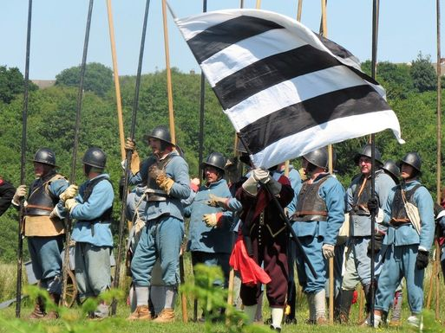
Saturday 3rd June

1pm+ Look out for members of Sir Thomas Lunsford’s Regiment passing through the villages

2-3pm Displays and drills on the Playing Field

3pm March to church

3.30pm Talk in church with demonstration of weapons, with small versions for children to handle.

Followed by Refreshments.

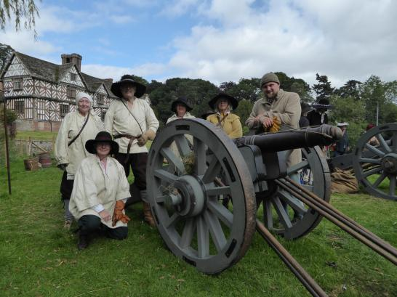
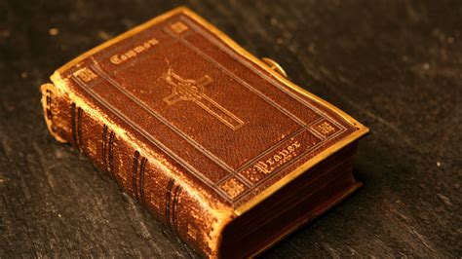

Sunday 4th June

A celebration of the beauty, poetry and majesty of the Book of Common Prayer restored in 1662 after the Restoration of the Monarchy with King Charles II.

11am Sung Matins (Book of Common Prayer) followed by coffee/lunch.

In church during the afternoon:
displays of 17th century and Civil War items, exhibitions, and tours up the tower and
further drills by Sir Thomas Lunsford’s Regiment in the Playing Field.

3.30pm Talk ‘1662 and all that: the origins and development of the Book of Common Prayer’ by Iain Milne, a trustee of the Prayer Book Society.

4.30pm tea.

6.30pm Choral Evensong (Book of Common Prayer) followed by reception with wine.

N.B. Exact programme subject to amendment

