Benefice Online Magazine

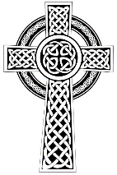
for the Parishes of Topcliffe, Baldersby with Dishforth and Skipton on Swale, and Dalton
Cross Talk
May 2023
Cross Talk is published monthly by email. To receive a copy please contact kitnorris@live.co.uk
Cross Talk contains the weekly Collect and Readings together with details of Church services in the Benefice and news and items of interest supplied by our readers. The magazine will also be available on the web sites: www.achurchnearyou.com/church/3447 and baldersbychurch.com.

CHURCH SERVICES

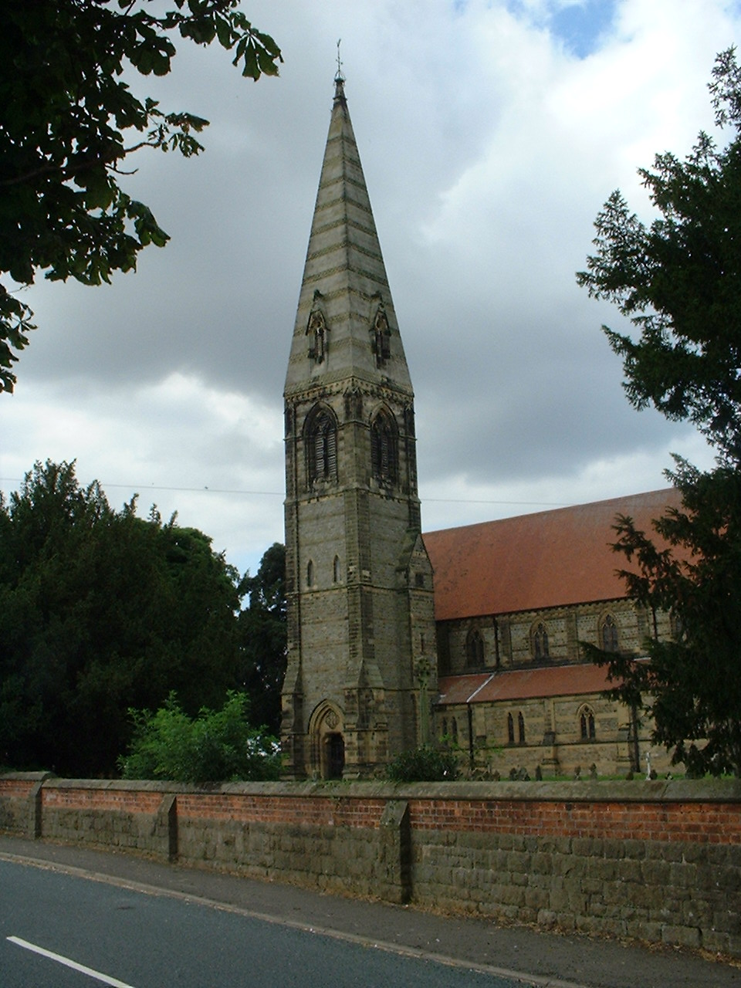
St. James’ Church, Baldersby St. James with Dishforth, Rainton
and Skipton on Swale
Sunday 7th May, 10.45am Communion Service
Sunday 14th May, 9.30am Breakfast Service
Sunday 21st May, 10.45am Communion Service
Sunday 28th May, 9.30am Morning Service
All services have refreshments.

St. Columba’s Church, Topcliffe
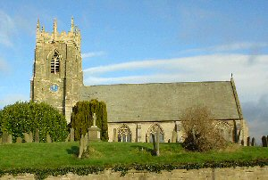
Corporate Member of the Prayer Book Society
Sunday 7th May, 6.30pm Coronation Evensong
Service
followed by refreshments & wine

Sunday 14th May, 10.45am Holy Communion
led by Rev’d Robert Williamson

Sunday 21st May, 10.45am Choral Matins

Sunday 28th May, 10.45am Holy Communion
led by Rev’d Robert Williamson

refreshments after the morning services

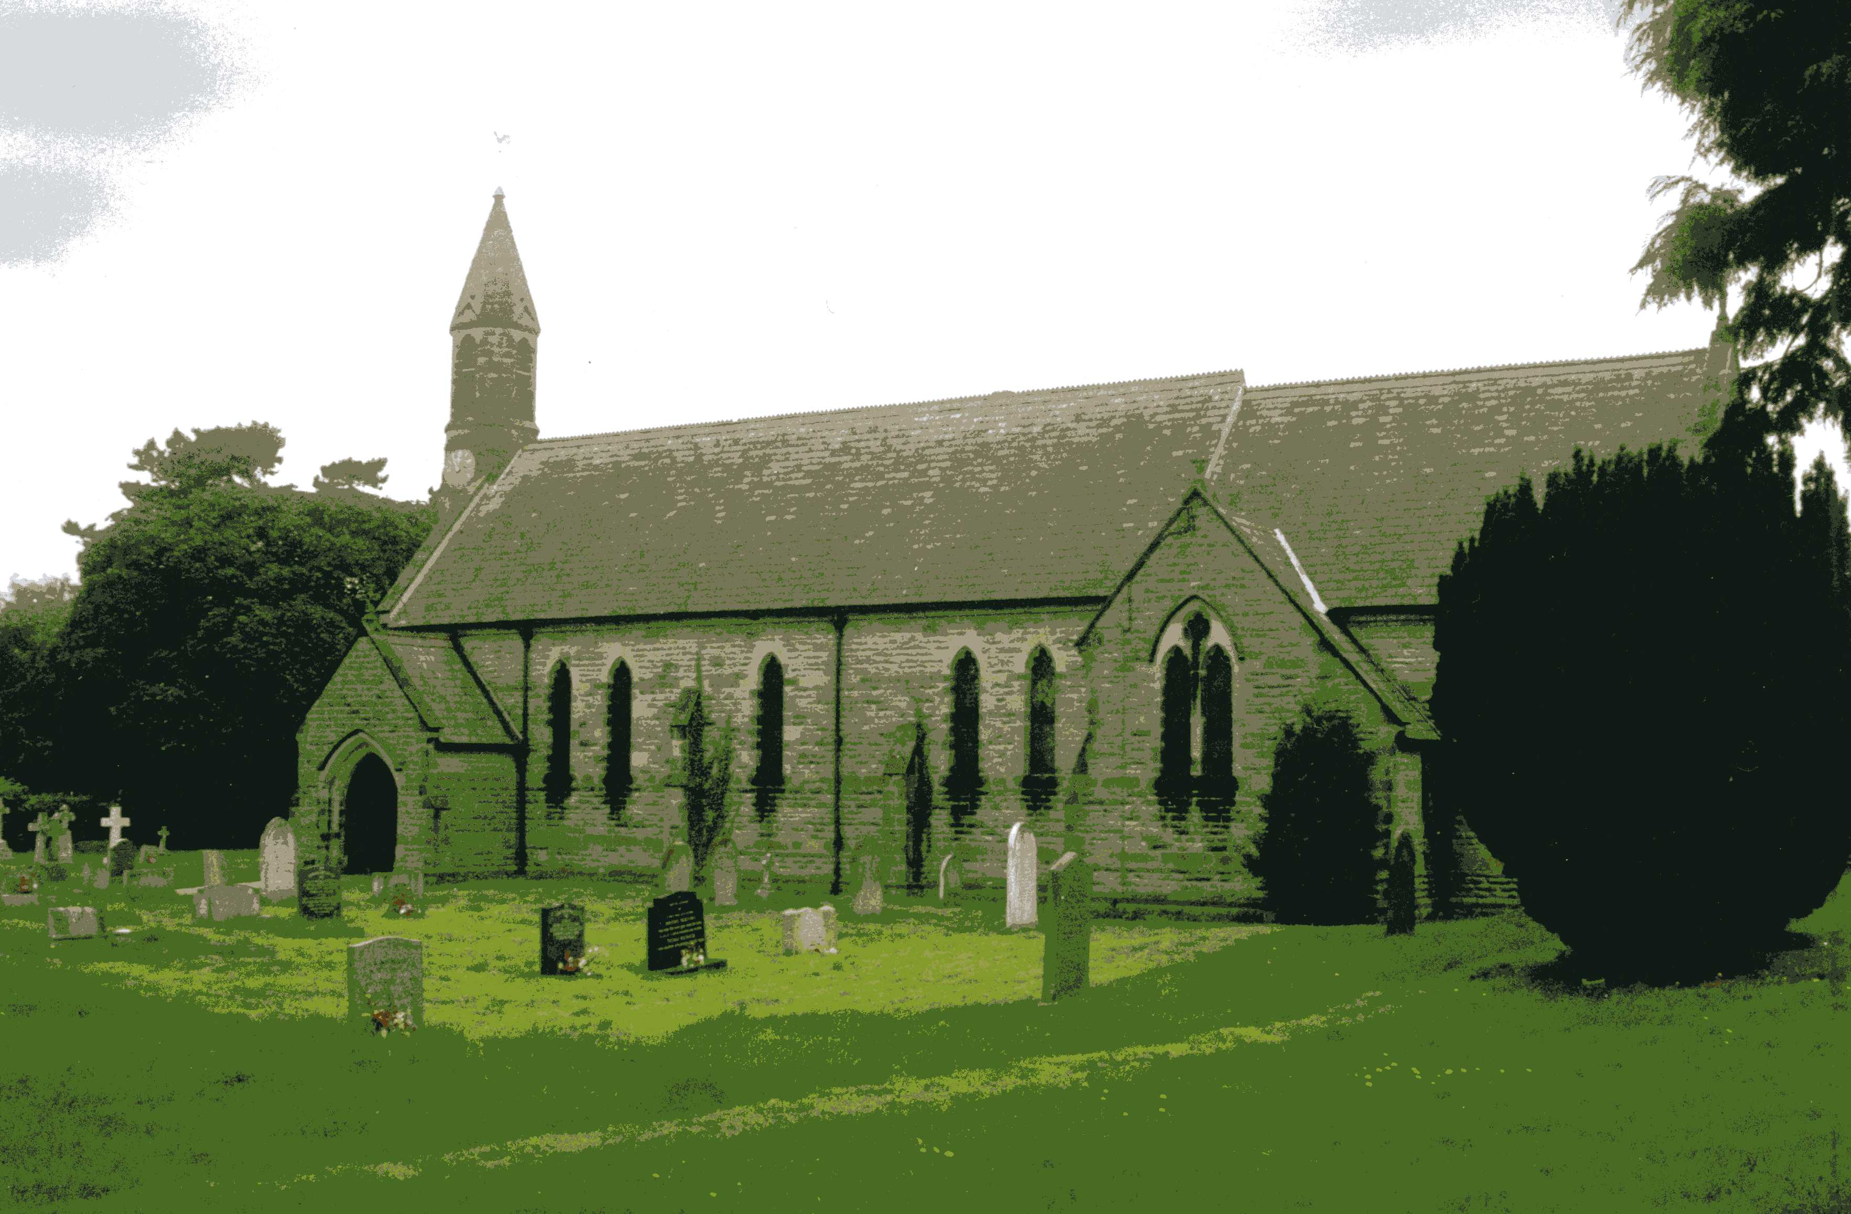
St John the Evangelist Church, Dalton
Sunday 7th May, 11am Family Communion
Sunday 21st May, 11am Family Service

Baldersby St James Events see page 7
Dalton Events see page 7

Readings for 5th Sunday of Easter to Whit Sunday
(Page numbers refer to the Common Worship Lectionary.)

Sunday 7th May : 5th Sunday of Easter
Collect
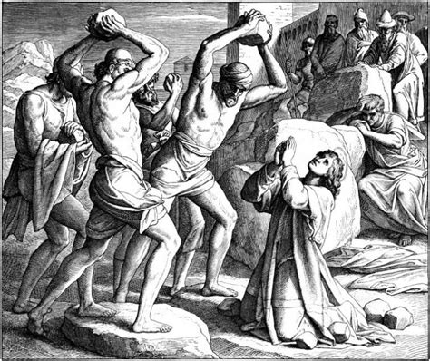
Almighty God,
who through your only-begotten Son Jesus Christ
have overcome death and opened to us
the gate of everlasting life:
grant that, as by your grace going before us
you put into our minds good desires,
so by your continual help
we may bring them to good effect;
through Jesus Christ our risen Lord,
who is alive and reigns with you,
in the unity of the Holy Spirit
one God, now and for ever.

Readings (p179)
Acts 7.55-60 Martyrdom of St Stephen (Acts 7.55-60)
Psalm 31.1-5, [15-16]
1 Peter 2.2-10
Gospel: John 14.1-14

Sunday 14th May : 6th Sunday of Easter : Rogation Sunday
Collect
God our redeemer,
you have delivered us from the power of darkness
and brought us into the kingdom of your Son:
grant, that as by his death he has recalled us to life,
so by his continual presence in us he may raise us
to eternal joy;
through Jesus Christ your Son our Lord,
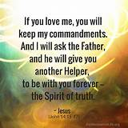
who is alive and reigns with you,
in the unity of the Holy Spirit,
one God, now and for ever.

Readings (p.181)
Acts 17.22-31
Psalm 66.7-18
1 Peter 3.13-22
Gospel: John 14.15-21

Thursday 18th May : Ascension Day

Collect
Grant, we pray, almighty God,

that as we believe your only-begotten Son
our Lord Jesus Christ
to have ascended into the heavens,
so we in heart and mind may also ascend
and with him continually dwell;
who is alive and reigns with you,
in the unity of the Holy Spirit,
one God, now and for ever.

Readings (p.184)
Acts 1.1-11 or Daniel 7.9-14
Psalm 47 or Psalm 93
Ephesians 1.15-23 or Acts 1.1-11
Gospel: Luke 24.44-53

Sunday 21st May : 7th Sunday of Easter

Collect
O God the king of glory,
you have exalted your only Son Jesus Christ
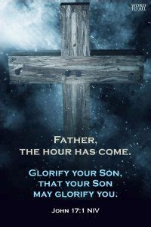
with great triumph to your kingdom in heaven:
we beseech you, leave us not comfortless,
but send your Holy Spirit to strengthen us
and exalt us to the place
where our Saviour Christ is gone before,
who is alive and reigns with you,
in the unity of the Holy Spirit,
one God, now and for ever.

Readings (p.189)
Acts 1.6-14
Psalm 68.1-10, [33-36]
1 Peter 4.12-14; 5.6-11
Gospel: John 17.1-11

Sunday 28th May : Day of Pentecost, Whit Sunday

Collect
God, who as at this time
taught the hearts of your faithful people
by sending to them the light of your Holy Spirit:
grant us by the same Spirit
to have a right judgement in all things
and evermore to rejoice in his holy comfort;
through the merits of Christ Jesus our Saviour,
who is alive and reigns with you
in the unity of the Holy Spirit,
one God, now and for ever.

Readings (p.193)
Acts 2.1-21 or Numbers 11.24-30
Psalm 104.25-35, [36,] 37
1 Corinthians 12.3b-13 or Acts 2.1-21
Gospel: John 20.19-23 or John 7.37-39

May Reflection, 2023

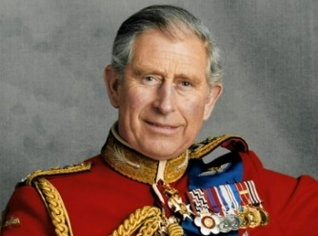
The coronation of King Charles III on 6th May will be a historic moment in the life of our nation. The coronation service will take place, by long standing tradition, at Westminster Abbey with the first documented coronation at Westminster Abbey being that of William the Conqueror on 25th December 1066 (or the Saxon King Harold II in January 1066 depending on which source you believe).
Over the years the duties of the monarch have changed radically from absolute ruler where the monarch ruled with unlimited power, to our present constitutional monarch who has in reality much less power and whilst remaining Head of State, the ability to make and pass legislation resides with the elected Parliament.
With such a variation in the definition of kingship, we need to be aware of what we mean when we talk about ‘The Kingdom of God’ or when we see Jesus described as ‘King of the Jews’.
The idea that Jesus could be a legitimate king would have seemed to Pilate, utterly absurd. And Jesus’ definition of his kingdom would have made little sense to Pilate who only knew kingship in terms of absolute rulers. In John 18:36, Jesus says ‘My kingdom is not of this world. If my kingdom were from this world, my followers would be fighting to keep me from being handed over to the Jewish authorities. But as it is my kingdom is not from here’.
So, what is the Kingdom of God? It is an idea that has often been manipulated to promote a particular idea that gives power to a certain group of people. It has been used to identify the church as an institution of God’s domain, to impose conformity and obedience. The resurgence of white supremacism in the USA has often been accompanied by a belief that the racial inequalities of the nation are God sanctioned.
Alternatively, there have been Christians on the political left who have promoted the idea that the Kingdom of God is a future socialist paradise.
When Jesus spoke about the Kingdom of God, he did so most of the time in parables and not in terms of a political system that can be found or made on the earth.
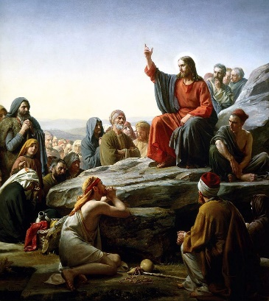
In St Mark ‘s gospel we read of Jesus repeatedly saying how precious it is to seek and glimpse the Kingdom of God and in St Luke’s Gospel we are given the picture of the banquet, where all are invited, to sit and eat together, in the host’s presence. The host is God himself and whenever we come together to share the Eucharist, we are sitting together, with all our differences, celebrating that human solidarity that was at the centre of Jesus’ preaching.
Only in St Matthew do we get clear guidance on how we are to be to be a part of God’s kingdom. In the beatitudes in the sermon on the Mount, we get something totally at odds with the coldness and self-centredness of Pilate. We get the lived truth which Christ represented:
To be able to grieve and to have a forgiving and a humble heart. To show mercy and forgiveness. To be hungry for the right way to live. To make and build peace. To be willing to put your head above the parapet for the sake of others and your convictions.
Hatred and totalitarianism, self, family or nation coming first whatever the cost to others, none of these have any room in the Kingdom of God, for which we pray every time we say the Lord’s Prayer.
In his first speech as King, Charles III said he felt “profound sorrow” over the death of his mother, Queen Elizabeth II, and vowed to carry on her “lifelong service” to the nation. Echoing the pledge made by his mother before assuming the throne, the King said: “that promise of lifelong service I renew to you today . . . . Whatever may be your background or beliefs, I shall endeavour to serve you with loyalty, respect, and love.”
In keeping this promise his kingship will be much closer to that ideal of the Kingdom of God than the absolute monarchy of some of his ancestors.
A Prayer for The King
Almighty God, the fountain of all goodness, bless our Sovereign Lord, King Charles, and all who are in authority under him; that they may order all things in wisdom and equity, righteousness and peace, to the honour of your name, and the good of your Church and people; through Jesus Christ our Lord. Amen.
The Venerable Bede
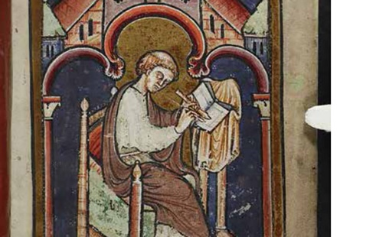
The Venerable Bede, also known as Saint Bede, was an English monk at the monastery of St Peter and its companion monastery of St Paul (the twin monastery of Monkwearmouth–Jarrow) in the Kingdom of Northumbria of the Angles. His feast day is 25th May which is the anniversary of his death in 735AD.
Bede is regarded as ‘the father of English history’. He wrote several works including a natural history, a ‘universal chronology of the Christian era’ based on astronomical studies but is best remembered for his Ecclesiastical History of the English People, a history of the church in England. It was completed in about 731AD, and Bede implies that he was then in his fifty-ninth year, which would give a birth date in 672 or 673AD.
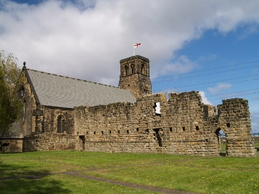
At the age of seven, Bede was sent to the monastery of Monkwearmouth by his family to be educated by Benedict Biscop and later by Ceolfrith. Bede says nothing of his origins, but his connections with men of noble ancestry suggest that his own family was high ranking. It was fairly common in Ireland at this time for young boys, particularly those of noble birth, to be fostered out as an oblate; the practice was also likely to have been common among the Germanic peoples in England. Monkwearmouth's sister monastery at Jarrow was founded by Ceolfrith in 682AD, and Bede probably transferred to Jarrow with Ceolfrith that year.
The dedication stone for the church has survived; it is dated 23rd April 685, and as Bede would have been required to assist with menial tasks in his day-to-day life it is possible that he helped in building the original church.
In 686AD, plague broke out at Jarrow. ‘The Life of Ceolfrith’, written in about 710AD, records that only two surviving monks were capable of singing the full offices; one was Ceolfrith and the other a young boy, who according to the anonymous writer had been taught by Ceolfrith. The two managed to do the entire service of the liturgy until others could be trained. The young boy was almost certainly Bede, who would have been about 14 years old.
In about 701 Bede wrote his first works and he continued to write for the rest of his life, eventually completing over 60 books, most of which have survived. Another important area of study for Bede was the academic discipline of computus, otherwise known to his contemporaries as the science of calculating calendar dates. One of the more important dates Bede tried to compute was Easter, an effort that was mired in controversy. He also helped popularize the practice of dating forward from the birth of Christ (Anno Domini—in the year of our Lord), a practice which eventually became commonplace in medieval Europe.
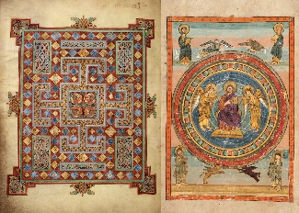
Bede may have worked on some of the Latin Bibles that were copied at Jarrow, one of which, the Codex Amiatinus, is now held by the Laurentian Library in Florence. Bede was a teacher as well as a writer; he enjoyed music and was said to be accomplished as a singer and as a reciter of poetry in the vernacular.
One oddity in his writings is that in one of his works, the ‘Commentary on the Seven Catholic Epistles’, he writes in a manner that gives the impression he was married. The section in question is the only one in that work that is written with a first-person view. Bede says: "Prayers are hindered by the conjugal duty because as often as I perform what is due to my wife, I am not able to pray." In another passage, in the Commentary on Luke, also mentions a wife in the first person.
Bede's tomb is in the Galilee Chapel at the west end of Durham Cathedral.
Bede died on the Feast of the Ascension, Thursday, 26th May 735. At three o'clock, according to Cuthbert, he asked for a box of his to be brought and distributed among the priests of the monastery ‘a few treasures’ of his: some pepper, and napkins, and some incense’. That night he dictated a final sentence to the scribe, a boy named Wilberht, and died soon afterwards.
Richard Byas

A couple of hikers were tramping through the countryside and had lost their way, so by the time they arrived at the "George and Dragon", the village pub where they'd arranged to stay the night, the doors were locked, and the owners had gone to bed. They knocked timidly on the front door.
A head appeared at an upstairs window and shouted, "Go away. Don't you know what time it is? We're closed," and the window slammed shut.
Undeterred, the hikers knocked again. "What is it now?" demanded the head.
"Could we speak to George this time please?" asked one of the hikers.

Baldersby St James Diary Dates

Sunday 25th June – Pet Service at St James Church

Thursday 29th June – Junction 50 First musical eventually

September 9th and 10th – Book Sale in church

Every Tuesday morning from 10 until 12 – Coffee and Chat

Dalton News

King’s Coronation Party
We are having our Coronation Party on Saturday 6th May from 2-5pm, with an afternoon tea for the village children. There will be a steel band, giant jenga, bouncy castle, owl display and the bar will be open.

Dalton Film Club in the Village Hall
Films are shown on the 2nd Sunday of every month. Popcorn and sweets are available for sale, and the bar will be open.
On 14th May at 2pm the matinee for the kids will be “Up” and at 7pm the film for 15+ will be “Belfast”. The shows are free of charge, but any donations towards the costs involved would be greatly appreciated.

Dalton 120 Club
Results for April:
£15 – Michaela Kitching (No.82)
£10 – John Wagstaff (No.75)
£6 – Mel Brice (No.108).

Sylvia Binks

PARISH DIRECTORY
The Parishes of Topcliffe, Baldersby with Dishforth and Skipton on Swale, and Dalton.
There is currently no Vicar of the parishes. Until one is appointed, please contact our Area Dean,
Revd Mary Rolls, tel: 01845 400480 email: revmaryrolls@gmail.com.

BALDERSBY with DISHFORTH and SKIPTON-ON-SWALE - PCC Secretary: Mrs Jennifer Wharton wharton370@btinternet.com

DALTON - PCC Secretary: Mrs Hannah Bissett tel: 07739 382831 spannerb79@gmail.com

TOPCLIFFE – PCC Secretary: Mrs Roz Norris RozNorris@aol.com

