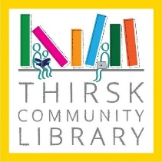

AUTUMN ACTIVITIES 2022

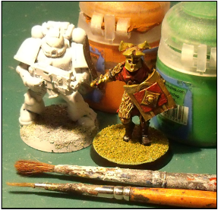
WARHAMMER WARGAMES CLUB
Mondays weekly term time 3.45 – 4.45pm
8 – 14 years children
Cost £2 per child
Suitable for both beginners and more experienced players/model makers
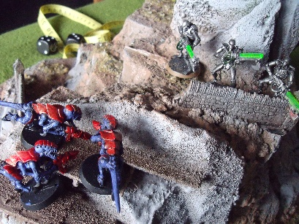
Learn quick and simple Warhammer game rules to get straight into battle! Try out different ways of painting figures; learn to make your own battlefield scenery; have the chance to try out other gaming with Lord of the Rings, Doctor Who, Star Wars and Battle Cars. Booking essential: email library@thirskcommunitylibrary.org.uk or phone 01609 534589.
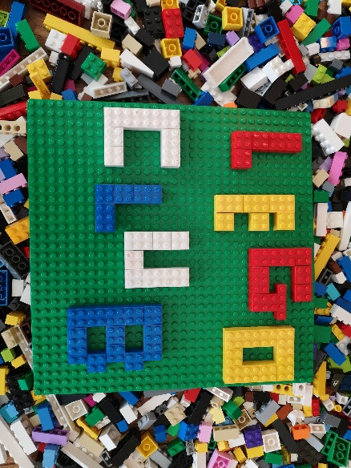

LEGO CLUB
Tuesdays and Thursdays weekly term time 3.45 – 4.45pm
Cost £1 per child
Calling all Lego builders and creators out there to our after school Lego Club suitable for children aged 5 and over. Lego is provided and each week we shall have a different theme. Booking essential. E: library@thirskcommunitylibrary.org.uk or phone 01609 534589.

STORYTIME MONDAYS
Mondays weekly 1.30 – 2.15pm
All preschool children welcome – term time only
FREE - enjoy stories, rhymes and songs and activities for young children in the library. Just turn up; no booking required.

CONSTRUCTION PLAY
Weekly every Friday from 10.30am until 4pm
All preschool children welcome and it’s FREE – bricks, DUPLO, train just play and build.
Just turn up

