Benefice Online Magazine

for the Parishes of Topcliffe, Baldersby with Dishforth, Dalton and Skipton on Swale
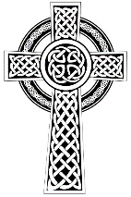 Cross Talk
August 2022
Cross Talk is published monthly by email. To receive a copy please contact kitnorris@live.co.uk
Cross Talk contains the weekly Collect and Readings together with details of Church services in the Benefice and news and items of interest supplied by our readers. The magazine will also be available on the web sites: www.achurchnearyou.com/church/3447 and baldersbychurch.com.

CHURCH SERVICES

St. James’ Church, Baldersby St. James with Dishforth and Rainton
Sunday 7th August, 10.45am Communion Service followed by refreshments.
Sunday 14th August, 9.30am Breakfast Service with Coffee and Croissants
Sunday 21st August, 10.45am Communion Service followed by refreshments.
Sunday 28th August, 9.30am Morning Service followed by refreshments

St. Columba’s Church, Topcliffe
Corporate Member of the Prayer Book Society
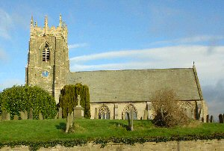Sunday 7th August, 6.30pm Choral Evensong with hymns

Sunday 14th August, 10.45am Holy Communion with hymns
followed by refreshments
Sunday 21st August, 10.45am Choral Matins with hymns
followed by refreshments
Sunday 28th August, 10.45am Holy Communion with hymns
followed by refreshments

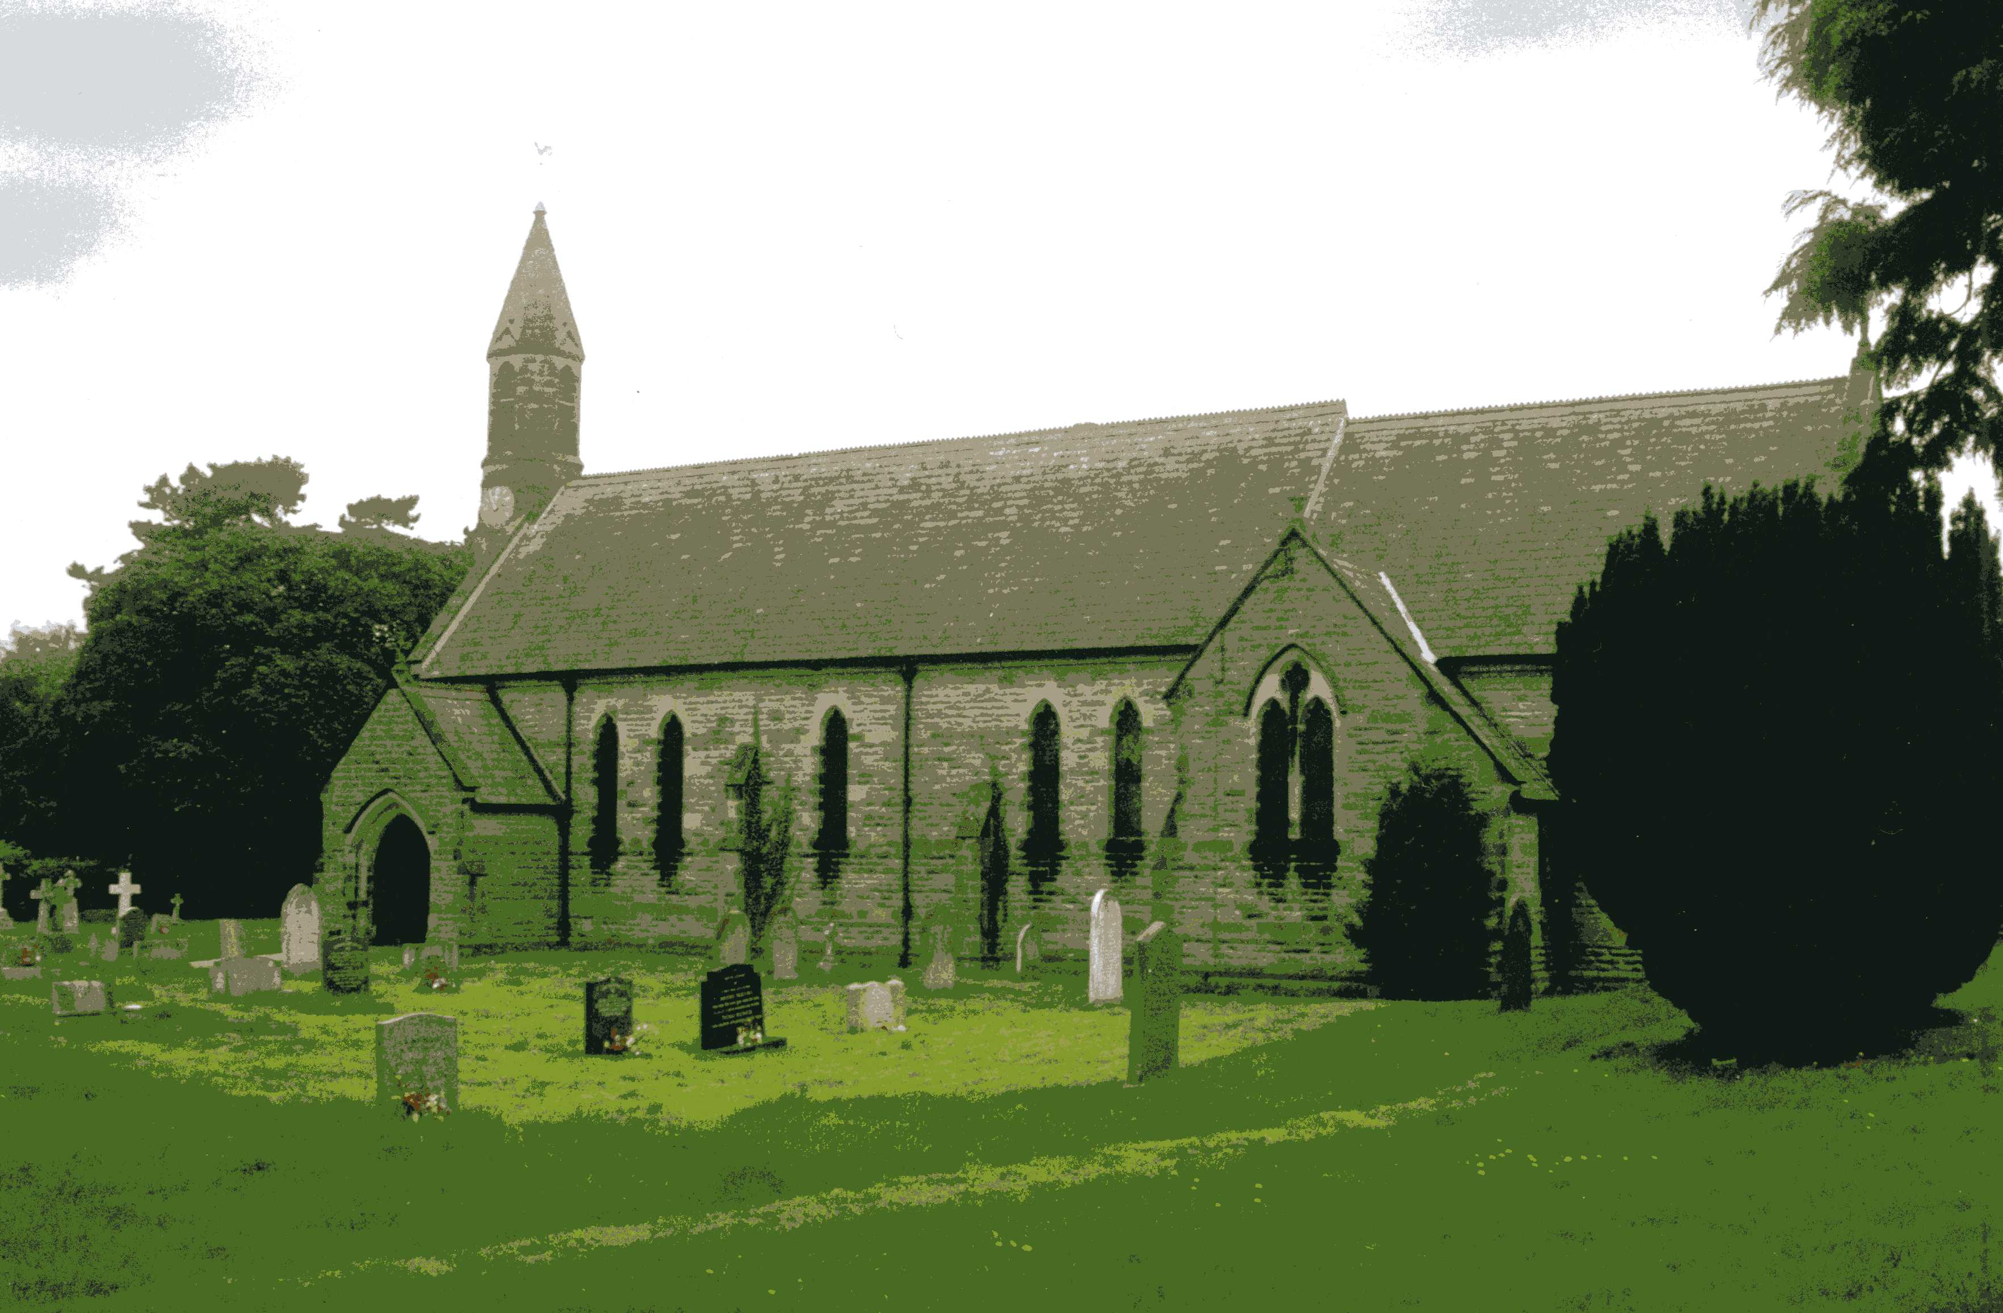St John the Evangelist Church, Dalton
Sunday 7th August, 11am Holy Communion
Sunday 21st August, 11am Holy Communion

Baldersby St James News is listed on page 8.

Dalton Social Events will be listed in a separate update.

Readings for 8th Sunday after Trinity to 11th Sunday after Trinity
(Page numbers refer to the Common Worship Lectionary.)

Sunday 7th August : 8th Sunday after Trinity
Collect
Almighty Lord and everlasting God,
we beseech you to direct, sanctify and govern
both our hearts and bodies
in the ways of your laws
and the works of your commandments;
that through your most mighty protection, both here and ever,
we may be preserved in body and soul;
through our Lord and Saviour Jesus Christ,
who is alive and reigns with you,
in the unity of the Holy Spirit,
one God, now and for ever.
Readings (p.1009) – Proper 14, Related
Genesis 15.1-6
Psalm 33.12-21, [22]
Hebrews 11.1-3, 8-16
Gospel: Luke 12.32-40

Sunday 14th August : 9th Sunday after Trinity
Collect
Almighty God,
who sent your Holy Spirit
to be the life and light of your Church:
open our hearts to the riches of your grace,
that we may bring forth the fruit of the Spirit
in love and joy and peace;
through Jesus Christ your Son our Lord,
who is alive and reigns with you
in the unity of the Holy Spirit,
one God, now and for ever.

Readings (p.1015) – Proper 15, Related
Jeremiah 23.23-29
Psalm 82
Hebrews 11.29-12.2
Gospel: Luke 12.49-56

Sunday 21st August : 10th Sunday after Trinity
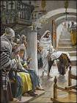Collect
Let your merciful ears, O Lord,
be open to the prayers of your humble servants;
and that they may obtain their petitions
make them to ask such things as shall please you;
through Jesus Christ your Son our Lord,
who is alive and reigns with you,
in the unity of the Holy Spirit,
one God, now and for ever.

Readings (p.1020) - Proper 16, Related
Isaiah 58.9b-14
Psalm 103.1-8
Hebrews 12.18-29
Gospel: Luke 13.10-17
Jesus heals the crippled woman

Sunday 28th August : 11th Sunday after Trinity
Collect
Let your merciful ears, O Lord,
be open to the prayers of your humble servants;
and that they may obtain their petitions
make them to ask such things as shall please you;
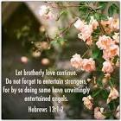through Jesus Christ your Son our Lord,
who is alive and reigns with you,
in the unity of the Holy Spirit,
one God, now and for ever.

Readings (p.1026) – Proper 17, Related
Ecclesiasticus 10.12-18 or Proverbs 25.6-7
Psalm 112
Hebrews 13.1-8, 15-16
Gospel: Luke 14.1, 7-14

August Reflection, 2022
August Reflection 2022
We are now in the middle of the summer holidays. For many it is a time to relax, to go on holiday and to refresh. And yet for many others that just isn‘t how life is.
If we are lucky enough to be going on holiday the process of getting there will often involve traffic jams or airport queues and cancelled flights leaving us feeling more fatigued than when we had started. And for others, the prospect of children and parents being together for six weeks without school to break up the day can lead to all sorts of tensions. For many poorer families there is the added pressure of having to find another meal for the children every day for the six weeks when there are no free school meals.
That might sound like a very negative way to open some thoughts on rest and relaxing, but it does pose the question as to what we think might enable us to feel relaxed and refreshed. Is it the perfect holiday? Or possibly is it the time and space to finally get around to reading that book without interruptions? Or is it maybe just not having to take responsibility for everything for a while………..
Jesus told his followers that real rest was to be found elsewhere. He told them ‘Come to me, all you that are weary and are carrying heavy burdens, and I will give you rest. Take my yoke upon you and learn from me; for I am gentle and humble in heart, and you will find rest for your souls’.
After the crises of the last couple of years, it seems that there are very few of us who aren‘t weary in some way. And so Jesus’ invitation is for us to come to Him, as in Jesus we find out what life is truly about and can therefore let go of so much that causes us to stress or to strive.
Throughout Christian history, Jesus’ followers have experienced that rest and refreshment through spending time with Him. This rhythm of taking time to be with God each day is sometimes called the Daily Office. The word ‘office‘ comes from a word meaning ‘work‘ and so rather than being an avoiding of our daily issues, our regular time with God is part of our ‘work‘ of being human.
How we spend that time will vary from person to person. It might include prayer, music, reading the Bible, having a walk in the countryside, silence or solitude depending on our nature. We each need to find ways of connecting with God that are genuinely refreshing, recognising that these may change over time. And yet it is the spending time with God that enables us to reorientate and to refresh.
Jesus does talk about putting on his ‘yoke‘, an image of carrying something, but the point that he is making is that so often we take on ourselves more than we can or should carry. In coming to Jesus, we get to work out what the appropriate things are that we should be carrying, and in doing so we find that our tasks may even be life giving rather than life draining because they fit with our God given gifts and talents.
If we do take up Jesus’ invitation to order our life in alignment with Jesus‘ own connection to God and purpose in the world then the result is rest. Not just metaphorical rest but actual rest for our souls. A rest and relaxation not confined to the summer holidays.
Richard Byas

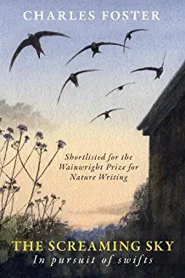The Screaming Sky – in pursuit of swifts. Charles Foster
For me the sound of summer in Topcliffe and Asenby are gangs of swifts darting through the sky and issuing a high-pitched screaming call.
By August some swifts will already have left us and by the end of the month few if any will be left flying over the villages. We see the first swifts in May; by July at dusk the sky can seem filled with them as they gather in 'screaming parties', the exact purpose of which is unknown.
Swifts are the UK's fastest bird in level fight, recorded at nearly 70 miles per hour. The peregrine falcon is faster, but only when aided by gravity when flying downward. Sleeping, eating, bathing and even mating on the wing, swifts rarely touch the ground. They are plain sooty brown, with a white throat, but in flight against the sky they appear black. They have long, scythe-like wings and a short, forked tail. Swifts are summer visitors, breeding across the UK, but are most numerous in the south and east. Spending their winters in Africa, swifts migrate 3,400 miles twice a year, stopping off to refuel in places like Portugal and France along the way. By doing this, swifts live in perpetual summer.
Swifts use their speed and agility to catch flying insects on the wing. They can take a range of prey but avoid stinging insects like bees and wasps.
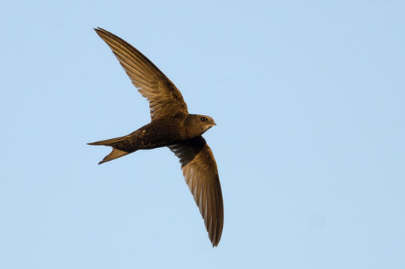Swifts pair for life, returning to the same site each year for a little nest renovation before laying and incubating their eggs. Historically, swifts would have nested in holes in large trees, cliffs and crevices. However, today's UK population depends almost entirely on buildings for nest sites. The nest is built under the eaves of old buildings and is made from any materials the swift can catch in flight. The birds then use their own saliva to hold the nest together.
Two to three eggs are normally laid, hatching after three to four weeks. The chicks will spend up to eight weeks in the nest before fledging. They like to live in houses and churches, squeezing through tiny gaps to nest inside roofs. But as more old buildings are renovated and gaps in soffits closed up, swift nest sites are fast disappearing. This, in part, has resulted in swifts being added to the Red List in the 2021 UK Conservation Status Report. The UK's swift population has suffered a worrying decline, with a fall of more than 51% estimated between 1995 and 2015.
Soon the swifts over our villages will be gone for another year – a sign that summer’s days are numbered.
Charles Foster’s book ‘The Screaming Sky, in pursuit of swifts’ takes us on their annual journey starting in January when they are in Africa. He reminds us that ‘our’ swifts are not really ours at all as they make their annual journeys over thousands of miles never resting for too long in any place.
Richard Byas

“If I had all the beer in the world, all the drink in the world even all the whisky in the world I’d take it and throw it in the river,” a vicar said as he finished a temperance sermon.
As the vicar sat down the curate stood up and announced the final hymn “Let us sing Hymn number 365: “Shall We Gather at the River”


Baldersby St James News
COFFEE and CHAT
Drop in every Tuesday morning between 10am until 12 noon.
MUSIC AT JUNCTION 50
Thursday 1st September at 7pm. We welcome Sirocco Winds – three young professional musicians playing the flute, clarinet and bassoon. Tickets £10. Pay on the door or collect from The Good Food Shop in Baldersby. To reserve tickets contact Colin Reid, tel: 07770620897.
BOOK SALE
The Book Sale is on Saturday 10th and Sunday 11th September from 10am to 5pm each day. Free entry. Helpers are needed to put out books on Thursday 8th / Friday 9th prior to the event and set out tables etc on the Wednesday evening. If you can help please contact Stuartt/Rosemarie on 01765 640360, e-mail: carter-stuart@btconnect.com for further details.
Susan Brown
Dalton Events
Will be listed in a separate update.

PARISH DIRECTORY
The Parishes of Topcliffe, Baldersby with Dishforth, Dalton and Skipton on Swale
There is currently no Vicar of the parishes. Until one is appointed, please ring our Area Dean,
The Revd Fiona Mayer-Jones tel: 07450 402953 or revdfmj@gmail.com until 24th July.. Revd Mary Rolls will be commissioned as Area Dean on 25th July.

BALDERSBY with DISHFORTH - PCC Secretary: Mrs Jennifer Wharton wharton370@btinternet.com

DALTON - PCC Secretary: Mrs Hannah Bissett tel: 07739 382831 spannerb79@gmail.com

SKIPTON-on-SWALE – PCC Secretary: Mr Alan Kitching tel: 01845 567457

TOPCLIFFE – PCC Secretary: Mrs Roz Norris RozNorris@aol.com

