Topcliffe & Asenby Jubilee Celebrations Information Leaflet 2nd-5th June 2022
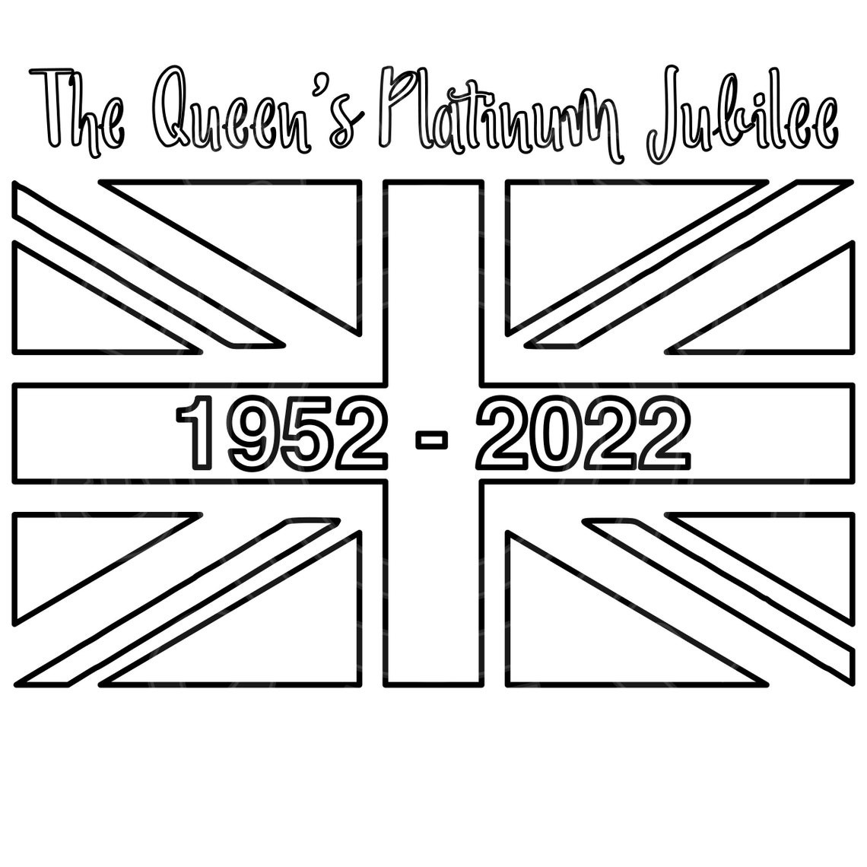

Afternoon Tea Order Slip:
The tea will include a selection of sandwiches, a savory Item, Quiche/sausage Roll, Scone and piece of cake.
Please note any specific dietary requirements: …………………………………………
Number of People ………………..
£5pp to be paid in cash on the day. Collection from 2pm at Topcliffe Bowling Club.
Pre-orders by Wednesday 1st June.

Sunday 5th June
Platinum Jubilee Sunday Brunch
A team from the Village Hall Committee will be holding a Brunch from 10am to Noon. There will be breakfast buns and a range of cakes, tea, coffees and cold drinks available. They’ll also be Sunday papers: all money raised goes to the village hall.

Children’s Art Competition Judging and Awards – The Children at Topcliffe School have been asked to submit a piece of Art, each year group has a different theme. The Art work will be displayed at the Village Hall during the Brunch. The prizes will be given out at noon – don’t miss it.

Bringing the weekend to a close – 6.30pm at St Columba’s
St Columba’s are organising a platinum Jubilee Choral Evensong, with a full choir, from 6.30pm followed by refreshments.
Everyone is warmly welcome.

Thursday & Friday 2nd & 3rd June
The Angel Inn Platinum Jubilee Celebration: 12Noon to 5pm:
Activities include a bouncy castle, treasure hunt, garden games and live music.

Saturday 4th June
A view from above: 2pm onwards
St Columba’s will be open for guided tours, your chance to see the wonderful view of our decorated village from the Church Tower.

Platinum Jubilee Party in the Park: 2pm onwards
You are invited, on behalf of the Parish Council of Topcliffe, to Topcliffe playing Field for an afternoon of fun and music.
Bring your own picnic blanket and refreshments, lay back and enjoy the afternoon. (Limited Gazebo Pitches available at £10 each, to book call Jenny on 07840468672)
You can also pre-order afternoon tea from Louise Bumby on 01845 577358 or by filling the slip out and posting it at Rangimarie, Long Street. (Next to the farm)
We need all orders by Wednesday 1st June. You can collect your tea at the Bowling Club from 2pm on the day. There will be tables from the Bowling Club set up if people wish to use them.
There will be an inflatable Obstacle Course, Children’s Garden games, Live Music from 4pm: Harry Hutchinson & Cai followed by The Black Marcs.
The Ice Cream van will also be making an appearance and Topcliffe Bowling Club will be organising a family flat green bowls competition.
*All children must be accompanied by and adult*
Entry is by donations on the day, all money raised will go to Topcliffe Parish Council.

Children Crown Competition – Please encourage your children to make and wear their crown to the Jubilee Party in the Park – There are prizes for the best ones!!

Decorate your house - All residents are encouraged to decorate their house for this special event, have your house ready to judge on Saturday morning: We have some amazing prizes, generously donated by local businesses.

