Benefice Online Magazine

for the Parishes of Topcliffe, Baldersby with Dishforth, Dalton and Skipton on Swale
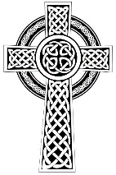
Cross Talk
May 2022
Cross Talk is published monthly by email. To receive a copy please contact kitnorris@live.co.uk
Cross Talk contains the weekly Collect and Readings together with details of Church services in the Benefice and news and items of interest supplied by our readers.
The magazine will also be available on the web sites: www.achurchnearyou.com/church/3447 and baldersbychurch.com.

CHURCH SERVICES
The following services are planned subject to changes in the Covid-19 regulations.

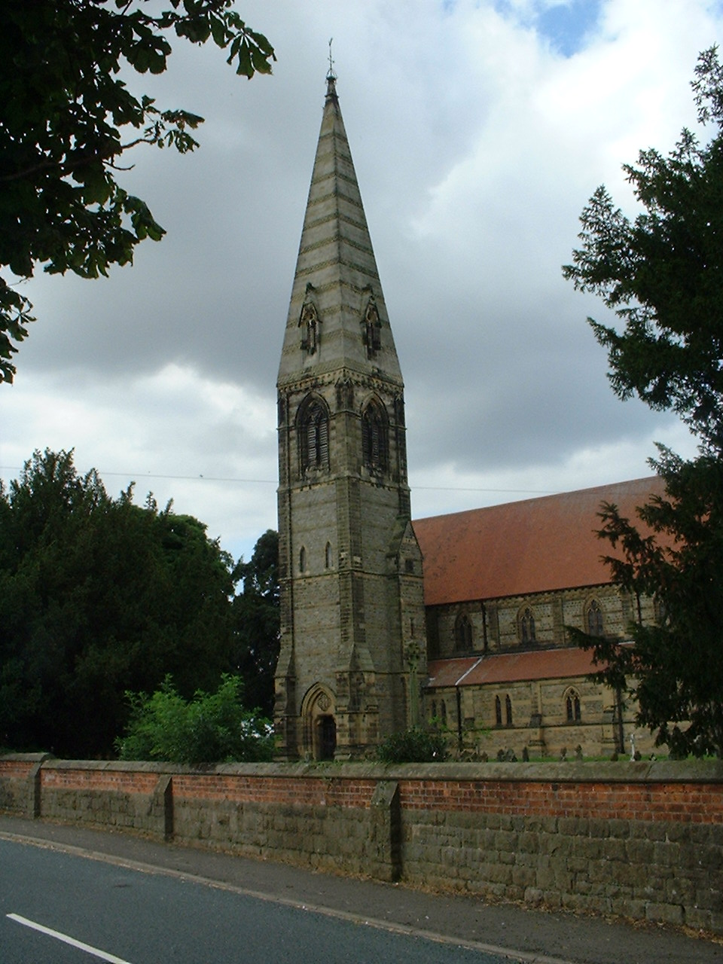
St. James’ Church, Baldersby St. James with Dishforth and Rainton
Sunday 1st May, 10.45am Communion Service with Revd. Sheilagh Williamson.
Sunday 8th May, 9.30am Breakfast Service with Reader Peter Carrotte.
Sunday 15th May, 10.45am Communion Service with Revd. Sheilagh Williamson.
Sunday 22nd May, 9.30am Morning Prayer with Reader Peter Carrotte. (short spoken service)
Sunday 29th May No service

All services followed by coffee.

St. Columba’s Church, Topcliffe
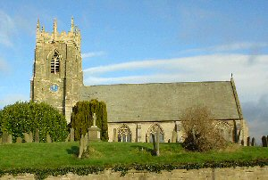
Sunday 1st May, 6.30pm Choral Evensong

Sunday 8th May, 10.45am Holy Communion
Sunday 15th May, 10.45am Choral Matins
Sunday 22nd May, 10.45am Holy Communion
Sunday 29th May, No service

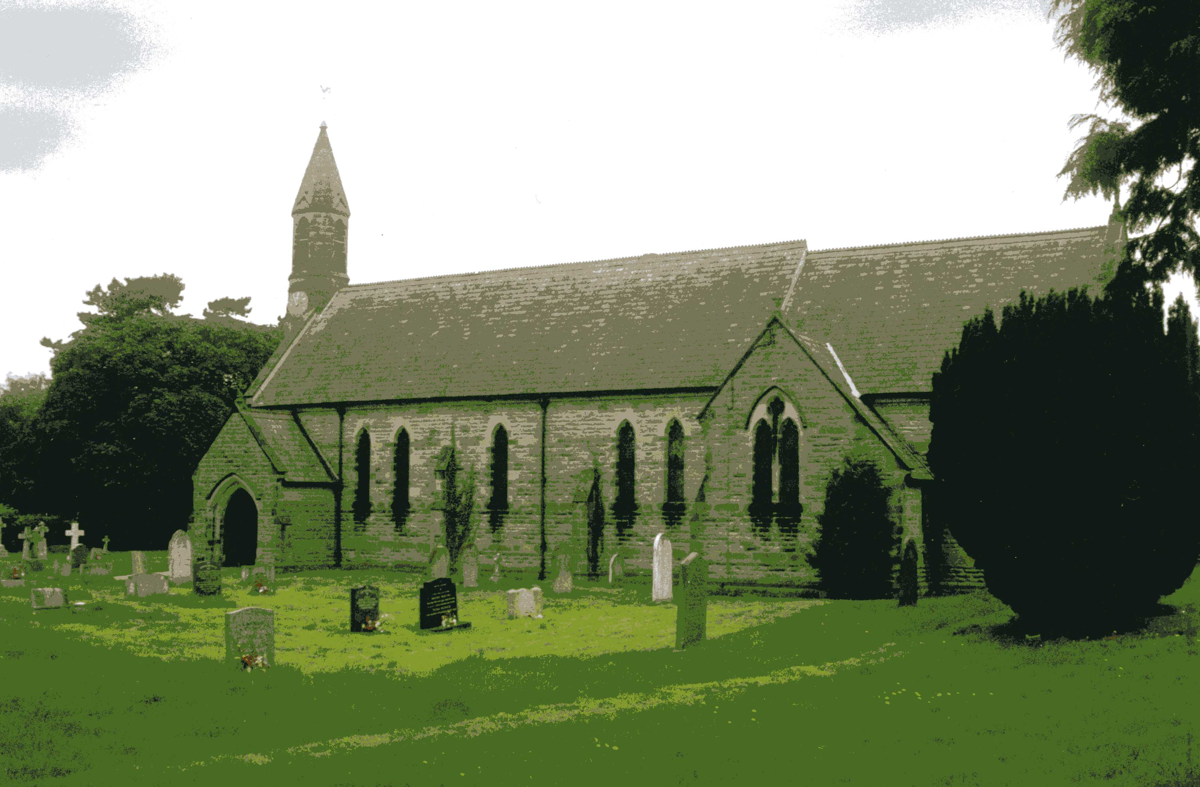
St John the Evangelist Church, Dalton
Sunday 1st May, 11am Family Service
Sunday 15th May, 11am Family Service

Baldersby St James News is listed on page 7.
Dalton Social Events are listed on pages 7 and 8.
Collects and Readings for 3rd Sunday of Easter to 7th Sunday of Easter
(Page numbers refer to the Common Worship Lectionary.)

Sunday 1st May : 3rd Sunday of Easter
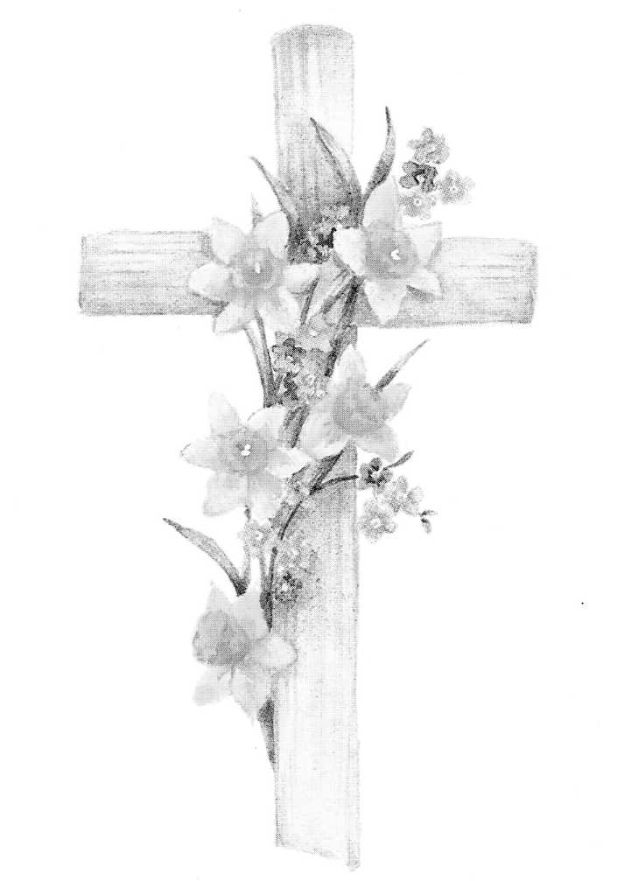
Collect
Almighty Father,
who in your great mercy gladdened the disciples
with the sight of the risen Lord:
give us such knowledge of his presence with us,
that we may be strengthened and sustained
by his risen life
and serve you continually in righteousness and truth;
through Jesus Christ your Son our Lord,
who is alive and reigns with you,
in the unity of the Holy Spirit,
one God, now and for ever.

Readings (p.902)
Acts 9.1-6, [7-20]
Psalm 30
Revelation 5.11-14
Gospel: John 21.1-19

Sunday 8th May : 4th Sunday of Easter
Collect
Almighty God,
whose Son Jesus Christ is the resurrection and the life:
raise us, who trust in him,
from the death of sin to the life of righteousness
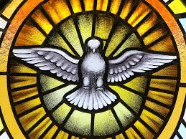
that we may seek those things which are above,
where he reigns with you
in the unity of the Holy Spirit,
one God, now and for ever.

Readings (p.905)
Acts 9.36-43
Psalm 23
Revelation 7.9-17
Gospel: John 10.22-30

Sunday 15th May : 5th Sunday of Easter
Collect
Almighty God,
who through your only-begotten Son Jesus Christ
have overcome death and opened to us
the gate of everlasting life:
grant that, as by your grace going before us
you put into our minds good desires,
so by your continual help
we may bring them to good effect;
through our Lord Jesus Christ,
who is alive and reigns with you,
in the unity of the Holy Spirit,
one God, now and for ever.

Readings (p.908)
Acts 11.1-18
Psalm 148.1-6, [7-14]
Revelation 21.1-6
Gospel: John 13.31-35

Sunday 22nd May : 6th Sunday of Easter : Rogation Sunday
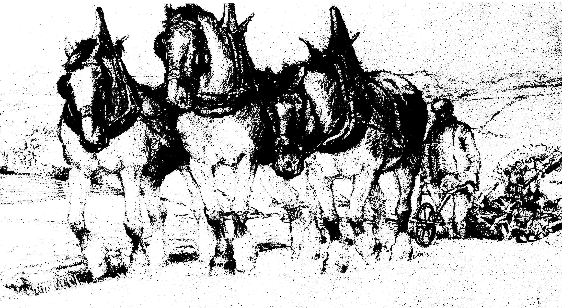
Collect
God our redeemer,
you have delivered us from the power of darkness
and brought us into the kingdom of your Son:
grant, that as by his death he has recalled us to life,
so by his continual presence in us he may raise us
to eternal joy;
through Jesus Christ your Son our Lord,
who is alive and reigns with you,
in the unity of the Holy Spirit,
one God, now and for ever.

Readings (p.911)
Acts 16.9-15
Psalm 67
Revelation 21.10, 22-22.5
Gospel: John 14.23-29 or John 5.1-9


Thursday 26th May : Ascension Day
Collect
Grant, we pray, almighty God
That as we believe your only-begotten Son
our Lord Jesus Christ
to have ascended into the heavens,
so we in heart and mind may also ascend
and with him continually dwell;
who is alive and reigns with you,
in the unity of the Holy Spirit,
one God, now and for ever.

Readings (p.914)
(the reading from Acts must be used as either the first or second reading)
Acts 1.1-11 or Daniel 7.9-14
Psalm 47 or Psalm 93
Ephesians 1.15-23 or Acts 1.1-11
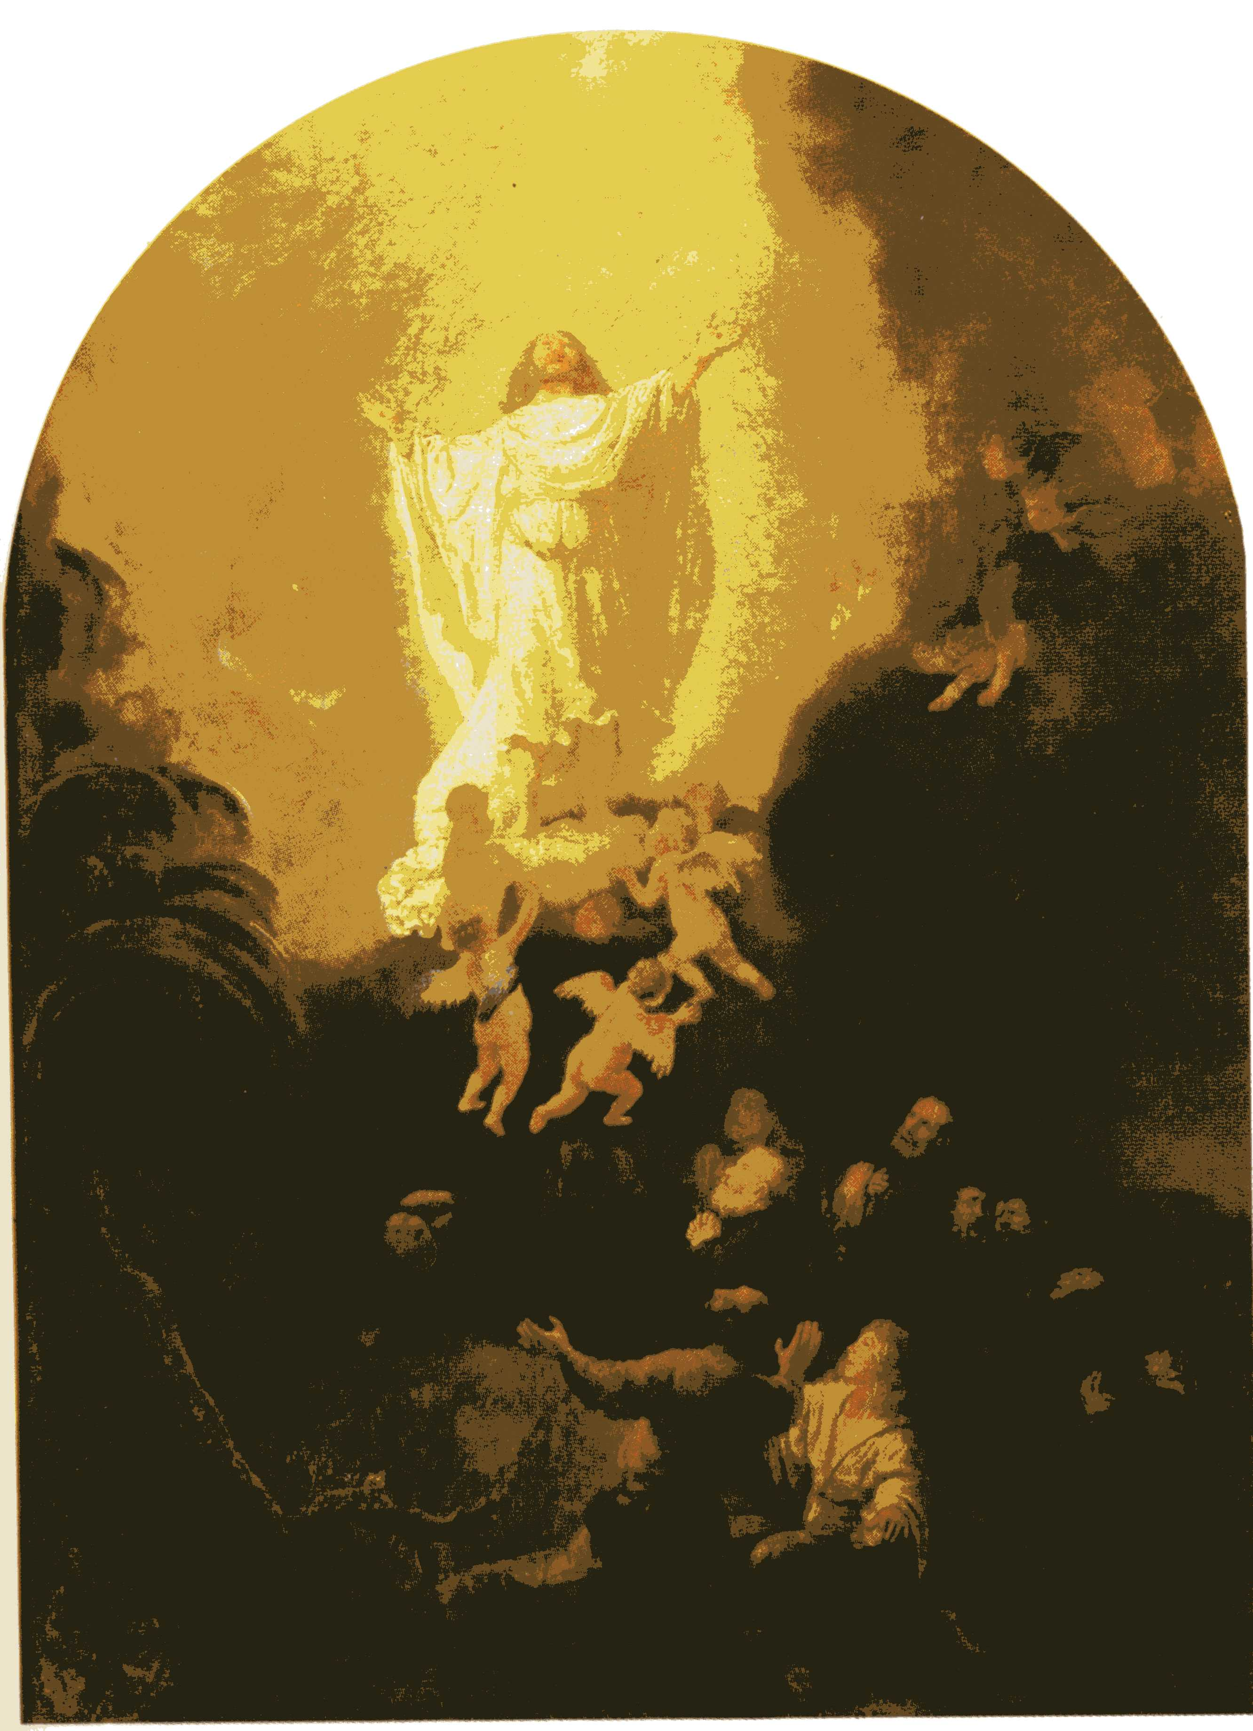
Gospel: Luke 24.44-53

Sunday 29th May : 7th Sunday of Easter
Collect
O God the king of glory,
you have exalted your only Son Jesus Christ
with great triumph to your kingdom in heaven:
we beseech you, leave us not comfortless,
but send your Holy Spirit to strengthen us
and exalt us to the place
where our Saviour Christ is gone before,
who is alive and reigns with you,
in the unity of the Holy Spirit,
one God, now and for ever.

Readings (p.919)
Acts 16.16-34
Psalm 97
Revelation 22.12-14, 16-17, 20-21
Gospel: John 17.20-26

May Reflection
For about two months now as I’ve been driving or walking in the countryside, I’ve been seeing lambs with their mothers in the fields. A lovely sight on a warm, sunny day but I feel very sorry for the small lambs huddling up to their mothers in cold, windy and wet weather.
Sheep and shepherds are frequently mentioned in the Bible, both in the Old and New Testaments with Jesus referring to himself as the Good Shepherd.
John 10: 11-15 (Jesus said) ‘I am the good shepherd. The good shepherd lays down his life for the sheep. The hired hand, who is not the shepherd and does not own the sheep, sees the wolf coming and leaves the sheep and runs away—and the wolf snatches them and scatters them. The hired hand runs away because a hired hand does not care for the sheep. I am the good shepherd. I know my own and my own know me, just as the Father knows me and I know the Father. And I lay down my life for the sheep.
Although the churches of the Benefice are rural churches and there are sheep in many of the fields around us, I’m not sure that we have many shepherds in our community. We have farmers who keep sheep, but that is different to the idea of the shepherd.
My father was brought up on a farm on the Yorkshire Wolds near Driffield in the 1920’s and then there were still some genuine shepherds. It was a time when there were many farm workers, and most things were either done manually or using horse power.
Among the farm workers there was a real hierarchy – all knew their position and what jobs were expected of them. Towards the top of the hierarchy was the carter – responsible for a team of horses and all the various work they did; beneath him would be a carter’s lad to assist him and even lower in the pecking order was thoddy or third lad – the general dogsbody. However, some occupations were more distinct, they were slightly apart from the massed ranks of workers, and they were seen as having special skills. For the most part they would work alone or with their own team. This group would include the game keeper and the shepherd.
The shepherd’s only responsibility was looking after the sheep. He had no economic interest in them; they belonged to the farmer for whom he worked. His sole responsibility was their care. It certainly wasn’t a part-time occupation to be fitted in along side the other farm work but was a job entire in itself.
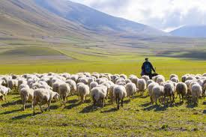
The job of shepherd would have been familiar to many of Jesus’ audience. And the position would have been much nearer to the shepherd of my father’s day than the present day farmer who keeps sheep as part of a number of enterprises on the farm. Shepherds in the 1920’s like sheep farmers today, drove their flocks of sheep between pastures or fields, often with the help of sheep dogs. The Middle Eastern shepherds of Jesus’ time actually led the sheep between grazings, the sheep being content to follow the sound of the shepherd’s voice. So, no doubt in the relative peace of the then Jewish countryside, without the background of mechanical sounds that are constantly present in our lives, the voices of the shepherds would be a familiar background noise.
The people listening to Jesus speak of himself as the Good Shepherd would also immediately think of David and Moses. Both had been actual shepherds looking after sheep as well as being the shepherds of the nation. Both would have defended actual sheep from predators. In this country a fox may take an occasional lamb, in the Middle East at the time of David both lions and bears were known to have attacked flocks – the job of shepherd could hold very real dangers. Both David and Moses had been good shepherds but not all those who had claimed to be shepherds of Israel had been good.
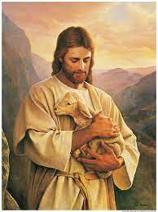
Jesus is the Good Shepherd because he saves his sheep rather than himself. He not only laid down his life for the sheep, but he did so willingly. He says (talking of his life), ‘No one takes it from me, but I lay it down of my own accord’ The difference between Jesus’ death and the death of a shepherd in Israel looking after his sheep is that if an actual shepherd were to die the sheep would then be scattered and likely to fall prey to predators, but with Jesus as the Good Shepherd his death was not a disaster, rather it is life.
It is a life not governed by hatred or violence or desire for power. Nor is it ultimately governed by money or greed. The life Jesus gives us is a life motivated by love. He showed us what love was like and he is the ultimate example of sacrificial love. Jesus is the Good Shepherd who lay down his life for the sheep and he did it freely and willingly.
Our world appears to be in a terrible mess. Greed, hatred and violence make life miserable for millions of people. The only hope for our world, the only way that people will discover life in its fullness is as they recognise the voice of the Good Shepherd and choose freely to follow him. And those who do will live through that motive of love will bring hope and grace to others.
Last month we celebrated Easter, next month we celebrate Pentecost when the Holy Spirit came down on the apostles and the community of believers. Jesus the Good Shepherd is still with us in spirit if not in body. When we say the creed, we affirm ‘we believe in the Holy Spirit, the Lord, the giver of life, who proceeds from the Father and the Son, who with the Father and the Son is worshipped and glorified, who has spoken through the prophets.
The Holy Spirit continues to speak through the church. As individuals and as a church through our words and actions we are called to introduce others to Jesus the Good Shepherd so that they can come to know Him for themselves.
Richard Byas

Bible Birds – The Dove
The dove is mentioned in the Bible more often than any other bird (over 50 times).
Doves, usually imagined as white in colour, are used in many settings in the Bible as symbols of peace, love, and as messengers with the most powerful symbolism of the dove in the Bible being the Spirit of God appearing as a dove.
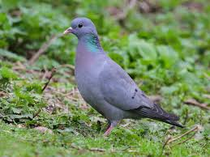
There are however a number of different species of dove and pigeon in Israel and in many cases in the Bible the exact species is not recorded. Those found include the Rock pigeon, the Stock dove, the Common woodpigeon, the European turtledove, the Oriental turtledove, the Eurasian collared-dove and the African collared-dove.
And rather than the white doves we often see in images related to Biblical stories, it is likely to be the common Stock dove that is most often referred to by the Biblical authors.

The Dove as a Symbol of Peace
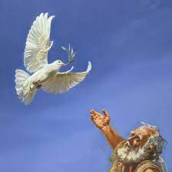
In the Old Testament possibly the best-known story involving a dove was the dove released by Noah after the Flood in order to find land. It came back carrying a freshly plucked olive leaf, a sign of life after the Flood and of God's bringing Noah, his family and the animals to land.
So the dove is a symbol of peace on earth. The dove brought back an olive branch to confirm that the floodwaters had receded and that it was safe to exit the ark. God’s punishment had ended, and it was time to repopulate the earth.

The Dove as a Symbol of Love
The dove is also used as a metaphor for beauty and love as in the Old Testament book the Song of Songs (Song of Solomon). The following verses show this use; (maybe not quite how we would now express ourselves, but the meaning is clear)
How beautiful you are, my darling! Oh, how beautiful! Your eyes are doves. I slept but my heart was awake.
Listen! My beloved is knocking: “Open to me, my sister, my darling, my dove, my flawless one. My head is drenched with dew, my hair with the dampness of the night.”
His eyes are like doves by the water streams, washed in milk, mounted like jewels.
The Dove as a Messenger
The most powerful symbolism of the Dove in the Bible, however, is in the Spirit of God appearing as a dove.
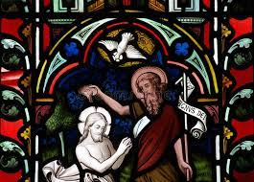
As soon as Jesus was baptized, he went up out of the water. At that moment heaven was opened, and he saw the Spirit of God descending like a dove and alighting on him. ‘and the Holy Spirit descended on him in bodily form like a dove. And a voice came from heaven: You are my Son, whom I love; with you I am well pleased.’
The Holy Spirit is just that—a spirit—He is not visible to us in a physical way. In these accounts, however, the Spirit of God took on a visible appearance and could be seen by witnesses. A very powerful and beautiful symbol.
Richard Byas

Baldersby St James News

Organist – Sadly our Church Organist is moving to a new job and away from Baldersby. If anyone would like to play the Organ or our Baby Grand Piano twice a month at Communion Services please contact our Church Warden Rosemarie Carter on 01765 640360 for details.

Church Visitors – Several years ago we installed a people counter in the porch at St James as part of a project to show the numbers of people in and out of churches. If your church is open every day you will be amazed how many people drop by, many just to sit quietly. In St. James from 1st January to end of March we have had 1,340 through the door! Amazing numbers which include church services, school services, drop in coffee morning (every Tuesday at 10.00a.m.) and visitors making themselves a drink and looking round.

Dalton Events

Village Clock
A very big thank you to John Boddy who for over 30 years has been winding the village clock, along with his faithful assistant, Terry Thorpe, who has helped over the past few years. The clock, which was installed in the church tower in 1922, was funded by subscription as a memorial to the men who died in the First World War. The clock has recently been converted to electricity. So, John and Terry, you can now have a well-earned rest. Thanks guys.

Results of the new 120 Club for March are as follows:
£15 Lol Crossley (No.88); £10 Barbara Pearson-Briggs (No.90); £6 Maggie Hovvels (No.98).

Domino Drive
The next monthly Domino Drive will be held on Saturday 28th May at 7pm. There will be a raffle, and tea and biscuits will be served in the interval. Entry is £2. Everyone is welcome.

Commemoration Oak Tree
An oak tree has been planted on the village green, by Mr and Mrs Croft on behalf of the Parish Council, to commemorate the Queen’s Platinum Jubilee.

Queen’s Jubilee Picnic
There will be a ‘bring your own’ picnic on the playing field for the Queen’s Jubilee on Friday 5th June, 11am until 3pm. There will be a bouncy castle, giant jenga and giant connect 4. Strawberries and cream and scones will be on sale in the village hall, and there will also be a bar.

Dalton Fest
This will be held on Saturday 11th June on the village hall playing field. Tickets are £10 and going fast. Contact Eleanor on 07841 036340 for tickets.

Church Summer Lunch
The lunch will be held on Sunday 26th June at 12 for 12.30. There will be cold meats, salads and warm potatoes, followed by lots of lovely home-made deserts. You won’t go home hungry! Tickets are £12 for adults, 2 adults and 2+ children costs £30, available from Judy on 01845 577607. Places are limited, so don’t wait.
Sylvia Binks

PARISH DIRECTORY
The Parishes of Topcliffe, Baldersby with Dishforth, Dalton and Skipton on Swale
There is currently no Vicar of the parishes. Until one is appointed, please ring our Area Dean,
The Revd Fiona Mayer-Jones tel: 07450 402953 or revdfmj@gmail.com

BALDERSBY with DISHFORTH - PCC Secretary: Mrs Jennifer Wharton wharton370@btinternet.com

DALTON - PCC Secretary: Mrs Hannah Bissett tel: 07739 382831 spannerb79@gmail.com

SKIPTON-on-SWALE – PCC Secretary: Mr Alan Kitching tel: 01845 567457

TOPCLIFFE – PCC Secretary: Mrs Roz Norris RozNorris@aol.com

