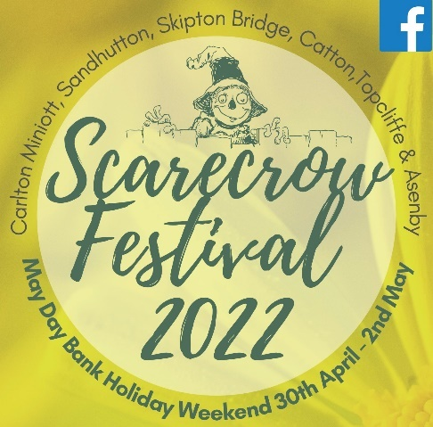
Scarecrow Festival 2022: Trail Information Pack
Thank you for your interest in displaying a scarecrow for our Trail this year. You’ll find in this information pack:
- Introduction to how the Trails work
- Instructions for scarecrow displays
- A form to complete and return to FOS@carltonminiottacademy.org, to complete the registration of your scarecrow.

Introduction
This year’s theme is ‘Scarecrow Royalty’; it’s a nod to the Queen’s Jubilee celebrations but please interpret this however you see fit.
The Festival is being held to raise funds for two of our local primary schools – Carlton Miniott and Topcliffe – and is being jointly organised by the two Friends of School Committees associated with these schools. Both are registered with the Charity Commission of England and Wales.
Our fundraising works by asking those following the trails and spotting your scarecrows to vote for their favourites by making cash donations. We ask you to collect and count your donations then pass on to us.
When you return your forms to us, we use them to collate and produce ‘trail maps’ showing the locations of scarecrows so people can follow the trails and spot the scarecrows. Unfortunately, this means we can only accept entries from scarecrows displayed in one of the six participating villages. The Trail Maps are then made available at local collection points (such as pubs and shops) and can be downloaded/printed from our Facebook pages.
A trophy will be awarded to the owners of the scarecrows collecting the most donations by cash value in the three categories below:
A: Carlton Miniott/Sandhutton
B: Catton/Skipton Bridge (Skipton-on-Swale)
C: Topcliffe and Asenby

We encourage creative approaches to collect as many donations as possible; e.g., last year some offered honey or eggs in return for donations to their scarecrow collection pots.

Instructions
- Decide where you’re going to display your scarecrow
- Find the approximate what3words location on the app or at www.what3words.com... If you are unsure how to use the what3words website or app, we can do this for you! Please just get in touch by email and one of us will help.
- Register your scarecrow by completing and returning the form below by Sunday 24th April 2022.
- We will respond with a reference number once we have completed the trail maps.
- Design and make your scarecrow
- Fashion a cash-collecting vessel
- Display your scarecrow with the cash-collecting vessel by 10am on Saturday 30th April 2022.
- Please leave your Scarecrow in place until after 6pm on Monday 2nd May 2022.
- Count the cash you’ve collected and either bank transfer that amount to us or contact us at FOS@carltonminiottacademy.org to arrange for us to collect the cash from you by Sunday 8th May 2022:
Friends of Carlton Miniott School
Account Number: 00126017
Sort code: 30-18-64
- We will announce the trophy winners shortly after.
- If you have any questions, please don’t hesitate to email us.

Registration Form
Please complete and return to FOS@CarltonMiniottAcademy.org by Sunday 24th April 2022.
Your Name

Which village will your scarecrow be displayed in?
(Please ensure you have permission to display a scarecrow in the location you have identified below).

Your email address

Your phone number/s

What3words location of your scarecrow

Please confirm you agree to donate the money your scarecrows raise to Friends of School Carlton Miniott/Friends of Topcliffe School (‘I agree’)

